Chapter 10 Means of Egress
CALIFORNIA BUILDING CODE — MATRIX ADOPTION TABLE
CHAPTER 10 — MEANS OF EGRESS
(Matrix Adoption Tables are nonregulatory, intended only as an aid to the code user. See Chapter 1 for state agency authority and building applications.)
Adopting agency | BSC | BSC-  CG | SFM | HCD |  |  | DSA |  |  | OSHPD |  |  |  |  |  |  | BSCC | DPH | AGR | DWR | CEC | CA | SL | SLC
 |  |  |  | 1 | 2 | 1/AC | AC | SS | SS/CC | 1 | 1R | 2 | 3 | 4 | 5 | 6
Adopt entire chapter | X |  |  |  |  |  |  | X | X |  |  |  | X |  |  | X
Adopt entire chapter as amended (amended sections listed below) |  |  | X | X | X | X |  |  |  | X | X | X |  | X | X
Adopt only those sections that are listed below |  |  |  |  |  |  | X
Chapter / Section
1003.1 |  |  | X |  |  | X | X
1003.1.1 |  |  |  |  |  |  |  |  |  | X
1003.1.2 |  |  |  |  |  |  |  |  |  |  | X | X |  |  | X
1003.2 |  |  | X
1003.3, Exception |  |  | X
1003.3.1 |  |  | X
1003.3.3.1 |  |  | X
1003.3.4 |  |  |  | X | X | X
1003.5 |  |  | X | X | X
Table 1004.5 |  |  | X
1004.9 |  |  | X
1005.3.1 |  |  | X
1005.3.2 |  |  | X
1005.7.1 |  |  | X
1005.7.2 |  |  | X
1006.2.1 |  |  | X
Table 1006.2.1 |  |  | X
1006.2.2 |  |  | X
1006.2.2.3 |  |  | X
1006.2.2.4 |  |  | X
1006.2.2.6 |  |  | X
1006.2.2.7 |  |  | X
1006.2.2.8 |  |  | X
Table 1006.3.4(1) |  |  | X
Table 1006.3.4(2) |  |  | X
1008.2 |  |  | X
1008.3 |  |  | X
1008.3.2 |  |  | X
1009.1 |  |  | X | X | X | X | X
1009.2 |  |  |  |  |  | X | X
1009.3 |  |  |  |  |  | X | X
1009.4.1 |  |  | X
1009.4.2 |  |  |  |  |  |  | X
1009.5 |  |  | X | X | X | X | X
1009.6 |  |  |  |  |  |  | X
1009.6.3 |  |  | X | X | X | X | X
1009.6.4 |  |  |  |  |  |  | X
1009.7.2 |  |  |  |  |  |  | X
1009.8.1.1 |  |  |  |  |  | X | X
1009.8.2 |  |  | X |  |  | X | X
1009.9 |  |  |  |  |  | X | X
1009.10 |  |  |  |  |  |  | X
1009.11 |  |  |  |  |  | X | X
1009.12 |  |  | X |  |  | X | X
1010 (1st paragraph below title only) |  |  |  |  |  |  | X
1010.1.1 |  |  | X |  |  | X
1010.1.1.1 |  |  | X
1010.1.2 |  |  | X
1010.1.2.1 |  |  | X
1010.1.4 |  |  |  |  |  | X | X
1010.1.6 |  |  |  |  |  | X | X
1010.1.7 |  |  |  |  |  | X | X
1010.2.1 |  |  | X
1010.2.2 |  |  | X |  |  | X | X
1010.2.4 |  |  | X
1010.2.7.1 |  |  | X
1010.2.7.2 |  |  | X
1010.2.8 |  |  | X
1010.2.8.1 |  |  | X
1010.2.11.1 |  |  | X
1010.2.12 |  |  | X
1010.2.12.1 |  |  | X
1010.2.12.1 (Item 4, 6.3 & 6.4 only) |  |  |  |  |  |  | X
1010.2.13 |  |  | X
1010.2.5 |  |  | X
1010.2.15 Reserved |  |  | X
1010.3.1 |  |  |  |  |  | X
1011 (1st paragraph below title only) |  |  |  |  |  |  | X
1011.2 |  |  | X
1011.5.2 |  |  | X
1011.5.2 [DSA-AC: exc. 4 only] |  |  |  |  |  |  | X
1011.6 |  |  | X
1011.11 |  |  | X
1011.11 (2nd paragraph only) |  |  |  |  |  |  | X
1011.15 |  |  | X
1012 (1st paragraph below title only) |  |  |  |  |  |  | X
1012.1 |  |  |  |  |  | X
1012.6.3 |  |  |  |  |  | X
1012.6.4 |  |  |  |  |  | X
1012.6.5 |  |  |  |  |  | X
1012.10 |  |  |  |  |  | X
1013.1 |  |  | X
1013.2 |  |  | X
1013.4 |  |  | X |  |  | X | X
1013.6.3 |  |  | X
1013.7 |  |  | X
1013.8 |  |  | X
1014 (1st paragraph below title only) |  |  |  |  |  |  | X
1014.8 |  |  | X |  |  | X
1015.2 |  |  | X |  |  |  | X
1015.3 |  |  | X | X | X | X | X
1015.4 |  |  | X
1015.8 |  |  |  | X | X | X
1016.2 |  |  | X
1016.2.2 |  |  | X
Table 1017.2 |  |  | X
1018.2 (1st paragraph below title only) |  |  |  |  |  |  | X
1018.3 Exception only |  |  |  |  |  |  | X
1018.5 Exception only |  |  |  |  |  |  | X
1019.3 |  |  | X
1019.4 |  |  | X
1020.2 |  |  | X
Table 1020.1 |  |  | X
Table 1020.2 |  |  | X
1020.5 |  |  | X |  |  |  |  |  |  | X |  | X |  | X
1020.6 |  |  | X
1020.7 |  |  | X
1022.3 |  |  | X
1023.2 |  |  | X
1023.9 |  |  | X |  |  | X
1023.9 (2nd paragraph only) |  |  |  |  |  |  | X
1023.9.1 |  |  | X
1023.11 |  |  |  |  |  | X
1024.2 |  |  | X
1026.4.1 |  |  | X
1026.4.2 |  |  | X
1026.6 |  |  | X
1028.5 |  |  | X
1029.3.1 |  |  | X
1029.9.1 |  |  | X
1030.2 |  |  | X
1030.3 |  |  | X
1030.6.3.2 |  |  | X
1030.9 |  |  | X
1031.2 |  |  | X
1031.2.1 |  |  | X
1031.2.2 |  |  | X
1031.2.3 |  |  | X
The state agency does not adopt sections identified with the following symbol: †
The Office of the State Fire Marshal's adoption of this chapter or individual sections is applicable to structures regulated by other state agencies pursuant to Section 1.11.
User notes:
About this chapter: Chapter 10 provides the general criteria for designing the means of egress established as the primary method for protection of people in buildings by allowing timely relocation or evacuation of building occupants. Both prescriptive and performance language is utilized in this chapter to provide for a basic approach in the determination of a safe exiting system for all occupancies. It addresses all portions of the egress system (exit access, exits and exit discharge) and includes design requirements as well as provisions regulating individual components. The requirements detail the size, arrangement, number and protection of means of egress components. Functional and operational characteristics that will permit the safe use of components without special knowledge or effort are specified.
The means of egress protection requirements work in coordination with other sections of the code, such as protection of vertical openings (see Chapter 7), interior finish (see Chapter 8), fire suppression and detection systems (see Chapter 9) and numerous others, all having an impact on life safety. Chapter 10 is subdivided into four main sections: general (Sections 1003—1015), exit access (Sections 1016—1021), exit (Sections 1022—1027) and exit discharge (Sections 1028—1029). Special allowances for the unique requirements for assembly spaces (Section 1030) and emergency escape and rescue openings (Section 1031) complete the chapter. Chapter 10 of this code is duplicated in Chapter 10 the California Fire Code; however, the California Fire Code contains one additional section on maintenance of the means of egress system in existing buildings.
Section 1001 Administration
1001.1 General
Diagram
Buildings or portions thereof shall be provided with a means of egress system as required by this chapter. The provisions of this chapter shall control the design, construction and arrangement of means of egress components required to provide an approved means of egress from structures and portions thereof.
UpCodes Diagram (1)
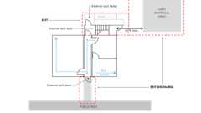
Means of Egress: Basic Components
1001.2 Minimum Requirements
Diagram
It shall be unlawful to alter a building or structure in a manner that will reduce the number of exits or the minimum width or required capacity of the means of egress to less than required by this code.
UpCodes Diagram (1)
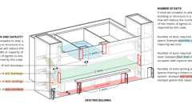Primary
Egress: Min. Reqs., Existing Buildings
Section 1002 Maintenance and Plans
[F] 1002.1 Maintenance
Means of egress shall be maintained in accordance with the California Fire Code.
[F] 1002.2 Fire Safety and Evacuation Plans
Diagram
Fire safety and evacuation plans shall be provided for all occupancies and buildings where required by the California Fire Code. Such fire safety and evacuation plans shall comply with the applicable provisions of Sections 401.2 and 404 of the California Fire Code.
UpCodes Diagrams (4)
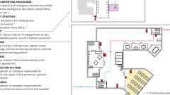Primary
Fire Safety Plans
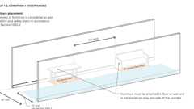
Projections in Nursing Home Corridors
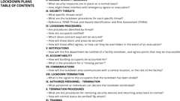
Lockdown Plans: Table of Contents
Fire and Emerg. Plans
Section 1003 General Means of Egress
1003.1 Applicability
Diagram
The general requirements specified in Sections 1003 through 1015 shall apply to all three elements of the means of egress system, in addition to those specific requirements for the exit access, the exit and the exit discharge detailed elsewhere in this chapter.
[DSA-AC & HCD 1-AC] In addition to the requirement of this chapter, means of egress, which provide access to, or egress from, buildings or facilities where accessibility is required for applications listed in Section 1.8.2.1.2 regulated by the Department of Housing and Community Development, or Section 1.9.1 regulated by the Division of the State Architect—Access Compliance, shall also comply with Chapter 11A or Chapter 11B, as applicable.
Exception: [SFM] Exiting requirements for Fixed Guideway Transit Systems shall be as per Section 443.
UpCodes Diagrams (3)
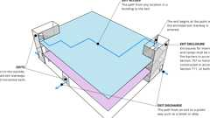Primary
Exit Access, Exit and Exit Discharge
Means of Egress: Basic Components
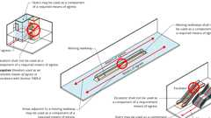
Elevators, Escalators or Moving Walks in Means of Egress
1003.1.1 Means of Egress for Hospitals
[OSHPD 1] In addition to the requirements of this chapter, means of egress for hospitals shall comply with Part 10 California Existing Building Code Section 311A.
1003.1.2 Means of Egress for Hospital Buildings Removed From Acute Care Service, Skilled Nursing Facilities, Intermediate Care Facilities and Acute Psychiatric Hospitals
[OSHPD 1R, 2 & 5] In addition to the requirements of this chapter, means of egress for hospital buildings removed from acute care service, skilled nursing facilities, intermediate care facilities and acute psychiatric hospitals shall comply with OSHPD amendments to Part 10 California Existing Building Code Section 311.
1003.2 Ceiling Height
Diagram
The means of egress shall have a ceiling height of not less than 7 feet 6 inches (2286 mm) above the finished floor.
Exceptions:
- Sloped ceilings in accordance with Section 1208.2.
- Ceilings of dwelling units and sleeping units within residential occupancies in accordance with Section 1208.2.
- Allowable projections in accordance with Section 1003.3.
- Stair headroom in accordance with Section 1011.3.
- Door height in accordance with Section 1010.1.1.
- Ramp headroom in accordance with Section 1012.5.2.
- The clear height of floor levels in vehicular and pedestrian traffic areas of public and private parking garages in accordance with Section 406.2.2.
- Areas above and below mezzanine floors in accordance with Section 505.2.
- In Group I-2 and I-3 occupancies, the means of egress shall have a ceiling height of not less than 8 feet (2439 mm).
UpCodes Diagram (1)
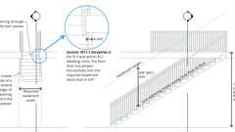
Stairway Headroom and Vert. Rise
1003.3 Protruding Objects
Diagram
Protruding objects on circulation paths shall comply with the requirements of Sections 1003.3.1 through 1003.3.4.
Exception: In Group I-2 occupancies, protruding objects shall not extend more than 12 inches (305 mm) below the minimum ceiling height required by Section 1003.2.
UpCodes Diagrams (2)
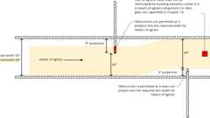
Means of Egress Continuity: Obstructions
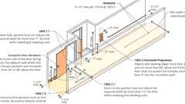
Corridors: Unobstructed Width
1003.3.1 Headroom
Protruding objects are permitted to extend below the minimum ceiling height required by Section 1003.2 where a minimum headroom of 80 inches (2032 mm) is provided over any circulation paths, including walks, corridors, aisles and passageways. In other than Group I-2 occupancies, not more than 50 percent of the ceiling area of a means of egress shall be permitted to be reduced in height by protruding objects.
Exception: Door closers, overhead doorstops, frame stops, power door operators and electromagnetic door locks shall be permitted to project into the door opening height not lower than 78 inches (1980 mm) above the floor.
A barrier shall be provided where the vertical clearance above a circulation path is less than 80 inches (2032 mm) high above the finished floor. The leading edge of such a barrier shall be located 27 inches (686 mm) maximum above the finished floor.
1003.3.2 Post-Mounted Objects
A free-standing object mounted on a post or pylon shall not overhang that post or pylon more than 4 inches (102 mm) where the lowest point of the leading edge is more than 27 inches (686 mm) and less than 80 inches (2032 mm) above the finished floor. Where a sign or other obstruction is mounted between posts or pylons and the clear distance between the posts or pylons is greater than 12 inches (305 mm), the lowest edge of such sign or obstruction shall be 27 inches (686 mm) maximum or 80 inches (2032 mm) minimum above the finished floor or ground.
Exception: These requirements shall not apply to sloping portions of handrails between the top and bottom riser of stairs and above the ramp run.
1003.3.3 Horizontal Projections
Diagram
Objects with leading edges more than 27 inches (685 mm) and not more than 80 inches (2030 mm) above the finished floor shall not project horizontally more than 4 inches (102 mm) into the circulation path.
Exception: Handrails are permitted to protrude 4¹/₂ inches (114 mm) from the wall or guard.
UpCodes Diagrams (2)
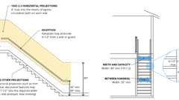Primary
Stairs Horizontal Encroachments
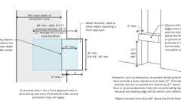Primary
Recessed Objects
1003.3.3.1 Horizontal Projections for Group I-2 Occupancies
Structural elements, fixtures or furnishings shall not project horizontally from either side more than 1¹/₂ inches (38 mm) into the required width of an exit access corridor serving any area caring for one or more nonambulatory or bedridden persons.
Exceptions:
- Handrails are permitted to protrude 3¹/₂ inches (89 mm) from the wall.
- Alcohol-based hand-rub dispensers are permitted to protrude 4 inches.
- Manual fire alarm boxes with a protective cover installed are permitted to protrude 4 inches.
1003.3.4 Clear Width
Diagram
Protruding objects shall not reduce the minimum clear width of accessible routes as required in Chapter 11A or Chapter 11B.
UpCodes Diagram (1)
Recessed Objects
1003.4 Slip-Resistant Surface
Diagram
Circulation paths of the means of egress shall have a slip-resistant surface and be securely attached.
UpCodes Diagrams (2)
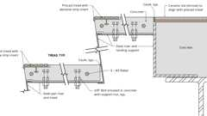Primary
Example: Precast Stairway Treads
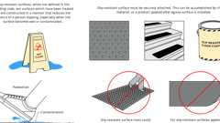Primary
Slip-Resistant Surfaces
1003.5 Elevation Change
Diagram
Where changes in elevation of less than 12 inches (305 mm) exist in the means of egress, sloped surfaces shall be used. Where the slope is greater than one unit vertical in 20 units horizontal (5-percent slope), ramps complying with Section 1012 shall be used. Where the difference in elevation is 6 inches (152 mm) or less, the ramp shall be equipped with either handrails or floor finish materials that contrast with adjacent floor finish materials.
Exceptions:
- Steps at exterior doors complying with Section 1010.1.4.
- A stair with a single riser or with two risers and a tread is permitted at locations not required to be accessible by Chapter 11A or 11B where the risers and treads comply with Section 1011.5, the minimum depth of the tread is 13 inches (330 mm) and not less than one handrail complying with Section 1014 is provided within 30 inches (762 mm) of the centerline of the normal path of egress travel on the stair.
- A step is permitted in aisles serving seating that has a difference in elevation less than 12 inches (305 mm) at locations not required to be accessible by Chapter 11A or 11B, provided that the risers and treads comply with Section 1030.14 and the aisle is provided with a handrail complying with Section 1030.16.
Throughout a story in a Group I-2 occupancy, any change in elevation in portions of the means of egress that serve nonambulatory persons shall be by means of a ramp or sloped walkway.
UpCodes Diagram (1)
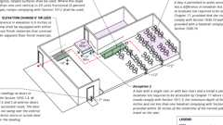Primary
Elevation Changes
1003.6 Means of Egress Continuity
Diagram
The path of egress travel along a means of egress shall not be interrupted by a building element other than a means of egress component as specified in this chapter. Obstructions shall not be placed in the minimum width or required capacity of a means of egress component except projections permitted by this chapter. The minimum width or required capacity of a means of egress system shall not be diminished along the path of egress travel.
UpCodes Diagram (1)
Primary
Means of Egress Continuity: Obstructions
1003.7 Elevators, Escalators and Moving Walks
Diagram
Elevators, escalators and moving walks shall not be used as a component of a required means of egress from any other part of the building.
Exception: Elevators used as an accessible means of egress in accordance with Section 1009.4.
UpCodes Diagrams (2)
Primary
Elevators, Escalators or Moving Walks in Means of Egress
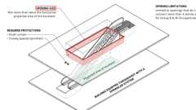
Escalator Openings (New Const.)
Section 1004 Occupant Load
Diagram
UpCodes Diagrams (14)
Occupant Loads: Outdoor Areas
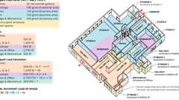
Occupant Load Calc: Gallery
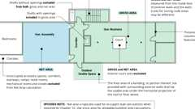
Gross vs. Net Area
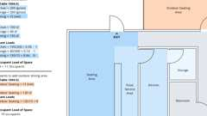
Occupant Load Calc: Small Space
Cumulative Occ. Loads: Mezzanines
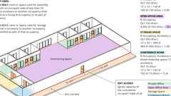
Cumulative Occ. Loads: Intervening Spaces/Accessory Areas
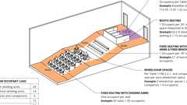
Occupant Loads: Fixed Seating
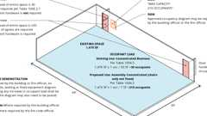
Increased Occupant Load
Means of Egress: Multiple Occupancies
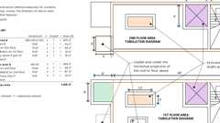
Gross Area Calc.
Show 4 more
1004.1 Design Occupant Load
Diagram
In determining means of egress requirements, the number of occupants for whom means of egress facilities are provided shall be determined in accordance with this section.
UpCodes Diagrams (2)
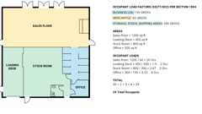Primary
Occupant Loads: Retail
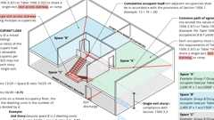
Single Exits: Multiple Occupancies
1004.2 Cumulative Occupant Loads
Where the path of egress travel includes intervening rooms, areas or spaces, cumulative occupant loads shall be determined in accordance with this section.
1004.2.1 Intervening Spaces or Accessory Areas
Diagram
Where occupants egress from one or more rooms, areas or spaces through others, the design occupant load shall be the combined occupant load of interconnected accessory or intervening spaces. Design of egress path capacity shall be based on the cumulative portion of occupant loads of all rooms, areas or spaces to that point along the path of egress travel.
UpCodes Diagram (1)
Primary
Cumulative Occ. Loads: Intervening Spaces/Accessory Areas
1004.2.2 Adjacent Levels for Mezzanines
Diagram
That portion of the occupant load of a mezzanine with required egress through a room, area or space on an adjacent level shall be added to the occupant load of that room, area or space.
UpCodes Diagram (1)
Primary
Cumulative Occ. Loads: Mezzanines
1004.2.3 Adjacent Stories
Diagram
Other than for the egress components designed for convergence in accordance with Section 1005.6, the occupant load from separate stories shall not be added.
UpCodes Diagram (1)
Egress Convergence at Intermediate Levels
1004.3 Multiple Function Occupant Load
Diagram
Where an area under consideration contains multiple functions having different occupant load factors, the design occupant load for such area shall be based on the floor area of each function calculated independently.
UpCodes Diagrams (3)
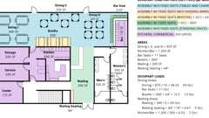Primary
Occupant Load: Multiple Function Spaces
Occupant Load Calc: Gallery
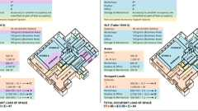
Occupancy Groups: Art Studios
1004.4 Multiple Occupancies
Diagram
Where a building contains two or more occupancies, the means of egress requirements shall apply to each portion of the building based on the occupancy of that space. Where two or more occupancies utilize portions of the same means of egress system, those egress components shall meet the more stringent requirements of all occupancies that are served.
UpCodes Diagrams (3)
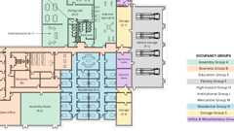Primary
Multiple Occupancy Building - Occupancy Groups
Primary
Means of Egress: Multiple Occupancies
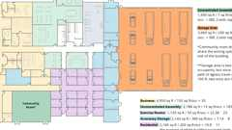
Multiple Occupancy Building: Design Occupant Load
1004.5 Areas Without Fixed Seating
Diagram
The number of occupants shall be computed at the rate of one occupant per unit of area as prescribed in Table 1004.5. For areas without fixed seating, the occupant load shall be not less than that number determined by dividing the floor area under consideration by the occupant load factor assigned to the function of the space as set forth in Table 1004.5. Where an intended function is not listed in Table 1004.5, the building official shall establish a function based on a listed function that most nearly resembles the intended function.
Exception: Where approved by the building official, the actual number of occupants for whom each occupied space, floor or building is designed, although less than those determined by calculation, shall be permitted to be used in the determination of the design occupant load.
TABLE 1004.5—MAXIMUM FLOOR AREA ALLOWANCES PER OCCUPANT
FUNCTION OF SPACE | OCCUPANT LOAD FACTORª
Accessory storage areas, mechanical equipment room | 300 gross
Agricultural building | 300 gross
Aircraft hangars | 500 gross
Airport terminal
Baggage claim | 20 gross
Baggage handling | 300 gross
Concourse | 100 gross
Waiting areas | 15 gross
Assembly
Gaming floors (keno, slots, etc.) | 11 gross
Exhibit gallery and museum | 30 net
Assembly with fixed seats | See Section 1004.6
Assembly without fixed seats
Concentrated (chairs only—not fixed) | 7 net
Standing space | 5 net
Unconcentrated (tables and chairs) | 15 net
Bowling centers, allow 5 persons for each lane including 15 feet of runway, and for additional areas | 7 net
Business areas | 150 gross
Concentrated business use areas | See Section 1004.8
Courtrooms—other than fixed seating areas | 40 net
Day care | 35 net
Dormitories | 50 gross
Educational
Classroom area | 20 net
Shops and other vocational room areas | 50 net
Exercise rooms | 50 gross
Group H-5 fabrication and manufacturing areas | 200 gross
Industrial areas | 100 gross
Information technology equipment facilities | 300 gross
Institutional areas^{c}
Inpatient treatment areas | 240 gross
Outpatient areas | 100 gross
Sleeping areas | 120 gross
Kitchens, commercial | 200 gross
Laboratory
Educational (K—12th grade) | 50 net
Laboratories, non-educational | 100 net
Laboratory suite^{b} | 200 gross
Library
Reading rooms | 50 net
Stack area | 100 gross
Locker rooms | 50 gross
Mall buildings—covered and open | See Section 402.8.2
Mercantile | 60 gross
Storage, stock, shipping areas | 300 gross
Parking garages | 200 gross
Residential | 200 gross
Skating rinks, swimming pools
Rink and pool | 50 gross
Decks | 15 gross
Stages and platforms | 15 net
Warehouses | 500 gross
For SI: 1 foot = 304.8 mm, 1 square foot = 0.0929 m².
- Floor area in square feet per occupant.
- See Section 453.2.
- See Table 408.3.13 for I-3 facilities.
UpCodes Diagrams (13)
Primary
Occupant Load Calc: Small Space
Primary
Occupant Load Calc: Gallery
Primary
Occupancy Groups: Art Studios
Primary
Gross Area Calc.
Gross vs. Net Area
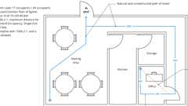
Example: Single Exit Condition
Occupant Loads: Retail
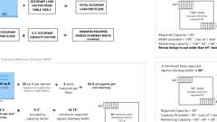
Min. Stairway Widths and Loss of Exit
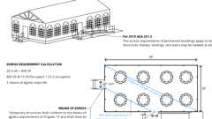
Egress Req. for Temporary Structures
Occupant Loads: Fixed Seating
Show 3 more
1004.5.1 Increased Occupant Load
Diagram
The occupant load permitted in any building, or portion thereof, is permitted to be increased from that number established for the occupancies in Table 1004.5, provided that all other requirements of the code are met based on such modified number and the occupant load does not exceed one occupant per 7 square feet (0.65 m²) of occupiable floor space. Where required by the building official, an approved aisle, seating or fixed equipment diagram substantiating any increase in occupant load shall be submitted. Where required by the building official, such diagram shall be posted.
UpCodes Diagram (1)
Primary
Increased Occupant Load
1004.6 Fixed Seating
Diagram
For areas having fixed seats and aisles, the occupant load shall be determined by the number of fixed seats installed therein. The occupant load for areas in which fixed seating is not installed, such as waiting spaces, shall be determined in accordance with Section 1004.5 and added to the number of fixed seats.
The occupant load of wheelchair spaces and the associated companion seat shall be based on one occupant for each wheelchair space and one occupant for the associated companion seat provided in accordance with Section 1109.2.3.
For areas having fixed seating without dividing arms, the occupant load shall be not less than the number of seats based on one person for each 18 inches (457 mm) of seating length.
The occupant load of seating booths shall be based on one person for each 24 inches (610 mm) of booth seat length measured at the backrest of the seating booth.
UpCodes Diagrams (2)
Primary
Occupant Loads: Fixed Seating
Occupant Load: Multiple Function Spaces
1004.7 Outdoor Areas
Diagram
Yards, patios, occupiable roofs, courts and similar outdoor areas accessible to and usable by the building occupants shall be provided with means of egress as required by this chapter. The occupant load of such outdoor areas shall be assigned by the building official in accordance with the anticipated use. Where outdoor areas are to be used by persons in addition to the occupants of the building, and the path of egress travel from the outdoor areas passes through the building, means of egress requirements for the building shall be based on the sum of the occupant loads of the building plus the outdoor areas.
Exceptions:
- Outdoor areas used exclusively for service of the building need only have one means of egress.
- Both outdoor areas associated with Group R-3 and individual dwelling units of Group R-2.
UpCodes Diagram (1)
Primary
Occupant Loads: Outdoor Areas
1004.8 Concentrated Business Use Areas
Diagram
The occupant load factor for concentrated business use shall be applied to telephone call centers, trading floors, electronic data entry and similar business use areas with a higher density of occupants than would normally be expected in a typical business occupancy environment. Where approved by the building official, the occupant load for concentrated business use areas shall be the actual occupant load, but not less than one occupant per 50 square feet (4.65 m²) of gross occupiable floor space.
UpCodes Diagram (1)
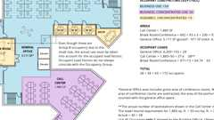
Occ. Loads: Business and Concentrated Business Use
1004.9 Posting of Occupant Load
Diagram
Every room or space which is used for assembly, classroom, dining, drinking or similar purposes having an occupant load of 50 or more shall have the occupant load of the room or space posted in a conspicuous place, near the main exit or exit access doorway from the room or space, for the intended configurations. Posted signs shall be of an approved legible permanent design and shall be maintained by the owner or the owner's authorized agent.
UpCodes Diagram (1)
Increased Occupant Load
Section 1005 Means of Egress Sizing
1005.1 General
Diagram
All portions of the means of egress system shall be sized in accordance with this section.
Exception: Aisles and aisle accessways in rooms or spaces used for assembly purposes complying with Section 1030.
UpCodes Diagrams (5)
Corridor Widths in Hospitals
Egress: Min. Reqs., Existing Buildings
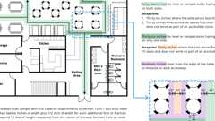
Aisles with Tables and Fixtures
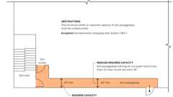
Exit Passageways: Width and Capacity
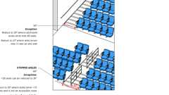
Min. Assembly Aisle Widths
1005.2 Minimum Width Based on Component
The minimum width, in inches (mm), of any means of egress components shall be not less than that specified for such component, elsewhere in this code.
1005.3 Required Capacity Based on Occupant Load
The required capacity, in inches (mm), of the means of egress for any room, area, space or story shall be not less than that determined in accordance with Sections 1005.3.1 and 1005.3.2.
1005.3.1 Stairways
Diagram
The capacity, in inches, of means of egress stairways shall be calculated by multiplying the occupant load served by such stairways by a means of egress capacity factor of 0.3 inch (7.6 mm) per occupant. Where stairways serve more than one story, only the occupant load of each story considered individually shall be used in calculating the required capacity of the stairways serving that story.
Exceptions:
- For other than Group H and I-2 occupancies, the capacity, in inches, of means of egress stairways shall be calculated by multiplying the occupant load served by such stairways by a means of egress capacity factor of 0.2 inch (5.1 mm) per occupant in buildings equipped throughout with an automatic sprinkler system installed in accordance with Section 903.3.1.1 or 903.3.1.2 and an emergency voice/alarm communication system in accordance with Section 907.5.2.2.
- Facilities with smoke-protected assembly seating shall be permitted to use the capacity factors in Table 1030.6.2 indicated for stepped aisles for exit access or exit stairways where the entire path for means of egress from the seating to the exit discharge is provided with a smoke control system complying with Section 909.
- Facilities with open-air assembly seating shall be permitted to the capacity factors in Section 1030.6.3 indicated for stepped aisles for exit access or exit stairways where the entire path for means of egress from the seating to the exit discharge is open to the outdoors.
- For Group H-1, H-2, H-3 and H-4 occupancies the total width of means of egress in inches (mm) shall not be less than the total occupant load served by the means of egress multiplied by 0.7 inches (7.62 mm) per occupant.
UpCodes Diagram (1)
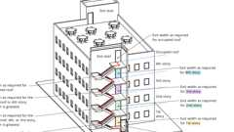
Stairway Continuity of Required Width
1005.3.2 Other Egress Components
Diagram
The capacity, in inches, of means of egress components other than stairways shall be calculated by multiplying the occupant load served by such component by a means of egress capacity factor of 0.2 inch (5.1 mm) per occupant.
Exceptions:
- For other than Group H and I-2 occupancies, the capacity, in inches, of means of egress components other than stairways shall be calculated by multiplying the occupant load served by such component by a means of egress capacity factor of 0.15 inch (3.8 mm) per occupant in buildings equipped throughout with an automatic sprinkler system installed in accordance with Section 903.3.1.1 or 903.3.1.2 and an emergency voice/alarm communication system in accordance with Section 907.5.2.2.
- Facilities with smoke-protected assembly seating shall be permitted to use the capacity factors in Table 1030.6.2 indicated for level or ramped aisles for means of egress components other than stairways where the entire path for means of egress from the seating to the exit discharge is provided with a smoke control system complying with Section 909.
- Facilities with open-air assembly seating shall be permitted to the capacity factors in Section 1030.6.3 indicated for level or ramped aisles for means of egress components other than stairways where the entire path for means of egress from the seating to the exit discharge is open to the outdoors.
- For Group H-1, H-2, H-3 and H-4 occupancies the total width of means of egress in inches (mm) shall not be less than the total occupant load served by the means of egress multiplied by 0.4 inches (5.08 mm) per occupant.
UpCodes Diagrams (2)
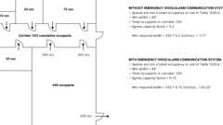Primary
Corridor Width Example
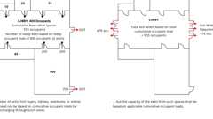
Exits through Lobbies
1005.4 Continuity
Diagram
The minimum width or required capacity of the means of egress required from any story of a building shall not be reduced along the path of egress travel until arrival at the public way.
UpCodes Diagrams (2)
Primary
Stairway Continuity of Required Width
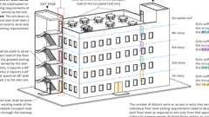
Egress From Stories or Occupied Roof
1005.5 Distribution of Minimum Width and Required Capacity
Diagram
Where more than one exit, or access to more than one exit, is required, the means of egress shall be configured such that the loss of any one exit, or access to one exit, shall not reduce the available capacity or width to less than 50 percent of the required capacity or width.
UpCodes Diagram (1)
Min. Stairway Widths and Loss of Exit
1005.6 Egress Convergence
Diagram
Where the means of egress from stories above and below converge at an intermediate level, the capacity of the means of egress from the point of convergence shall be not less than the largest minimum width or the sum of the required capacities for the stairways or ramps serving the two adjacent stories, whichever is larger.
UpCodes Diagram (1)
Primary
Egress Convergence at Intermediate Levels
1005.7 Encroachment
Diagram
Encroachments into the required means of egress width shall be in accordance with the provisions of this section.
UpCodes Diagram (1)
Primary
Corridors: Unobstructed Width
1005.7.1 Doors
Diagram
Doors, when fully opened, shall not reduce the required width by more than 7 inches (178 mm). Doors in any position shall not reduce the required width by more than one-half.
Exceptions:
- In other than Group I-2 occupancies, surface-mounted latch release hardware shall be exempt from inclusion in the 7-inch maximum (178 mm) encroachment where both of the following conditions exist:
  - The hardware is mounted to the side of the door facing away from the adjacent wall where the door is in the open position.
  - The hardware is mounted not less than 34 inches (865 mm) nor more than 48 inches (1219 mm) above the finished floor.
- The restrictions on door swing shall not apply to doors within individual dwelling units and sleeping units of Group R-2 occupancies and dwelling units of Group R-3 occupancies.
UpCodes Diagram (1)
Corridors: Unobstructed Width
1005.7.2 Other Projections
Diagram
Handrail projections shall be in accordance with the provisions of Section 1014.9. Other nonstructural projections such as trim and similar decorative features shall be permitted to project into the required width not more than 1¹/₂ inches (38 mm) on each side.
UpCodes Diagrams (3)
Means of Egress Continuity: Obstructions
Corridors: Unobstructed Width
Stairs Horizontal Encroachments
1005.7.3 Protruding Objects
Diagram
Protruding objects shall comply with the applicable requirements of Section 1003.3.
UpCodes Diagram (1)
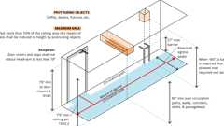
Protruding Objects: Headroom
Section 1006 Number of Exits and Exit Access Doorways
Diagram
UpCodes Diagrams (15)
Parking Garage Exiting: Vehicular Ramps
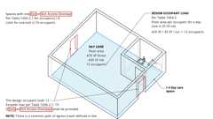
Group I-4 Exits
Egress: Min. Reqs., Existing Buildings
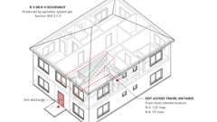
Exit Access Travel Distance: R-3 and R-4
Example: Single Exit Condition
Single Exits: Multiple Occupancies
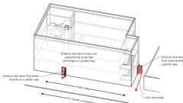
Exterior Egress Door Arrangement
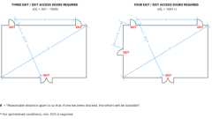
Required Exits: Three or More
Exits through Lobbies
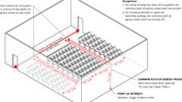
Common Path of Travel from Assembly Seating
Show 5 more
1006.1 General
The number of exits or exit access doorways required within the means of egress system shall comply with the provisions of Section 1006.2 for spaces, including mezzanines, and Section 1006.3 for stories or occupiable roofs.
1006.2 Egress From Spaces
Rooms, areas or spaces, including mezzanines, within a story or basement shall be provided with the number of exits or access to exits in accordance with this section.
1006.2.1 Egress Based on Occupant Load and Common Path of Egress Travel Distance
Diagram
Two exits or exit access doorways from any space shall be provided where the design occupant load or the common path of egress travel distance exceeds the values listed in Table 1006.2.1. The cumulative occupant load from adjacent rooms, areas or spaces shall be determined in accordance with Section 1004.2.
Exceptions:
- The number of exits from foyers, lobbies, vestibules or similar spaces need not be based on cumulative occupant loads for areas discharging through such spaces, but the capacity of the exits from such spaces shall be based on applicable cumulative occupant loads.
- Rooms and care suites in Group I-2 occupancies complying with Section 407.4.
- Unoccupied mechanical rooms and penthouses are not required to comply with the common path of egress travel distance measurement.
- In detention and correctional facilities and holding cells, such as are found in courthouse buildings, when the occupant load is more than 20 see Section 408.3.11.
TABLE 1006.2.1—SPACES WITH ONE EXIT OR EXIT ACCESS DOORWAY
OCCUPANCY | MAXIMUM OCCUPANT  LOAD OF SPACE | MAXIMUM COMMON PATH OF EGRESS TRAVEL DISTANCE  (feet)
OCCUPANCY | MAXIMUM OCCUPANT  LOAD OF SPACE | Without Automatic Sprinkler System  (feet) |  | With Automatic Sprinkler System  (feet)
OCCUPANCY | MAXIMUM OCCUPANT  LOAD OF SPACE | Occupant Load |  | With Automatic Sprinkler System  (feet)
OCCUPANCY | MAXIMUM OCCUPANT  LOAD OF SPACE | OL ≤ 30 | OL > 30 | With Automatic Sprinkler System  (feet)
A^{c}, E, M | 49 | 75 | 75 | 75ª
B | 49 | 100 | 75 | 100ª
F | 49 | 75 | 75 | 100ª
H-1, H-2, H-3 | 3 | NP | NP | 25^{b}
H-4, H-5 | 10 | NP | NP | 75^{b}
I-2^{d}, I-4 | 10 | NP^{i} | NP^{i} | 75ª
I-3h | 10 | NP | NP | 100ª
R-1 | 10 | NP | NP | 75ª
R-2 | 20 | NP | NP | 125ª
R-2.1 | 10 | NP | NP | 75ª
R-2.2 | 20 | NP | NP | 125ª
R-3e, R-3.1e | 20 | NP | NP | 125^{a, g}
R-4e | 20 | NP | NP | 125^{a, g}
S^{f} | 29 | 100 | 75 | 100ª
U | 49 | 100 | 75 | 75ª
L | See Section 453.6.1 |  | NP | NP
For SI: 1 foot = 304.8 mm.
NP = Not Permitted.
- Buildings equipped throughout with an automatic sprinkler system in accordance with Section 903.3.1.1 or 903.3.1.2. See Section 903 for occupancies where automatic sprinkler systems are permitted in accordance with Section 903.3.1.2.
- Group H occupancies equipped throughout with an automatic sprinkler system in accordance with Section 903.2.5.
- For a room or space used for assembly purposes having fixed seating, see Section 1030.8.
- For the travel distance limitations and number of exit and exit access requirements for rooms and spaces in Group I-2, see Section 407.4.
- The common path of egress travel distance shall only apply in a Group R-3 occupancy located in a mixed occupancy building.
- The length of common path of egress travel distance in a Group S-2 open parking garage shall be not more than 100 feet.
- For the travel distance limitations in Groups R-3 and R-4 equipped throughout with an automatic sprinkler system in accordance with Section 903.3.1.3, see Section 1006.2.2.6.
- For holding cells, see Section 408.3.11.
- In accordance with Health and Safety Code Section 13113(d), there is no requirement for automatic sprinkler protection in an existing Group I-2 located in Type IA construction.
UpCodes Diagrams (5)
Primary
Exits through Lobbies
Primary
Example: Single Exit Condition
Primary
Common Path of Egress Travel
Primary
Group I-4 Exits
Multiple Occupancy Building: Design Occupant Load
1006.2.1.1 Three or More Exits or Exit Access Doorways
Diagram
Three exits or exit access doorways shall be provided from any space with an occupant load of 501 to 1,000. Four exits or exit access doorways shall be provided from any space with an occupant load greater than 1,000.
UpCodes Diagram (1)
Required Exits: Three or More
1006.2.2 Egress Based on Use
Diagram
The numbers, configuration and types of components of exits or access to exits shall be provided in the uses described in Sections 1006.2.2.1 through 1006.2.2.7.
UpCodes Diagrams (2)
Parking Garage Exiting: Vehicular Ramps
Exit Access Travel Distance: R-3 and R-4
1006.2.2.1 Boiler, Incinerator and Furnace Rooms
Diagram
Two exit access doorways are required in boiler, incinerator and furnace rooms where the area is over 500 square feet (46 m²) and any fuel-fired equipment exceeds 400,000 British thermal units (Btu) (422 000 KJ) input capacity. Where two exit access doorways are required, one is permitted to be a fixed ladder or an alternating tread device. Exit access doorways shall be separated by a horizontal distance equal to one-half the length of the maximum overall diagonal dimension of the room.
UpCodes Diagrams (2)
Primary
Exits from Boiler, Incinerator and Furnace Rooms
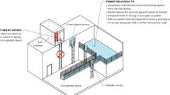
Ladders: Where Permitted
Building products (11)
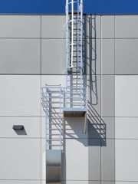
Heavy Duty Tubular Rail Fixed Access Ladder - 501 Access Ladder
O'Keeffe's

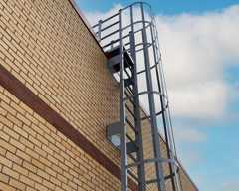
High Parapet Access with Platform and Return - 533 Cage Ladder
O'Keeffe's

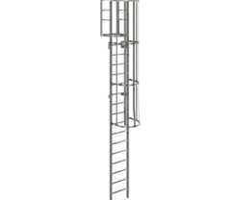
Low Parapet Access with Platform and No Return - 533A Cage Ladder
O'Keeffe's

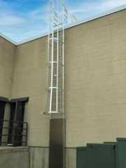
Low Parapet Access with Roofover Rail Extensions - 532 Cage Ladder
O'Keeffe's

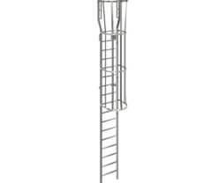
Low Parapet with Walk Through Rail Extension - 534 Cage Ladder
O'Keeffe's

Standard Cage Ladder - 531 Cage Ladder
O'Keeffe's

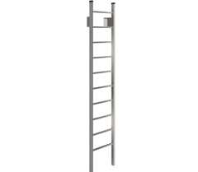
Standard Duty Channel Rail Fixed Access Ladder - 500 Access Ladder
O'Keeffe's

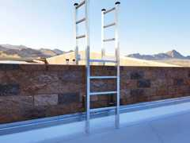
Tubular Rail High Parapet Access Ladder with Platform and Return - 503 Access Ladder
O'Keeffe's

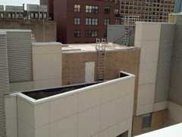
Tubular Rail Low Parapet Access Ladder with Platform Only - 503A Access Ladder
O'Keeffe's

Tubular Rail Low Parapet Access Ladder with Roofover Rail Extensions - 502 Access Ladder
O'Keeffe's

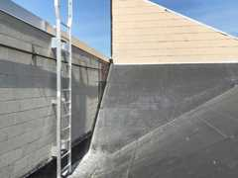
Tubular Rail Low Parapet Access Ladder with Walk Through Rail Extensions - 504 Access Ladder
O'Keeffe's

1006.2.2.2 Refrigeration Machinery Rooms
Diagram
Machinery rooms larger than 1,000 square feet (93 m²) shall have not less than two exits or exit access doorways. Where two exit access doorways are required, one such doorway is permitted to be served by a fixed ladder or an alternating tread device. Exit access doorways shall be separated by a horizontal distance equal to one-half the maximum horizontal dimension of the room.
Exit access travel distance shall be determined as specified in Section 1017.1, but all portions of a refrigeration machinery room shall be within 150 feet (45 720 mm) of an exit or exit access doorway where such rooms are not protected by an approved automatic sprinkler system. Egress is allowed through adjoining refrigeration machinery rooms or adjoining refrigerated rooms or spaces.
Exit and exit access doorways shall swing in the direction of egress travel and shall be equipped with panic hardware, regardless of the occupant load served. Exit and exit access doorways shall be tight fitting and self-closing.
UpCodes Diagrams (2)
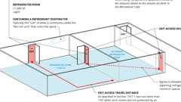
Refrigerated Rooms: Exits
Refrigeration Machinery Rooms: Exits
Building products (11)
Heavy Duty Tubular Rail Fixed Access Ladder - 501 Access Ladder
O'Keeffe's

High Parapet Access with Platform and Return - 533 Cage Ladder
O'Keeffe's

Low Parapet Access with Platform and No Return - 533A Cage Ladder
O'Keeffe's

Low Parapet Access with Roofover Rail Extensions - 532 Cage Ladder
O'Keeffe's

Low Parapet with Walk Through Rail Extension - 534 Cage Ladder
O'Keeffe's

Standard Cage Ladder - 531 Cage Ladder
O'Keeffe's

Standard Duty Channel Rail Fixed Access Ladder - 500 Access Ladder
O'Keeffe's

Tubular Rail High Parapet Access Ladder with Platform and Return - 503 Access Ladder
O'Keeffe's

Tubular Rail Low Parapet Access Ladder with Platform Only - 503A Access Ladder
O'Keeffe's

Tubular Rail Low Parapet Access Ladder with Roofover Rail Extensions - 502 Access Ladder
O'Keeffe's

Tubular Rail Low Parapet Access Ladder with Walk Through Rail Extensions - 504 Access Ladder
O'Keeffe's

1006.2.2.3 Refrigerated Rooms or Spaces
Diagram
Rooms or spaces having a floor area larger than 1,000 square feet (93 m²), containing a refrigerant evaporator and maintained at a temperature below 68°F (20°C), shall have access to not less than two exits or exit access doorways.
Exit access travel distance shall be determined as specified in Section 1017.1. All portions of a refrigerated room or space shall be within 150 feet (45 720 mm) of an exit or exit access doorway leading to a nonrefrigerated area where such rooms are not protected by an approved automatic sprinkler system. Egress is allowed through adjoining refrigerated rooms or spaces.
Exception: Where using refrigerants in quantities limited to the amounts based on the volume set forth in the California Mechanical Code. Egress is allowed through adjoining refrigerated rooms or spaces.
UpCodes Diagrams (2)
Primary
Refrigerated Rooms: Exits
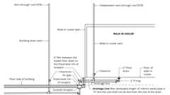
Walk In Coolers - Indirect Waste (UPC)
1006.2.2.4 Electrical Rooms
Diagram
The location and number of exit or exit access doorways shall be provided for electrical rooms in accordance with Section 110.26 of the California Electrical Code for electrical equipment rated 1,000 volts or less, and Section 110.33 of the California Electrical Code for electrical equipment rated over 1,000 volts. Panic hardware shall be provided where required in accordance with Section 1010.2.8.2.
UpCodes Diagrams (3)
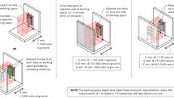
Electrical Working Space Conditions
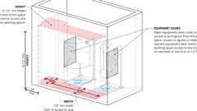
Allowed Clearance at Open Equipment Doors (<1000V)
Clearances at Electrical Equipment
1006.2.2.5 Vehicular Ramps
Diagram
Vehicular ramps shall not be considered as an exit access ramp unless pedestrian facilities are provided.
UpCodes Diagram (1)
Primary
Parking Garage Exiting: Vehicular Ramps
1006.2.2.6 Groups R-3 and R-4
Diagram
Where Group R-3 occupancies are permitted by Section 903.2.8 to be protected by an automatic sprinkler system installed in accordance with Section 903.3.1.3, the exit access travel distance for Group R-3 shall be not more than 125 feet (38 100 mm). Where Group R-4 occupancies are permitted by Section 903.2.8 to be protected by an automatic sprinkler system installed in accordance with Section 903.3.1.3, the exit access travel distance for Group R-4 shall be not more than 75 feet (22 860 mm).
UpCodes Diagrams (2)
Primary
Exit Access Travel Distance: R-3 and R-4
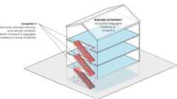
Exit Access Stair: Enclosure (Ex. 3)
1006.2.2.7 Large Family Day-Care Home
Every story or basement of a large family day-care home shall be provided with two exits which are remotely located from each other. Every required exit shall be of a size to permit the installation of a door not less than 32 inches (813 mm) in clear width and not less than 6 feet 8 inches (2,032 mm) in height. A manually operated horizontal sliding door may be used as one of the two required exits.
Where basements are used for day-care purposes, one of the two required exits shall provide access directly to the exterior without entering the first story. The second exit from the basement may either pass through the story above or exit directly to the exterior.
Rooms used for day-care purposes shall not be located above the first story.
Exception: Buildings equipped with an automatic sprinkler system throughout and which have at least one of the required exits providing access directly to the exterior. NFPA 13R may be used in large family day-care homes. The sprinkler omissions of NFPA 13R shall not apply unless approved by the enforcing agency.
Exit doors, including manually operated horizontal sliding doors, shall be openable from the inside without use of a key or any special knowledge or effort.
Tables 1006.3.3(1) and 1006.3.3(2) are not applicable to this occupancy classification.
1006.2.2.8 Group I-4 Means of Egress
Diagram
Group I-4 facilities, rooms or spaces where care is provided for more than 10 children that are 36 months of age or less shall have access to not less than two exits or exit access doorways.
UpCodes Diagram (1)
Group I-4 Exits
1006.3 Egress From Stories or Occupiable Roofs
Diagram
All spaces located on a story or occupiable roof shall have access to the required number of separate and distinct exits or access to exits based on the aggregate occupant load served in accordance with this section.
UpCodes Diagrams (5)
Primary
Egress From Stories or Occupied Roof
Occupant Loads: Outdoor Areas
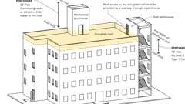
Penthouse Stair Access to Roof
Single Exits: Multiple Occupancies
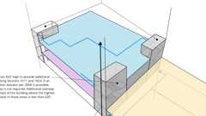
High Rise: Additional Stairway
1006.3.1 Occupant Load
Where stairways serve more than one story, or more than one story and an occupiable roof, only the occupant load of each story or occupiable roof, considered individually, shall be used when calculating the required number of exits or access to exits serving that story.
1006.3.2 Path of Egress Travel
Diagram
The path of egress travel to an exit shall not pass through more than one adjacent story.
Exception: The path of egress travel to an exit shall be permitted to pass through more than one adjacent story in any of the following:
- In Group R-1, R-2 or R-3 occupancies, exit access stairways and ramps connecting four stories or less serving and contained within an individual dwelling unit, sleeping unit or live/work unit.
- Exit access stairways serving and contained within a Group R-3 congregate residence or a Group R-4 facility.
- Exit access stairways and ramps within an atrium complying with Section 404.
- Exit access stairways and ramps in open parking garages that serve only the parking garage.
- Exit access stairways and ramps serving smoke-protected assembly seating and open-air assembly seating complying with the exit access travel distance requirements of Section 1030.7.
- Exit access stairways and ramps between the balcony, gallery or press box and the main assembly floor in occupancies such as theaters, places of religious worship, auditoriums and sports facilities.
- Exterior exit access stairways and ramps between occupiable roofs.
UpCodes Diagrams (2)
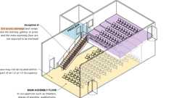
Exit Access Stair: Balconies (Ex. 8)
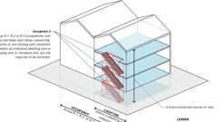
Exit Access Stair: Enclosure (Ex. 2)
1006.3.3 Egress Based on Occupant Load
Diagram
Each story and occupiable roof shall have the minimum number of separate and distinct exits, or access to exits, as specified in Table 1006.3.3. A single exit or access to a single exit shall be permitted in accordance with Section 1006.3.4. The required number of exits, or exit access stairways or ramps providing access to exits, from any story or occupiable roof shall be maintained until arrival at the exit discharge or a public way.
TABLE 1006.3.3—MINIMUM NUMBER OF EXITS OR ACCESS TO EXITS PER STORY OR OCCUPIABLE ROOFS
OCCUPANT LOAD PER  STORY OR OCCUPIABLE ROOF | MINIMUM NUMBER OF EXITS OR ACCESS  TO EXITS PER STORY OR OCCUPIABLE ROOF
1-500 | 2
501-1,000 | 3
More than 1,000 | 4
UpCodes Diagrams (3)
Required Exits: Three or More
Multiple Occupancy Building: Design Occupant Load
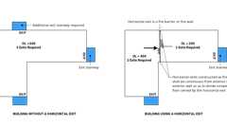
Horizontal Exit Egress Analysis
1006.3.4 Single Exits
Diagram
A single exit or access to a single exit shall be permitted from any story or occupiable roof where one of the following conditions exists:
- The occupant load, number of dwelling units and exit access travel distance do not exceed the values in Table 1006.3.4(1) or 1006.3.4(2).
- Rooms, areas and spaces complying with Section 1006.2.1 with exits that discharge directly to the exterior at the level of exit discharge, are permitted to have one exit or access to a single exit.
- Parking garages where vehicles are mechanically parked shall be permitted to have one exit or access to a single exit.
- Group R-3 and R-4 occupancies shall be permitted to have one exit or access to a single exit.
- Individual single-story or multistory dwelling units shall be permitted to have a single exit or access to a single exit from the dwelling unit provided that both of the following criteria are met:
  - 5.1. The dwelling unit complies with Section 1006.2.1 as a space with one means of egress.
  - 5.2. Either the exit from the dwelling unit discharges directly to the exterior at the level of exit discharge, or the exit access outside the dwelling unit's entrance door provides access to not less than two approved independent exits.
TABLE 1006.3.4(1)—STORIES AND OCCUPIABLE ROOFS WITH ONE EXIT OR ACCESS TO ONE EXIT FOR R-2 AND R-3 OCCUPANCIES
STORY | OCCUPANCY | MAXIMUM NUMBER OF DWELLING UNITS | MAXIMUM EXIT ACCESS TRAVEL DISTANCE
Basement, first, second or third story above grade plane and occupiable  roofs over the first or second story above grade plane | R-2^{a, b, c}  R-3ª | 4 dwelling units  NA | 125 feet  NA
Fourth story above grade plane  and higher | R-3ª | NA | 125 feet
For SI: 1 foot = 304.8 mm.
NP = Not Permitted.
NA = Not Applicable.
- Buildings classified as Group R-2 equipped throughout with an automatic sprinkler system in accordance with Section 903.3.1.1 or 903.3.1.2 and provided with emergency escape and rescue openings in accordance with Section 1031.
- This table is used for Group R-2 occupancies consisting of dwelling units. For Group R-2 occupancies consisting of sleeping units, use Table 1006.3.4(2).
- This table is for occupiable roofs accessed through and serving individual dwelling units in Group R-2 occupancies. For Group R-2 occupancies with occupiable roofs that are not accessed through and serving individual units, use Table 1006.3.4(2).
TABLE 1006.3.4(2)—STORIES AND OCCUPIABLE ROOFS WITH ONE EXIT OR ACCESS TO ONE EXIT FOR OTHER OCCUPANCIES
STORY AND OCCUPIABLE ROOF | OCCUPANCY^{e} | MAXIMUM OCCUPANT  LOAD PER STORY AND  OCCUPIABLE ROOF | MAXIMUM EXIT ACCESS  TRAVEL DISTANCE (feet)
First story above or below grade plane and  occupiable roofs over the first story above grade  plane | A, B^{b}, E, F^{b}, M, U | 49 | 75
 | H-2, H-3 | 3 | 25
 | H-4, H-5, I, R-1, R-2^{a, c}, R-2.2 | 10 | 75
 | I-2 | 7 | 50
 | S^{b, d} | 29 | 75
Second story above grade plane | B, F, M, S^{d} | 29 | 75
Third story above grade plane and higher | NP | NA | NA
For SI: 1 foot = 304.8 mm.
NP = Not Permitted.
NA = Not Applicable.
- Buildings classified as Group R-2 equipped throughout with an automatic sprinkler system in accordance with Section 903.3.1.1 or 903.3.1.2 and provided with emergency escape and rescue openings in accordance with Section 1031.
- Group B, F and S occupancies in buildings equipped throughout with an automatic sprinkler system in accordance with Section 903.3.1.1 or an occupiable roof of such buildings shall have a maximum exit access travel distance of 100 feet.
- This table is used for Group R-2 occupancies consisting of sleeping units. For Group R-2 occupancies consisting of dwelling units, use Table 1006.3.4(1).
- The length of exit access travel distance in a Group S-2 open parking garage shall be not more than 100 feet.
- For Group L Occupancies see Section 453.6.1.
UpCodes Diagrams (3)
Egress Balcony: Wall Separation
Common Path of Egress Travel
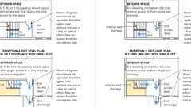
Stairway Door Operations - Excpt. 4 & 5
1006.3.4.1 Mixed Occupancies
Diagram
Where one exit, or exit access stairway or ramp providing access to exits at other stories, is permitted to serve individual stories, mixed occupancies shall be permitted to be served by single exits provided that each individual occupancy complies with the applicable requirements of Table 1006.3.4(1) or 1006.3.4(2) for that occupancy. Where applicable, cumulative occupant loads from adjacent occupancies shall be considered to be in accordance with the provisions of Section 1004.1. In each story of a mixed occupancy building, the maximum number of occupants served by a single exit shall be such that the sum of the ratios of the calculated number of occupants of the space divided by the allowable number of occupants indicated in Table 1006.3.4(2) for each occupancy does not exceed one. Where dwelling units are located on a story with other occupancies, the actual number of dwelling units divided by four plus the ratio from the other occupancy does not exceed one.
UpCodes Diagram (1)
Primary
Single Exits: Multiple Occupancies
Section 1007 Exit and Exit Access Doorway Configuration
Diagram
UpCodes Diagrams (7)
Egress: Min. Reqs., Existing Buildings
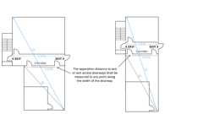
Separation of Exit and Exit Access Doors
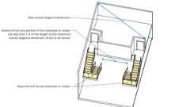
Remoteness of Exit Access
Exit Separation Measurement Points
Exterior Egress Door Arrangement
Required Exits: Three or More
Separation of a Third Stairway
1007.1 General
Exits, exit access doorways, and exit access stairways and ramps serving spaces, including individual building stories, shall be separated in accordance with the provisions of this section.
1007.1.1 Two Exits or Exit Access Doorways
Assembly
Diagram
Where two exits, exit access doorways, exit access stairways or ramps, or any combination thereof, are required from any portion of the exit access, they shall be placed a distance apart equal to not less than one-half of the length of the maximum overall diagonal dimension of the building or area to be served measured in a straight line between them. Interlocking or scissor stairways shall be counted as one exit stairway.
Exceptions:
- Where interior exit stairways or ramps are interconnected by a 1-hour fire-resistance-rated corridor conforming to the requirements of Section 1020, the required exit separation shall be measured along the shortest direct line of travel within the corridor.
- Where a building is equipped throughout with an automatic sprinkler system in accordance with Section 903.3.1.1 or 903.3.1.2, the separation distance shall be not less than one-third of the length of the maximum overall diagonal dimension of the area served.
UpCodes Diagrams (7)
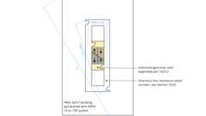Primary
Exit Separation at Scissor Stairs
Primary
Exit Separation Distance with Rated Corridors - Excpt. 1
Primary
Separation of Exit and Exit Access Doors
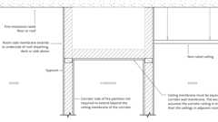
Fire Partition Continuity: Corridors (Ex. 2.1)
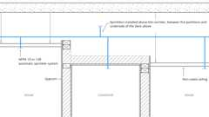
Fire Partition Continuity: Corridors (Ex. 2.2)
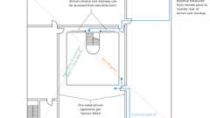
Exit Stairways in Atriums
Example: OL, Exits and Common Path of Travel
Assemblies (5)
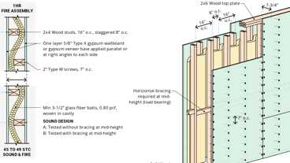
WP 3371: 1hr, 45-49 STC, Wood Studs & Insulation
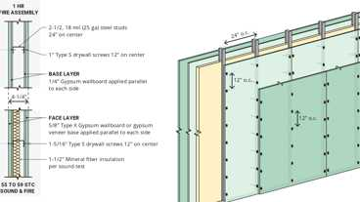
WP 1015: 1hr, 55-59 STC, Steel Stud
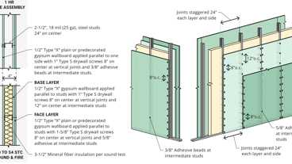
WP 1021: 1hr, 50-54 STC, Steel Stud
WP 1051: 1hr, 50-54 STC, Steel Stud
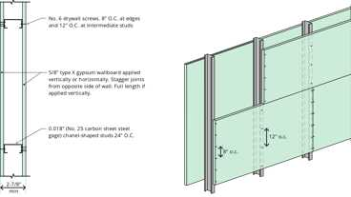
13-1.1: 1hr Steel Studs
1007.1.1.1 Measurement Point
Diagram
The separation distance required in Section 1007.1.1 shall be measured in accordance with the following:
- The separation distance to exit or exit access doorways shall be measured to any point along the width of the doorway.
- The separation distance to exit access stairways shall be measured to the closest riser.
- The separation distance to exit access ramps shall be measured to the start of the ramp run.
UpCodes Diagrams (2)
Primary
Exit Separation Measurement Points
Exits from Boiler, Incinerator and Furnace Rooms
1007.1.2 Three or More Exits or Exit Access Doorways
Diagram
Where access to three or more exits is required, not less than two exit or exit access doorways shall be arranged in accordance with the provisions of Section 1007.1.1. Additional required exit or exit access doorways shall be arranged a reasonable distance apart so that if one becomes blocked, the others will be available.
UpCodes Diagrams (3)
Primary
Separation of a Third Stairway
Primary
Required Exits: Three or More
Stair Separations in High Rise Buildings
1007.1.3 Remoteness of Exit Access Stairways or Ramps
Diagram
Where two exit access stairways or ramps provide the required means of egress to exits at another story, the required separation distance shall be maintained for all portions of such exit access stairways or ramps.
UpCodes Diagram (1)
Primary
Remoteness of Exit Access
1007.1.3.1 Three or More Exit Access Stairways or Ramps
Where more than two exit access stairways or ramps provide the required means of egress, not less than two shall be arranged in accordance with Section 1007.1.3.
Section 1008 Means of Egress Illumination
Diagram
UpCodes Diagrams (7)
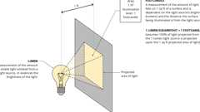
Lumens and Footcandles
Lumens and Footcandles - Calculations
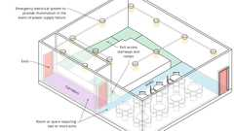
Emergency Electrical System: Locations for Illumination - Part 1
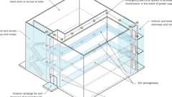
Emergency Electrical System: Locations for Illumination - Part 2
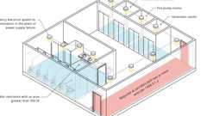
Emergency Electrical System: Locations for Illumination - Part 3
Illumination Level Under Normal Power
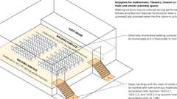
Illumination Level Under Normal Power - Exception
1008.1 Means of Egress Illumination
Illumination shall be provided in the means of egress in accordance with Section 1008.2. Inthe event of power supply failure, means of egress illumination shall comply with Section 1008.2.4.
1008.2 Illumination Required
The means of egress serving a room or space shall be illuminated at all times that the room or space is occupied.
Exceptions:
- Occupancies in Group U.
- Self-service storage units 400 square feet (37.2 m²) or less in area and accessed directly from the exterior of the building.
- Aisle accessways in Group A.
- Dwelling units and sleeping units in Groups R-1, R-2 and R-3.
- Sleeping units of Group I, R-2.1 and R-4 occupancies.
1008.2.1 Illumination Level Under Normal Power
Diagram
The means of egress illumination level shall be not less than 1 footcandle (11 lux) at the walking surface. Along exit access stairways, exit stairways and at their required landings, the illumination level shall not be less than 10 footcandles (108 lux) at the walking surface when the stairway is in use.
Exception: For auditoriums, theaters, concert or opera halls and similar assembly occupancies, the illumination at the walking surface is permitted to be reduced during performances by one of the following methods provided that the required illumination is automatically restored upon activation of a premises' fire alarm system:
- Externally illuminated walking surfaces shall be permitted to be illuminated to not less than 0.2 footcandle (2.15 lux).
- Steps, landings and the sides of ramps shall be permitted to be marked with self-luminous materials in accordance with Sections 1025.2.1, 1025.2.2 and 1025.2.4 by systems listed in accordance with UL 1994.
UpCodes Diagrams (2)
Primary
Illumination Level Under Normal Power - Exception
Primary
Illumination Level Under Normal Power
1008.2.2 Group I-2
In Group I-2 occupancies where two or more exits are required, on the exterior landings required by Section 1010.1.5, means of egress illumination levels for the exit discharge shall be provided such that failure of a single lamp in a luminaire shall not reduce the illumination level on that landing to less than 1 footcandle (11 lux).
1008.2.3 Exit Discharge
Diagram
Illumination shall be provided along the path of travel for the exit discharge from each exit to the public way.
Exception: Illumination shall not be required where the path of the exit discharge meets both of the following requirements:
- The path of exit discharge is illuminated from the exit to a safe dispersal area complying with Section 1028.5.
- A dispersal area shall be illuminated to a level not less than 1 footcandle (11 lux) at the walking surface.
UpCodes Diagram (1)
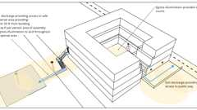Primary
Means of Egress Illumination: Exit Discharge
1008.2.4 Power for Illumination
The power supply for means of egress illumination shall normally be provided by the premises' electrical supply.
1008.3 Illumination Required by an Emergency Electrical System
Diagram
An emergency electrical system shall be provided to automatically illuminate the following areas in the event of a power supply failure:
- In rooms or spaces that require two or more exits or access to exits:
  - 1.1. Aisles.
  - 1.2. Corridors.
  - 1.3. Exit access stairways and ramps.
- In buildings that require two or more exits or access to exits:
  - 2.1. Interior exit access stairways and ramps.
  - 2.2. Interior and exterior exit stairways and ramps.
  - 2.3. Exit passageways.
  - 2.4. Vestibules and areas on the level of discharge used for exit discharge in accordance with Section 1028.2.
  - 2.5. Exterior landings as required by Section 1010.1.5 for exit doorways that lead directly to the exit discharge.
  - 2.6. Group I-2 exit discharge stairways, ramps, aisles, walkways and escalators leading to a public way or to a safe dispersal area in accordance with Section 1028.5.
- In other rooms and spaces:
  - 3.1. Electrical equipment rooms.
  - 3.2. Fire command centers.
  - 3.3. Fire pump rooms.
  - 3.4. Generator rooms.
  - 3.5. Public restrooms with an area greater than 300 square feet (27.87 m²).
- Group I-2 exit discharge stairways, ramps, aisles, walkways and escalators leading to a public way or to a safe dispersal area in accordance with Section 1028.5.
UpCodes Diagrams (3)
Primary
Emergency Electrical System: Locations for Illumination - Part 3
Primary
Emergency Electrical System: Locations for Illumination - Part 2
Primary
Emergency Electrical System: Locations for Illumination - Part 1
1008.3.1 Duration
The emergency power system shall provide power for a duration of not less than 90 minutes and shall consist of storage batteries, unit equipment or an on-site generator. The installation of the emergency power system shall be in accordance with Section 2702.
1008.3.2 Illumination Level Under Emergency Power
Diagram
Emergency lighting facilities shall be arranged to provide initial illumination that is not less than an average of 1 footcandle (11 lux) and a minimum at any point of 0.1 footcandle (1 lux) measured along the path of egress at floor level. Illumination levels shall be permitted to decline to 0.6 footcandle (6 lux) average and a minimum at any point of 0.06 footcandle (0.6 lux) at the end of the emergency lighting time duration. A maximum-to-minimum illumination uniformity ratio of 40 to 1 shall not be exceeded. In Group I-2 occupancies, failure of a single lamp in a luminaire shall not reduce the illumination level to less than 0.2 footcandle (2.2 lux).
UpCodes Diagrams (2)
Primary
Lumens and Footcandles - Calculations
Primary
Lumens and Footcandles
Section 1009 Accessible Means of Egress
Diagram
UpCodes Diagrams (5)
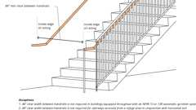
Accessible Means of Egress: Stairways
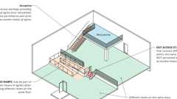
Exit Access Stairs: Accessible Means of Egress
Exterior Area of Refuge at Exit (CA)
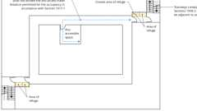
Travel Distance to Area of Refuge
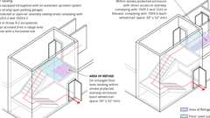
Accessible Means of Egress: Area of Refuge (CA)
1009.1 Accessible Means of Egress Required
Diagram
Accessible means of egress shall comply with this section. Accessible spaces shall be provided with not less than one accessible means of egress. Where more than one means of egress is required by Section 1006.2 or 1006.3 from any accessible space, each accessible portion of the space shall be served by not less than two accessible means of egress in at least the same number as required by Sections 1006.2 or 1006.3. In addition to the requirements of this chapter, means of egress, which provide access to, or egress from, buildings for persons with disabilities, shall also comply with the requirements of Chapter 11A or 11B as applicable.
Exceptions:
- One accessible means of egress is required from an accessible mezzanine level in accordance with Section 1009.3, 1009.4 or 1009.5, and Chapter 11A or 11B, as applicable.
- In assembly areas with ramped aisles or stepped aisles, one accessible means of egress is permitted where the common path of egress travel is accessible and meets the requirements in Section 1030.8 and Chapter 11A or 11B, as applicable.
UpCodes Diagram (1)
Common Path of Egress Travel
1009.2 Continuity and Components
Diagram
Each required accessible means of egress shall be continuous to a public way and shall consist of one or more of the following components:
- Accessible routes complying with Chapter 11A, Sections 1110A.1 and 1119A, or Chapter 11B, Sections 11B-206 and 11B-402, as applicable.
- Interior exit stairways complying with Sections 1009.3 and 1023, and Chapter 11A, Section 1123A, or Chapter 11B, Sections 11B-210 and 11B-504, as applicable.
- Exit access stairways complying with Sections 1009.3 and 1019.3 or 1019.4, and Chapter 11A, Section 1123A, or Chapter 11B, Sections 11B-210 and 11B-504, as applicable.
- Exterior exit stairways complying with Sections 1009.3 and 1027, Chapter 11A, Section 1115A, or Chapter 11B, Sections 11B-210 and 11B-504, as applicable, and serving levels other than the level of exit discharge.
- Elevators complying with Section 1009.4, and Chapter 11A, Section 1124A, or Chapter 11B, Sections 11B-206.6 and 11B-407, as applicable.
- Platform lifts complying with Section 1009.5, and Chapter 11A, Section 1124A, or Chapter 11B, Sections 11B-206.7, 11B-207.2 and 11B-410, as applicable.
- Horizontal exits complying with Section 1026.
- Ramps complying with Section 1012, and Chapter 11A, Sections 1114A and 1122A, or Chapter 11B, 11B-405, as applicable.
- Areas of refuge complying with Section 1009.6.
- Exterior areas for assisted rescue complying with Section 1009.7 serving exits at the level of exit discharge.
- Safe dispersal areas where they are allowed under Section 1028.5.
UpCodes Diagrams (2)
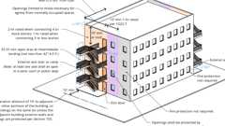
Exterior Exit Stairway and Ramp Protection
Horizontal Exit Egress Analysis
1009.2.1 Elevators Required
Diagram
In buildings where a required accessible floor is four or more stories above or below a level of exit discharge or where an accessible occupiable roof is above a story that is three or more stories above the level of exit discharge, not less than one required accessible means of egress shall include an elevator complying with Section 1009.4.
Exceptions:
- In buildings equipped throughout with an automatic sprinkler system installed in accordance with Section 903.3.1.1 or 903.3.1.2, the elevator shall not be required as part of the accessible means of egress on floors provided with a horizontal exit and located at or above the levels of exit discharge.
- In buildings equipped throughout with an automatic sprinkler system installed in accordance with Section 903.3.1.1 or 903.3.1.2, the elevator shall not be required as part of the accessible means of egress on floors or occupiable roofs provided with a ramp conforming to the provisions of Section 1012.
UpCodes Diagram (1)
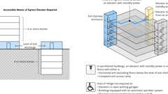Primary
Access. Means of Egress: Elevators
1009.2.2 Doors
Where doors are part of an accessible route to provide access to an exit, area of refuge or exterior area of assisted rescue, maneuvering clearances shall be provided at such doors as required by ICC A117.1 in the direction of egress. Where doors lead to an area of refuge or exterior area for assisted rescue and reentry to the floor is possible, door maneuvering clearances shall be provided on both sides of the door.
Exception: Maneuvering clearances are not required at doors to exit stairways for levels above and below the level of exit discharge where the exit enclosure does not include an area of refuge.
1009.3 Stairways
Diagram
In order to be considered part of an accessible means of egress, a stairway between stories shall comply with Sections 1009.3.1 through 1009.3.3. [DSA-AC & HCD 1-AC] In addition, exit stairways shall comply with Chapter 11A, Sections 1115A and 1123A, or Chapter 11B, Sections 11B-210 and 11B-504, as applicable.
UpCodes Diagrams (6)
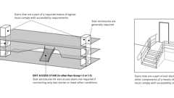Primary
Access. Means of Egress: Stairways
Accessible Means of Egress: Stairways
Area of Refuge Access to Stairway or Elevator
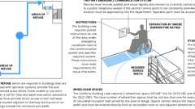
Areas of Refuge (CA)
Accessible Means of Egress: Area of Refuge (CA)
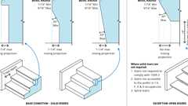
Stair Nosing Size
1009.3.1 Exit Access Stairways
Diagram
Exit access stairways that connect levels in the same story are not permitted as part of an accessible means of egress.
Exception: Exit access stairways providing means of egress from mezzanines are permitted as part of an accessible means of egress.
UpCodes Diagram (1)
Primary
Exit Access Stairs: Accessible Means of Egress
1009.3.2 Stairway Width
Diagram
Stairways shall have a clear width of 48 inches (1219 mm) minimum between handrails.
Exceptions:
- The clear width of 48 inches (1219 mm) between handrails is not required in buildings equipped throughout with an automatic sprinkler system installed in accordance with Section 903.3.1.1 or 903.3.1.2.
- The clear width of 48 inches (1219 mm) between handrails is not required for stairways accessed from a refuge area in conjunction with a horizontal exit.
UpCodes Diagrams (2)
Primary
Accessible Means of Egress: Stairways
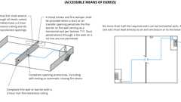
Horizontal Exits
1009.3.3 Area of Refuge
Diagram
Stairways shall either incorporate an area of refuge within an enlarged floor-level landing or shall be accessed from an area of refuge complying with Section 1009.6.
Exceptions:
- Areas of refuge are not required at exit access stairways where two-way communication is provided at the elevator landing in accordance with Section 1009.8.
- Areas of refuge are not required at stairways in buildings equipped throughout with an automatic sprinkler system installed in accordance with Section 903.3.1.1 or 903.3.1.2.
- Areas of refuge are not required at stairways serving open parking garages.
- Areas of refuge are not required for smoke-protected or open-air assembly seating areas complying with Sections 1030.6.2 and 1030.6.3.
- Areas of refuge are not required at stairways in Group R-2 occupancies.
- Areas of refuge are not required for stairways accessed from a refuge area in conjunction with a horizontal exit.
UpCodes Diagram (1)
Primary
Accessible Means of Egress: Area of Refuge (CA)
1009.4 Elevators
Diagram
In order to be considered part of an accessible means of egress, an elevator shall comply with Sections 1009.4.1 and 1009.4.2.
UpCodes Diagrams (4)
Elevators, Escalators or Moving Walks in Means of Egress
Area of Refuge Access to Stairway or Elevator
Access. Means of Egress: Elevators
Accessible Means of Egress: Area of Refuge (CA)
1009.4.1 Standby Power
The elevator shall meet the emergency operation and signaling device requirements of California Code of Regulations, Title 8, Division 1, Chapter 4, Subchapter 6, Elevator Safety Orders. Standby power shall be provided in accordance with Chapter 27 and Section 3003.
1009.4.2 Area of Refuge
The elevator shall be accessed from an area of refuge complying with Section 1009.6.
Exceptions:
- Areas of refuge are not required at the elevator in open parking garages.
- Areas of refuge are not required in buildings and facilities equipped throughout with an automatic sprinkler system installed in accordance with Section 903.3.1.1 or 903.3.1.2.
- Areas of refuge are not required at elevators not required to be located in a shaft in accordance with Section 712.
- Areas of refuge are not required at elevators serving smoke-protected or open-air assembly seating areas complying with Sections 1030.6.2 and 1030.6.3.
- Areas of refuge are not required for elevators accessed from a refuge area in conjunction with a horizontal exit.
1009.5 Platform Lifts
Diagram
Platform lifts shall be permitted to serve as part of an accessible means of egress where allowed as part of a required accessible route in Chapter 11A, Sections 1121A and 1124A.11, or Chapter 11B, Sections 11B-206.7.1 through 11B-206.7.10, as applicable. Standby power for the platform lift shall be provided in accordance with Chapter 27.
[DSA-AC] See Chapter 11B, Section 11B-207.2 for additional accessible means of egress requirements at platform lifts.
UpCodes Diagrams (3)
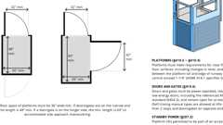Primary
Vertical Platform Lifts
Standby Power Systems
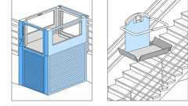
Platform Lift Types
1009.6 Areas of Refuge
Diagram
Every required area of refuge shall be accessible from the space it serves by an accessible means of egress.
[DSA-AC] Areas of refuge shall comply with the requirements of this code and shall adjoin an accessible route complying with Sections 11B-206 and 11B-402.
UpCodes Diagram (1)
Area of Refuge Access to Stairway or Elevator
1009.6.1 Travel Distance
Diagram
The maximum travel distance from any accessible space to an area of refuge shall not exceed the exit access travel distance permitted for the occupancy in accordance with Section 1017.1.
UpCodes Diagram (1)
Primary
Travel Distance to Area of Refuge
1009.6.2 Stairway or Elevator Access
Diagram
Every required area of refuge shall have direct access to a stairway complying with Sections 1009.3 and 1023 or an elevator complying with Section 1009.4.
Exception: An interior area of refuge at the level of exit discharge that provides direct access to an exterior exit door.
UpCodes Diagram (1)
Primary
Area of Refuge Access to Stairway or Elevator
1009.6.3 Size
Diagram
Each area of refuge shall be sized to accommodate two wheelchair spaces that are not less than 30 inches by 52 inches (762 mm by 1320 mm). The total number of such 30-inch by 52-inch (762 mm by 1320 mm) spaces per story shall be not less than one for every 200 persons of calculated occupant load served by the area of refuge. Such wheelchair spaces shall not reduce the means of egress minimum width or required capacity. Access to any of the required wheelchair spaces in an area of refuge shall not be obstructed by more than one adjoining wheelchair space.
Exception: The enforcing agency may reduce the size of each required area of refuge to accommodate one wheelchair space that is not less than 30 inches by 52 inches (762 mm by 1320 mm) on floors where the occupant load is less than 200.
UpCodes Diagrams (3)
Exterior Area for Assisted Rescue (CA)
Exterior Area of Refuge at Exit (CA)
Accessible Means of Egress: Area of Refuge (CA)
1009.6.4 Separation
Each area of refuge shall be separated from the remainder of the story by a smoke barrier complying with Section 709 or a horizontal exit complying with Section 1026. Each area of refuge shall be designed to minimize the intrusion of smoke.
Exceptions:
- Areas of refuge located within an enclosure for interior exit stairways complying with Section 1023.
- Areas of refuge in outdoor facilities where exit access is essentially open to the outside.
Building products (3)
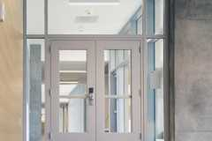
SuperLite® II-XL 60
SaftiFirst

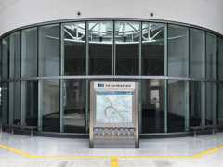
SuperLite® II-XLB 60
SaftiFirst

SuperLite® II-XLM 60
SaftiFirst

1009.6.5 Two-Way Communication
Areas of refuge shall be provided with a two-way communication system complying with Sections 1009.8.1 and 1009.8.2.
1009.7 Exterior Areas for Assisted Rescue
Diagram
Exterior areas for assisted rescue shall be accessed by an accessible route from the area served.
Where the exit discharge does not include an accessible route from an exit located on the level of exit discharge to a public way, an exterior area of assisted rescue shall be provided on the exterior landing in accordance with Sections 1009.7.1 through 1009.7.4.
UpCodes Diagrams (3)
Primary
Exterior Area of Refuge at Exit (CA)
Primary
Exterior Area for Assisted Rescue (CA)
Means of Egress: Basic Components
1009.7.1 Size
Each exterior area for assisted rescue shall be sized to accommodate wheelchair spaces in accordance with Section 1009.6.3.
1009.7.2 Separation
Assembly
Exterior walls separating the exterior area of assisted rescue from the interior of the building shall have a minimum fire-resistance rating of 1 hour, rated for exposure to fire from the inside. The fire-resistance-rated exterior wall construction shall extend horizontally not less than 10 feet (3048 mm) beyond the landing on either side of the landing or equivalent fire-resistance-rated construction is permitted to extend out perpendicular to the exterior wall not less than 4 feet (1219 mm) on the side of the landing. The fire-resistance-rated construction shall extend vertically from the ground to a point not less than 10 feet (3048 mm) above the floor level of the area for assisted rescue or to the roof line, whichever is lower. Openings within such fire-resistance-rated exterior walls shall be protected in accordance with Section 716.
Exception: The fire-resistance rating and opening protectives are not required in the exterior wall where the building is equipped throughout with an automatic sprinkler system installed in accordance with Section 903.3.1.1 or 903.3.1.2.
Assemblies (3)
WP 8105: 1hr, Sheathing & Wood Studs
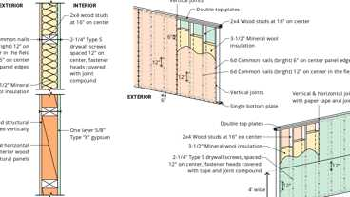
16-1.1: 1hr, Wood
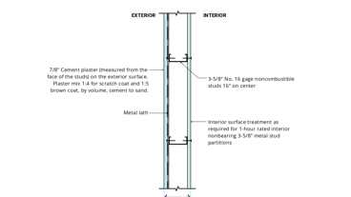
15-1.4: 1hr, Steel Stud
Building products (4)
GPX® Ballistic
SaftiFirst

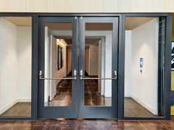
SuperClear® 45-HS
SaftiFirst


SuperClear® 45-HS-LI
SaftiFirst

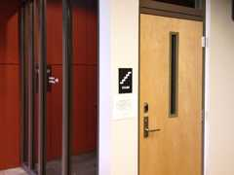
SuperLite® X-45/60/90
SaftiFirst

1009.7.3 Openness
The exterior area for assisted rescue shall be open to the outside air. The sides other than the separation walls shall be not less than 50 percent open, and the open area shall be distributed so as to minimize the accumulation of smoke or toxic gases.
1009.7.4 Stairways
Diagram
Stairways that are part of the means of egress for the exterior area for assisted rescue shall provide a minimum clear width of 48 inches (1219 mm) between handrails.
Exception: The minimum clear width of 48 inches (1219 mm) between handrails is not required at stairways serving buildings equipped throughout with an automatic sprinkler system installed in accordance with Section 903.3.1.1 or 903.3.1.2.
UpCodes Diagram (1)
Accessible Means of Egress: Stairways
1009.8 Two-Way Communication
Diagram
A two-way communication system complying with Sections 1009.8.1 and 1009.8.2 shall be provided at the landing serving each elevator or bank of elevators on each accessible floor that is one or more stories above or below the level of exit discharge.
Exceptions:
- Two-way communication systems are not required at the landing serving each elevator or bank of elevators where the two-way communication system is provided within areas of refuge in accordance with Section 1009.6.5.
- Two-way communication systems are not required on floors provided with ramps conforming to the provisions of Section 1012.
- Two-way communication systems are not required at the landings serving only service elevators that are not designated as part of the accessible means of egress or serve as part of the required accessible route into a facility.
- Two-way communication systems are not required at the landings serving only freight elevators.
- Two-way communication systems are not required at the landing serving a private residence elevator.
- Two-way communication systems are not required in Group I-2 or I-3 facilities.
UpCodes Diagram (1)
Areas of Refuge (CA)
1009.8.1 System Requirements
Two-way communication systems shall provide communication between each required location and the fire command center or a central control point location approved by the fire department. Where the central control point is not a constantly attended location, the two-way communication system shall have timed, automatic telephone dial-out capability that provides two-way communication with an approved supervising station or emergency services. The two-way communication system shall include both audible and visible signals. Systems shall be listed in accordance with UL 2525 and installed in accordance with NFPA 72.
1009.8.1.1 Visible Communication Method
[DSA-AC and HCD 1-AC] A button complying with Section 1138A.4 or Sections 11B-205 and 11B-309 in the area of refuge shall activate both a light in the area of refuge indicating that rescue has been requested and a light at the central control point indicating that rescue is being requested. A button at the central control point shall activate both a light at the central control point and a light in the area of refuge indicating that the request has been received.
1009.8.2 Directions
Directions for the use of the two-way communication system, instructions for summoning assistance via the two-way communication system and written identification of the location shall be posted adjacent to the two-way communication system. Signage shall comply with Chapter 11A, Section 1143A or Chapter 11B, Section 11B-703.5 requirements for visual characters.
1009.9 Signage
Diagram
Signage indicating special accessibility provisions shall be provided as shown:
- Each door providing access to an area of refuge from an adjacent floor area shall be identified by a sign stating, "AREA OF REFUGE."
- Each door providing access to an exterior area for assisted rescue shall be identified by a sign stating, "EXTERIOR AREA FOR ASSISTED RESCUE."
Signage shall comply with Chapter 11A, Section 1143A and Chapter 11B, Section 11B-703.5, as applicable, requirements for visual characters and include the International Symbol of Accessibility. Where exit sign illumination is required by Section 1013.3, the signs shall be illuminated. Additionally, visual characters, raised character and braille signage complying with Chapter 11A, Section 1143A or Chapter 11B, Sections 11B-703.1, 11B-703.2, 11B-703.3 and 11B-703.5 shall be located at each door to an area of refuge and exterior area for assisted rescue in accordance with Section 1013.4. The International Symbol of Accessibility shall comply with Chapter 11A, Section 1143A or Chapter 11B, Section 11B-703.7.2.1.
UpCodes Diagrams (2)
Primary
Signage: Area of Refuge
Exterior Area for Assisted Rescue (CA)
1009.10 Directional Signage
Directional signage complying with Chapter 11B, Section 11B-703.5 indicating the location of all other means of egress and which of those are accessible means of egress shall be provided at the following:
- At exits serving a required accessible space but not providing an approved accessible means of egress.
- At elevator landings.
- Within areas of refuge.
1009.11 Instructions
In areas of refuge, exterior areas for assisted rescue and locations required to provide two-way communications systems complying with Section 1009.8, instructions on the use of the area under emergency conditions shall be posted. Signage shall comply with the Chapter 11A, Section 1143A or Chapter 11B, Section 11B-703.5 requirements for visual characters. The instructions shall include all of the following:
- Persons able to use the exit stairway do so as soon as possible, unless they are assisting others.
- Information on planned availability of assistance in the use of stairs or supervised operation of elevators and how to summon such assistance.
- Directions for use of the two-way communication system where provided.
1009.12 Alarms/Emergency Warning Systems/Two-Way Communication Systems
Required emergency warning systems shall activate a means of warning the hearing impaired. Emergency warning systems provided as part of the fire-alarm system and two-way communication systems required by Chapter 10 shall be designed and installed in accordance with NFPA 72 as amended in Chapter 35.
Section 1010 Doors, Gates and Turnstiles
[DSA-AC] In addition to the requirements of this section, means of egress, which provide access to, or egress from, buildings or facilities where accessibility is required for applications listed in Section 1.9.1 regulated by the Division of the State Architect—Access Compliance, shall also comply with Chapter 11A or Chapter 11B, Sections 11B-206.5 and 11B-404, as applicable.
1010.1 General
Diagram
Doors in the means of egress shall comply with the requirements of Sections 1010.1.1 through 1010.3.4. Exterior exit doors shall also comply with the requirements of Section 1022.2. Gates in the means of egress shall comply with the requirements of Sections 1010.4 and 1010.4.1. Turnstiles in the means of egress shall comply with the requirements of Sections 1010.5 through 1010.5.4.
Doors, gates and turnstiles provided for egress purposes in numbers greater than required by this code shall comply with the requirements of this section.
Doors in the means of egress shall be readily distinguishable from the adjacent construction and finishes such that the doors are easily recognizable as doors. Mirrors or similar reflecting materials shall not be used on means of egress doors. Means of egress doors shall not be concealed by curtains, drapes, decorations or similar materials.
UpCodes Diagrams (17)
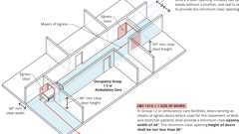
Width of Doors in I-2 / Ambulatory Care (Stretchers) (CA)
Locking Arrangements in Educational Occupancies
Stairway Door Operations - Excpt. 4 & 5
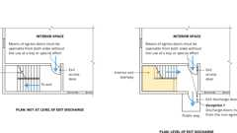
Stairway Door Operations - Excpt. 1
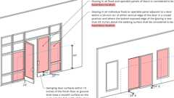
Glazing In / Adjacent to Doors
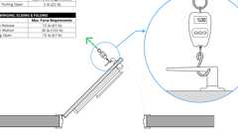
Door Opening Forces: Egress
Entry Door: 180° Viewer
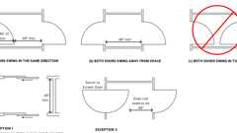
Arrangement of Doors in Series
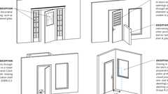
Glazing In / Adjacent to Doors - Except.
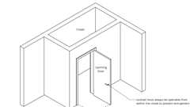
Latching: Closet Doors
Show 7 more
Building product (1)
GPX® Curtain Wall
SaftiFirst

1010.1.1 Size of Doors
Diagram
The required capacity of each door opening shall be sufficient for the occupant load thereof and shall provide a minimum clear opening width of 32 inches (813 mm). The clear opening width of doorways with swinging doors shall be measured between the face of the door and the frame stop, with the door open 90 degrees (1.57 rad). Where this section requires a minimum clear opening width of 32 inches (813 mm) and a door opening includes two door leaves without a mullion, one leaf shall provide a minimum clear opening width of 32 inches (813 mm). In Group I-2 or an ambulatory care facility, doors serving as means of egress doors where used for the movement of beds and stretcher patients shall provide a minimum clear opening width of 44 inches (1118 mm). Where this section requires a minimum clear opening width of 44 inches (1118 mm) and a door opening includes two door leaves without a mullion, one leaf shall provide a minimum clear opening width of 44 inches (1118 mm). The minimum clear opening height of doors shall be not less than 80 inches (2032 mm).
Exceptions:
- In Group R-2 and R-3 dwelling and sleeping units that are not required to be adaptable or accessible as specified in Chapter 11A the minimum width shall not apply to door openings that are not part of the required means of egress.
- In Group I-3, door openings to resident sleeping units that are not required to be adaptable or accessible as specified in Chapter 11A shall have a minimum clear opening width of 28 inches (711 mm).
- Door openings to storage closets less than 10 square feet (0.93 m²) in area shall not be limited by the minimum clear opening width.
- Door openings within a dwelling unit or sleeping unit shall have a minimum clear opening height of 78 inches (1981 mm).
- In dwelling and sleeping units that are not required to be adaptable or accessible as specified in Chapter 11A, exterior door openings other than the required exit door shall have a minimum clear opening height of 76 inches (1930 mm).
- In Groups R-2, R-3 and R-4 in dwelling and sleeping units that are not required to be adaptable or accessible as specified in Chapter 11A, the minimum clear opening widths shall not apply to interior egress doors.
- Doors serving sauna compartments, toilet compartments or dressing, fitting or changing compartments that are not required to comply with Chapter 11A or Chapter 11B shall have a minimum clear opening width of 20 inches (508 mm).
- Doors serving shower compartments shall comply with Section 408.6 of the California Plumbing Code.
UpCodes Diagrams (4)
Primary
Width of Doors in I-2 / Ambulatory Care (Stretchers) (CA)
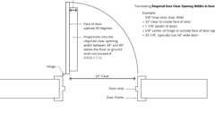Primary
Doors: Min. Required Clear Opening Width
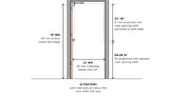Primary
Clear Width & Vertical Clearance of Doors & Gates
Exits through Lobbies
1010.1.1.1 Projections Into Clear Opening
Diagram
There shall not be projections into the required clear opening width lower than 34 inches (864 mm) above the floor or ground. Projections into the clear opening width between 34 inches (864 mm) and 80 inches (2032 mm) above the floor or ground shall not exceed 4 inches (102 mm).
Exceptions:
- Door closers, overhead doorstops, frame stops, power door operators, and electromagnetic door locks shall project into the door opening height not lower than 78 inches (1980 mm) above the floor.
- In a Group I-2 occupancy, there shall be no projections into the clear width of doors used for the movement of beds and stretcher patients in the means of egress.
UpCodes Diagrams (2)
Primary
Doors: Min. Required Clear Opening Width
Primary
Clear Width & Vertical Clearance of Doors & Gates
1010.1.2 Egress Door Types
Diagram
Egress doors shall be of the side-hinged swinging door, pivoted door, or balanced door types.
Exceptions:
- Private garages, office areas, factory and storage areas with an occupant load of 10 or less.
- Group I-3 occupancies used as a place of detention.
- Critical or intensive care patient rooms within suites of health care facilities.
- Doors within or serving a single dwelling unit in Groups R-2 and R-3.
- In other than Group H occupancies, revolving doors complying with Section 1010.3.1.
- In other than Group H occupancies, special purpose horizontal sliding, accordion or folding door assemblies complying with Section 1010.3.3.
- Power-operated doors in accordance with Section 1010.3.2.
- Doors serving a bathroom within an individual dwelling unit or sleeping unit in Group R-1.
- In other than Group H occupancies, manually operated horizontal sliding doors are permitted in a means of egress from spaces with an occupant load of 10 or less.
- In Group I-2 occupancies, exit doors serving an occupant load of 50 or more, shall not be of the pivoted or balanced type.
UpCodes Diagrams (2)
Ext. Doors and the Public Way
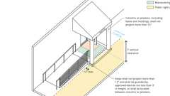
Encroachments of Public Way at Steps and Awnings
1010.1.2.1 Direction of Swing
Diagram
Side-hinged swinging doors, pivoted doors and balanced doors shall swing in the direction of egress travel where serving a room or area containing an occupant load of 50 or more persons or a Group H occupancy. For Group L occupancies, see Section 453.6.2.
In a Group I-2 occupancy, all required exterior egress doors shall open in the direction of egress regardless of the occupant load served.
UpCodes Diagrams (2)
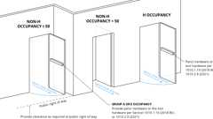Primary
Door Swing Direction
Ext. Doors and the Public Way
1010.1.3 Forces to Unlatch and Open Doors
Diagram
The forces to unlatch doors shall comply with the following:
- Where door hardware operates by push or pull, the operational force to unlatch the door shall not exceed 15 pounds (67 N).
- Where door hardware operates by rotation, the operational force to unlatch the door shall not exceed 28 inch-pounds (315 N-cm).
The force to open doors shall comply with the following:
- For interior swinging egress doors that are manually operated, other than doors required to be fire rated, the force for pushing or pulling open the door shall not exceed 5 pounds (22 N).
- For other swinging doors, sliding doors or folding doors, and doors required to be fire rated, the door shall require not more than a 30-pound (133 N) force to be set in motion and shall move to a full-open position when subjected to not more than a 15-pound (67 N) force.
UpCodes Diagram (1)
Primary
Door Opening Forces: Egress
1010.1.3.1 Location of Applied Forces
Forces shall be applied to the latch side of the door.
1010.1.3.2 Manual Horizontal Sliding Doors
Where a manual horizontal sliding door is required to latch, the latch or other mechanism shall prevent the door from rebounding into a partially open position when the door is closed.
1010.1.4 Floor Elevation
There shall be a floor or landing on each side of a door. Such floor or landing shall be at the same elevation on each side of the door. Landings shall be level except for exterior landings, which are permitted to have a slope not to exceed 0.25 unit vertical in 12 units horizontal (2-percent slope).
Exceptions:
- At doors serving individual dwelling units or sleeping units in Groups R-2 and R-3, a door is permitted to open at the top step of an interior flight of stairs, provided that the door does not swing over the top step.
- At exterior doors serving Groups F, H, R-2 and S and where such doors are not part of an adaptable or accessible route or, not required to be accessible by Chapter 11A or 11B of the California Building Code, the landing at an exterior door shall not be more than 7 inches (178 mm) below the landing on the egress side of the door, provided that the door, other than an exterior storm or screen door, does not swing over the landing.
- At exterior doors serving Group U and individual dwelling units and sleeping units in Groups R-2 and R-3, and where such units are not required to be adaptable or accessible, the landing at an exterior doorway shall be not more than 7³/₄ inches (197 mm) below the landing on the egress side of the door. Such doors, including storm or screen doors, shall be permitted to swing over either landing.
- Variations in elevation due to differences in finish materials, but not more than ¹/₂ inch (12.7 mm).
- Exterior decks, patios or balconies that are part of adaptable or accessible dwelling units or sleeping units, that have impervious surfaces and that are not more than 4 inches (102 mm) below the finished floor level of the adjacent interior space of the dwelling unit or sleeping unit. See also Chapter 11A, Section 1132A.4 or Chapter 11B, as applicable.
- Doors serving equipment spaces not required to be adaptable or accessible in accordance with Section 1103.2.9 and serving an occupant load of five or less shall be permitted to have a landing on one side to be not more than 7 inches (178 mm) above or below the landing on the egress side of the door.
1010.1.5 Landings at Doors
Diagram
Landings shall have a width not less than the width of the stairway or the door, whichever is greater. Doors in the fully open position shall not reduce a required dimension by more than 7 inches (178 mm). Where a landing serves an occupant load of 50 or more, doors in any position shall not reduce the landing to less than one-half its required width. Landings shall have a length measured in the direction of travel of not less than 44 inches (1118 mm).
Exception: Landing length in the direction of travel in Groups R-3 and U and within individual units of Group R-2 need not exceed 36 inches (914 mm).
UpCodes Diagram (1)
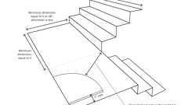
Stair Landings
1010.1.6 Thresholds
Thresholds at doorways shall not exceed ³/₄ inch (19.1 mm) in height above the finished floor or landing for sliding doors serving dwelling units or ¹/₂ inch (12.7 mm) above the finished floor or landing for other doors. Raised thresholds and floor level changes greater than ¹/₄ inch (6.4 mm) at doorways shall be beveled with a slope not greater than one unit vertical in two units horizontal (50-percent slope).
Exceptions:
- In occupancy Group R-2 or R-3, threshold heights for sliding and side-hinged exterior doors shall be permitted to be up to 7³/₄ inches (197 mm) in height if all of the following apply:
  - The door is not part of the required means of egress.
  - The door is not part of an accessible route as required by Chapter 11A or 11B.
  - The door is not part of an adaptable or accessible dwelling unit.
- In adaptable or accessible dwelling units, where Exception 5 to Section 1010.1.4 permits a 4-inch (102 mm) elevation change at the door, the threshold height on the exterior side of the door shall not exceed 4³/₄ inches (120 mm) in height above the exterior deck, patio or balcony for sliding doors or 4¹/₂ inches (114 mm) above the exterior deck, patio or balcony for other doors.
1010.1.7 Door Arrangement
Diagram
Space between two doors in a series shall be 48 inches (1219 mm) minimum plus the width of a door swinging into the space. Doors in a series shall swing either in the same direction or away from the space between the doors.
Exceptions:
- The minimum distance between horizontal sliding power-operated doors in a series shall be 48 inches (1219 mm).
- Storm and screen doors serving individual dwelling units in Groups R-2 and R-3 need not be spaced 48 inches (1219 mm) from the other door.
- Doors within individual dwelling units in Groups R-2 and R-3 other than adaptable or accessible dwelling units.
UpCodes Diagram (1)
Primary
Arrangement of Doors in Series
1010.2 Door Operations
Diagram
Except as specifically permitted by this section, egress doors shall be readily openable from the egress side without the use of a key or special knowledge or effort.
UpCodes Diagrams (6)
Locking Arrangements in Educational Occupancies
Stairway Door Operations - Excpt. 4 & 5
Stairway Door Operations - Excpt. 1
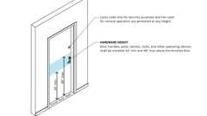
Door Hardware Height
Door Hardware: Operation
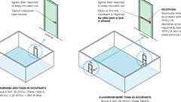
Alterations: Locking Arrangements in Educational Occupancies
1010.2.1 Unlatching
The unlatching of any door or leaf for egress shall require not more than one motion in a single linear or rotational direction to release all latching and all locking devices. Manual bolts are not permitted.
Exceptions:
- Places of detention or restraint.
- Doors with manual bolts, automatic flush bolts and constant latching bolts as permitted by Section 1010.2.4, Item 4.
- Doors from individual dwelling units and sleeping units of Group R occupancies as permitted by Section 1010.2.4, Item 5.
1010.2.2 Hardware
Diagram
Door handles, pulls, latches, locks and other operating devices on doors required to be accessible by Chapter 11A or 11B shall not require tight grasping, tight pinching or twisting of the wrist to operate.
These design requirements for door handles, pulls, latches, locks and other operating devices, intended for use on required means of egress doors in other than Group R and M occupancies with an occupant load of 10 or less, shall comply with SFM Standard 12-10-2, Section 12-10-202 contained in the CCR, Title 24, Part 12, California Referenced Standards Code.
UpCodes Diagrams (2)
Primary
Door Hardware: Operation
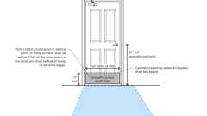
Door Hardware Req. (11A)
1010.2.3 Hardware Height
Diagram
Door handles, pulls, latches, locks and other operating devices shall be installed 34 inches (864 mm) minimum and 48 inches (1219 mm) maximum above the finished floor.
Exceptions:
- Locks used only for security purposes and not used for normal operation are permitted at any height.
- Where the California Building Code requires restricting access to a pool, spa or hot tub, and where door and gate latch release mechanisms are accessed from the outside of the barrier and are not of the self-locking type, such a mechanism shall be located above the finished floor or ground surface not less than 52 inches (1219 mm) and not greater than 54 inches (1370 mm), provided that the latch release mechanism is not a self-locking type such as where the lock is operated by means of a key, electronic opener or the entry of a combination into an integral combination lock.
UpCodes Diagrams (2)
Primary
Door Hardware Height
Door Hardware Req. (11A)
1010.2.4 Locks and Latches
Locks and latches shall be permitted to prevent operation of doors where any of the following exist:
- Places of detention or restraint.
- In Group I-2 and R-2.1 occupancies where the clinical needs of persons receiving care require containment or where persons receiving care pose a security threat, provided that all clinical staff can readily unlock doors at all times, and all such locks are keyed to keys carried by all clinical staff at all times or all clinical staff have the codes or other means necessary to operate the locks at all times.
- In buildings in occupancy Group A having an occupant load of 300 or less, Groups B, F, M and S, and in places of religious worship, the main door or doors are permitted to be equipped with key-operated locking devices from the egress side provided that:
  - 3.1. The doors are the main exterior doors to the building, or the doors are the main doors to the tenant space.
  - 3.2. The locking device is readily distinguishable as locked.
  - 3.3. A readily visible durable sign is posted on the egress side on or adjacent to the door stating: THIS DOOR TO REMAIN UNLOCKED WHEN THIS SPACE IS OCCUPIED. The sign shall be in letters 1 inch (25 mm) high on a contrasting background.
  - 3.4. The use of the key-operated locking device is revocable by the building official for due cause.
- Manual bolts, automatic flush bolts and constant latching bolts on the inactive leaf of a pair of doors in accordance with Table 1010.2.4, provided that the inactive leaf does not have a doorknob, panic hardware, or similar operating hardware.
- Single exit doors complying with Section 1006.2.1 or 1006.3.4 from individual dwelling or sleeping units of Group R occupancies and equipped with a night latch, dead bolt or security chain that requires a second releasing motion, provided that such devices are openable from the inside without the use of a key or tool.
- Fire doors after the minimum elevated temperature has disabled the unlatching mechanism in accordance with listed fire door test procedures.
- Doors serving roofs not intended to be occupied shall be permitted to be locked preventing entry to the building from the roof.
- Other than egress courts, where occupants must egress from an exterior space through the building for means of egress, exit access doors shall be permitted to be equipped with an approved locking device where installed and operated in accordance with all of the following:
  - 8.1. The maximum occupant load shall be posted where required by Section 1004.9. Such signage shall be permanently affixed inside the building and shall be posted in a conspicuous space near all the exit access doorways.
  - 8.2. A weatherproof telephone or two-way communication system installed in accordance with Sections 1009.8.1 and 1009.8.2 shall be located adjacent to not less than one required exit access door on the exterior side.
  - 8.3. The egress door locking device is readily distinguishable as locked and shall be a key-operated locking device.
  - 8.4. A clear window or glazed door opening, not less than 5 square feet (0.46 m²) in area, shall be provided at each exit access door to determine if there are occupants using the outdoor area.
  - 8.5. A readily visible, durable sign shall be posted on the interior side on or adjacent to each locked required exit access door serving the exterior area stating, "THIS DOOR TO REMAIN UNLOCKED WHEN THE OUTDOOR AREA IS OCCUPIED." The letters on the sign shall be not less than 1 inch (25.4 mm) high on a contrasting background.
  - 8.6. The occupant load of the occupied exterior area shall not exceed 300 occupants in accordance with Section 1004.
- Locking devices are permitted on doors to balconies, decks or other exterior spaces serving individual dwelling or sleeping units.
- Locking devices are permitted on doors to balconies, decks or other exterior spaces of 250 square feet (23.23 m²) or less serving a private office space.
TABLE 1010.2.4—MANUAL BOLTS, AUTOMATIC FLUSH BOLTS AND CONSTANT LATCHING BOLTS ON THE INACTIVE LEAF OF A PAIR OF DOORS
APPLICATION WITH A PAIR OF DOORS WITH AN ACTIVE LEAF AND AN INACTIVE LEAF | THE PAIR OF  DOORS IS  REQUIRED TO  COMPLY WITH  SECTION 716 | PERMITTED USES OF MANUAL BOLTS,  AUTOMATIC FLUSH BOLTS AND CONSTANT LATCHING  BOLTS ON THE INACTIVE LEAF OF A PAIR OF DOORS
 | THE PAIR OF  DOORS IS  REQUIRED TO  COMPLY WITH  SECTION 716 | Surface- or flush-  mounted manual bolts | Automatic  flush bolts | Constant  latching bolts
Group B, F or S occupancies with occupant load less than 50. | No | P | P | P
Group B, F or S occupancies with occupant load less than 50. | Yes | NP | NP^{b} | P
Group B, F or S occupancies where the building is equipped  with an automatic sprinkler system in accordance with  Section 903.3.1.1 and the inactive leaf is not needed to meet  egress capacity requirements. | No | P | P | P
 | Yes | NP | NP^{b} | P
Group I-2 patient care and sleeping rooms where inactive leaf  is not needed to meet egress capacity requirements. | No | NP | NP^{b} | P
 | Yes | NP | NP^{b} | P
Any occupancy where panic hardware is not required, egress  doors are used in pairs, and where both leaves are required to  meet egress capacity requirements. | No | NP | P | NP
 | Yes | NP | NP^{b} | NP
Storage or equipment rooms where the inactive leaf is not  needed to meet egress capacity requirements. | No | Pª | P | P
 | Yes | Pª | P | P
P = Permitted. NP = Not permitted.
- Not permitted on corridor doors in Group I-2 occupancies where corridor doors are required to be positive latching.
- Permitted where both doors are self closing or automatic closing, and are provided with a coordinator that causes the inactive leaf to be closed prior to the active leaf.
1010.2.5 Closet Doors
Diagram
Closet doors that latch in the closed position shall be openable from inside the closet.
UpCodes Diagram (1)
Primary
Latching: Closet Doors
1010.2.6 Stairway Doors
Diagram
Interior stairway means of egress doors shall be openable from both sides without the use of a key or special knowledge or effort.
Exceptions:
- Stairway discharge doors shall be openable from the egress side and shall only be locked from the opposite side.
- This section shall not apply to doors arranged in accordance with Section 403.5.3.
- Stairway exit doors shall not be locked from the side opposite the egress side, unless they are openable from the egress side and capable of being unlocked simultaneously without unlatching by any of the following methods:
  - Shall be capable of being unlocked individually or simultaneously upon a signal from the fire command center, where present, or a signal by emergency personnel from a single location inside the main entrance to the building.
  - Shall unlock simultaneously upon activation of a fire alarm signal when a fire alarm system is present in an area served by the stairway.
  - Shall unlock upon failure of the power supply to the electric lock or the locking system.
- Stairway exit doors shall be openable from the egress side and shall only be locked from the opposite side in Group B, F, M and S occupancies where the only interior access to the tenant space is from a single exit stairway where permitted in Section 1006.3.4.
- Stairway exit doors shall be openable from the egress side and shall only be locked from the opposite side in Group R-2 occupancies where the only interior access to the dwelling unit is from a single exit stairway where permitted in Section 1006.3.4.
UpCodes Diagrams (2)
Primary
Stairway Door Operations - Excpt. 1
Primary
Stairway Door Operations - Excpt. 4 & 5
1010.2.7 Locking Arrangements in Educational Occupancies
Diagram
In Group E occupancies, Group B educational occupancies and Group I-4 occupancies, egress doors from classrooms, offices and other occupied rooms with locking arrangements designed to keep intruders from entering the room shall comply with all of the following conditions:
- The door shall be capable of being unlocked from outside the room with a key or other approved means.
- The door shall be openable from within the room in accordance with Section 1010.2.
- Modifications shall not be made to listed panic hardware, fire door hardware or door closers.
- Modifications to fire door assemblies shall be in accordance with NFPA 80.
Remote locking or unlocking of doors from an approved location shall be permitted in addition to the unlocking operation in Item 1.
UpCodes Diagrams (2)
Primary
Locking Arrangements in Educational Occupancies
Group I-4 Exits
1010.2.7.1 Special Provisions—School Classrooms
School classrooms constructed after January 1, 1990, not equipped with automatic sprinkler systems, which have metal grilles or bars on all their windows and do not have at least two exit doors within 3 feet (914 mm) of each end of the classroom opening to the exterior of the building or to a common hallway used for evacuation purposes, shall have an inside release for the grilles or bars on at least one window farthest from the exit doors. The window or windows with the inside release shall be clearly marked as emergency exits.
1010.2.7.2 Group E Lockable Doors From the Inside
New buildings that are included in public schools (kindergarten through 12th grade) state funded projects and receiving state funding pursuant to Leroy F. Green, School Facilities Act of 1998, California Education Code Sections 17070.10 through 17079, and that are submitted to the Division of the State Architect for plan review after July 1, 2011 in accordance with Education Code 17075.50, shall include locks that allow doors to classrooms and any room with an occupancy of five or more persons to be locked from the inside. The locks shall conform to the specification and requirements found in Section 1010.2.
Exceptions:
- Doors that are locked from the outside at all times such as, but not limited to, janitor's closet, electrical room, storage room, boiler room, elevator equipment room and pupil restroom.
- Reconstruction projects that utilize original plans in accordance with California Administrative Code, Section 4-314.
- Existing relocatable buildings that are relocated within same site in accordance with California Administrative Code, Section 4-314.
1010.2.8 Panic and Fire Exit Hardware
Diagram
Swinging doors serving a Group H occupancy and swinging doors serving rooms or spaces with an occupant load of 50 or more in a Group A or E occupancy, assembly area not classified as an assembly occupancy, E or I-2 occupancies shall not be provided with a latch or lock other than panic hardware or fire exit hardware. For Group L occupancies see Section 453.6.3.
Exceptions:
- A main exit of a Group A occupancy shall be permitted to have locking devices in accordance with Section 1010.2.4, Item 3.
- Doors provided with panic hardware or fire exit hardware and serving a Group A or E occupancy shall be permitted to be electrically locked in accordance with Section 1010.2.10.
- Exit access doors serving occupied exterior areas shall be permitted to be locked in accordance with Section 1010.2.4, Item 8.
- Courtrooms shall be permitted to be locked in accordance with Section 1010.2.12, Item 3.
UpCodes Diagram (1)
Alterations: Locking Arrangements in Educational Occupancies
1010.2.8.1 Refrigeration Machinery Room
Diagram
Refrigeration machinery rooms larger than 1,000 square feet (93 m²) shall have not less than two exit or exit access doorways that swing in the direction of egress travel and shall be equipped with panic hardware or fire exit hardware.
UpCodes Diagrams (2)
Primary
Refrigeration Machinery Rooms: Exits
Refrigerated Rooms: Exits
1010.2.8.2 Rooms With Electrical Equipment
Diagram
Exit or exit access doors serving transformer vaults, rooms designated for batteries or energy storage systems, or modular data centers shall be equipped with panic hardware or fire exit hardware. Rooms containing electrical equipment rated 800 amperes or more that contain overcurrent devices, switching devices or control devices and where the exit or exit access door is less than 25 feet (7620 mm) from the equipment working space as required by the California Electrical Code, such doors shall not be provided with a latch or lock other than panic hardware or fire exit hardware. The doors shall swing in the direction of egress travel.
UpCodes Diagrams (7)
Primary
Rooms w/ Electrical Equipment: Exits
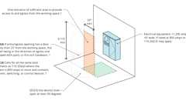
Elect. Equip.: Entrance/Egress from Working Space, pt. 1
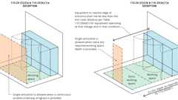
Elect. Equip.: Entrance/Egress from Working Space, pt. 3
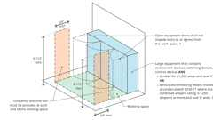
Elect. Equip.: Entrance/Egress from Working Space, pt. 2
Electrical Working Space Conditions
Allowed Clearance at Open Equipment Doors (<1000V)
Clearances at Electrical Equipment
1010.2.8.3 Installation
Where panic or fire exit hardware is installed, it shall comply with the following:
- Panic hardware shall be listed in accordance with UL 305.
- Fire exit hardware shall be listed in accordance with UL 10C and UL 305.
- The actuating portion of the releasing device shall extend not less than one-half of the door leaf width.
- The maximum unlatching force shall not exceed 15 pounds (67 N).
1010.2.8.4 Balanced Doors
If balanced doors are used and panic hardware is required, the panic hardware shall be the push-pad type and the pad shall not extend more than one-half the width of the door measured from the latch side.
1010.2.9 Monitored or Recorded Egress, and Access Control Systems
Where electrical systems that monitor or record egress activity are incorporated, or where the door has an access control system, the locking system on the egress side of the door shall comply with Section 1010.2.10, 1010.2.11, 1010.2.12, 1010.2.13, 1010.2.14 or 1010.2.15 or shall be readily openable from the egress side without the use of a key or special knowledge or effort.
1010.2.10 Door Hardware Release of Electrically Locked Egress Doors
Door hardware release of electrical locking systems shall be permitted on doors in the means of egress in any occupancy except Group H where installed and operated in accordance with all of the following:
- The door hardware that is affixed to the door leaf has an obvious method of operation that is readily operated under all lighting conditions.
- The door hardware is capable of being operated with one hand and shall comply with Section 1010.2.1.
- Operation of the door hardware directly interrupts the power to the electric lock and unlocks the door immediately.
- Loss of power to the electrical locking system automatically unlocks the electric lock.
- Where panic or fire exit hardware is required by Section 1010.2.8, operation of the panic or fire exit hardware also releases the electric lock.
- The electromechanical or electromagnetic locking device shall be listed in accordance with either UL 294 or UL 1034.
1010.2.11 Sensor Release of Electrically Locked Egress Doors
Sensor release of electrical locking systems shall be permitted on doors located in the means of egress in any occupancy except Group H where installed and operated in accordance with all of the following criteria:
- The sensor shall be installed on the egress side, arranged to detect an occupant approaching the doors, and shall cause the electrical locking system to unlock the electric lock.
- Upon a signal from a sensor or loss of power to the sensor, the electrical locking system shall unlock the electric lock.
- Loss of power to the electric lock or the electrical locking system shall automatically unlock the electric locks.
- The doors shall be arranged to unlock the electric lock from a manual unlocking device located 40 inches to 48 inches (1016 mm to 1219 mm) vertically above the floor and within 5 feet (1524 mm) of the secured doors. Ready access shall be provided to the manual unlocking device and the device shall be clearly identified by a sign that reads "PUSH TO EXIT." When operated, the manual unlocking device shall result in direct interruption of power to the electric lock—independent of other electronics—and the electric lock shall remain unlocked for not less than 30 seconds.
- Activation of the building fire alarm system, where provided, shall automatically unlock the electric lock, and the electric lock shall remain unlocked until the fire alarm system has been reset.
- Activation of the building automatic sprinkler system or fire detection system, where provided, shall automatically unlock the electric lock. The electric lock shall remain unlocked until the fire alarm system has been reset.
- Emergency lighting shall be provided on the egress side of the door.
- The electromechanical or electromagnetic locking device shall be listed in accordance with either UL 294 or UL 1034.
1010.2.11.1 Access-Controlled Elevator Lobby Doors in High-Rise Office Buildings
For elevator lobbies in high-rise office buildings where the occupants of the floor are not required to travel through the elevator lobby to reach an exit, when approved by the fire chief, the doors separating the elevator lobby from the adjacent occupied tenant space that also serve as the entrance doors to the tenant space shall be permitted to be equipped with an approved entrance and egress access control system provided all of the following requirements are met:
- The building is provided throughout with an automatic sprinkler system in accordance with Section 903.3.1.1.
- A smoke detector is installed on the ceiling on the tenant side of the elevator lobby doors along the center line of the door opening, not less than 1 foot and not more than 5 feet from the door opening, and is connected to the fire alarm system.
- A remote master switch capable of unlocking the elevator lobby doors shall be provided in the fire command center for use by the fire department.
- Locks for the elevator lobby shall be U.L. and California State Fire Marshal listed fail-safe type locking mechanisms. The locking device shall automatically release on activation of any fire alarm device on the floor of alarm (waterflow, smoke detector, manual pull stations, etc.). All locking devices shall unlock, but not unlatch, upon activation.
- A two-way voice communication system, utilizing dedicated lines, shall be provided from each locked elevator lobby to the 24-hour staffed location on site, annunciated as to location. Operating instructions shall be posted above each two way communication device.
Exception: When approved by the fire chief, two-way voice communication system to an off-site facility may be permitted where means to remotely unlock the access controlled doors from the off-site facility are provided.
- An approved momentary mushroom-shaped palm button connected to the doors and installed adjacent to each locked elevator lobby door shall be provided to release the door locks when operated by an individual in the elevator lobby. The locks shall be reset manually at the door. Mount palm button so that the center line is 48 inches above the finished floor.
  - Provide a sign stating:
  - "IN CASE OF EMERGENCY, PUSH PALM BUTTON,
DOOR WILL UNLOCK
AND SECURITY ALARM
WILL SOUND."
The sign lettering shall be ³/₄-inch high letters by ¹/₈-inch width stroke on a contrasting background.
- Loss of power to that part of the access control system which locks the doors shall automatically unlock the doors.
1010.2.12 Delayed Egress
Delayed egress electrical locking systems shall be permitted on doors in the means of egress serving the following occupancies in buildings that are equipped throughout with an automatic sprinkler system in accordance with Section 903.3.1.1 and an approved automatic smoke or heat detection system installed in accordance with Section 907.
- Group B, F, I, M, R, S and U occupancies.
- Group E classrooms with an occupant load of less than 50.
- In courtrooms in Group A-3 and B occupancies, delayed egress electrical locking systems shall be permitted to be installed on exit or exit access doors, other than the main exit or exit access door, in buildings that are equipped throughout with an automatic sprinkler system in accordance with Section 903.3.1.1 and an approved automatic smoke detection system installed in accordance with Section 907.
1010.2.12.1 Delayed Egress Locking System
The delayed egress electrical locking system shall be installed and operated in accordance with all of the following:
- The delay of the delayed egress electrical locking system shall deactivate upon actuation of the automatic sprinkler system required by Section 1010.2.13 and the delay electronics of the delayed egress locking system shall deactivate upon actuation of the smoke or heat detection system required by Section 1010.2.13, allowing immediate free egress.
- The delay of the delayed egress electrical locking system shall deactivate upon loss of electrical power to the electrical locking system or electrical lock, allowing immediate free egress, to any one of the following:
  - 2.1. The egress-control device itself.
  - 2.2. The smoke detection system.
  - 2.3. Means of egress illumination as required by Section 1008.
- The delay of the delayed egress locking electrical system shall have the capability of being deactivated at the fire command center and other approved locations.
- An attempt to egress shall initiate an irreversible process that shall allow such egress in not more than 15 seconds when a physical effort to exit is applied to the egress side door hardware for not more than 3 seconds. Initiation of the irreversible process shall activate an audible signal in the vicinity of the door. Once the delay has been deactivated, rearming the delay electronics shall be by manual means only. The time delay established for each egress-control device shall not be field adjustable. For applications listed in Section 1.9.1 regulated by the Division of the State Architect—Access Compliance, see Chapter 11B, 11B-404.2.9.
Exception: In facilities housing Alzheimer's or dementia clients, a delay of not more than 30 seconds is permitted on a delayed egress door.
- The egress path from any point shall not pass through more than one delayed egress locking system.
Exceptions:
  - In Group R-2.1, Group I-2 or I-3 occupancies, the egress path from any point in the building shall pass through not more than two delayed egress locking systems provided that the combined delay does not exceed 30 seconds.
    - 5.1. A tactile sign shall also be provided in Braille and raised characters, which complies with Chapter 11B, Sections 11B-703.1, 11B-703.2, 11B-703.3 and 11B-703.5.
  - In Group R-2.1 or Group I-4 occupancies, the egress path from any point in the building shall pass through not more than two delayed egress locking systems provided the combined delay does not exceed 30 seconds and the building is equipped throughout with an automatic sprinkler system in accordance with Section 903.3.1.1.
- A sign shall be provided on the door and shall be located above and within 12 inches (305 mm) of the door exit hardware.
Exception: Where approved, in Group I occupancies, the installation of a sign is not required where care recipients who because of clinical needs require restraint or containment as part of the function of the treatment area.
  - 6.1. For doors that swing in the direction of egress, the sign shall read, "PUSH UNTIL ALARM SOUNDS. DOOR CAN BE OPENED IN 15 [30] SECONDS."
  - 6.2. For doors that swing in the opposite direction of egress, the sign shall read, "PULL UNTIL ALARM SOUNDS. DOOR CAN BE OPENED IN 15 [30] SECONDS."
  - 6.3. The sign shall comply with the visual character requirements in Section 11B-703.5. Sign lettering shall be at least 1 inch (25 mm) in height and shall have a stroke of not less than ¹/₈ inch (3.2 mm).
  - 6.4. A tactile sign shall also be provided in Braille and raised characters, which complies with Chapter 11B, Sections 11B-703.1, 11B-703.2, 11B-703.3 and 11B-703.5.
- Emergency lighting shall be provided on the egress side of the door.
- The electromechanical or electromagnetic locking device shall be listed in accordance with either UL 294 or UL 1034.
- Actuation of the panic bar or other door-latching hardware shall activate an audible signal at the door.
- The unlatching shall not require more than one operation.
- Regardless of the means of deactivation, relocking of the egress-control device shall be by manual means only at the door.
1010.2.13 Controlled Egress Doors in Group I-2
Controlled egress electrical locking systems where egress is controlled by authorized personnel shall be permitted on doors in the means of egress in Group I-2 occupancies where the clinical needs of persons receiving psychiatric or mental health treatment require their restraint or containment. Controlled egress doors shall be permitted in such occupancies where the building is equipped throughout with an automatic sprinkler system in accordance with Section 903.3.1.1 and an approved automatic smoke detection system installed in accordance with Section 907, provided that the doors are installed and operate in accordance with all of the following:
- The door's electric locks shall unlock on actuation of the automatic sprinkler system or automatic smoke detection system allowing immediate free egress.
- The door's electric locks shall unlock on loss of power to the electrical locking system or to the electric lock mechanism allowing immediate free egress.
- The electrical locking system shall be installed to have the capability of unlocking the electric locks by a switch located at the fire command center, a nursing station or other approved location. The switch shall directly break power to the electric lock.
- A building occupant shall not be required to pass through more than one door equipped with a controlled egress locking system before entering an exit.
- All staff shall have the keys, codes or other means necessary to operate the controlled egress electrical locking systems.
- Emergency lighting shall be provided at the door.
- The electromechanical or electromagnetic locking device shall be listed in accordance with either UL 294 or UL 1034.
Exception: Items 1 through 4 shall not apply to doors to areas occupied by persons who, because of clinical needs, require restraint or containment as part of the function of a psychiatric or mental health treatment area.
1010.2.14 Elevator Lobby Exit Access Doors
Diagram
Electrically locked exit access doors providing egress from elevator lobbies shall meet the following conditions:
- For all occupants of the floor, the path of exit access travel to not less than two exits is not required to pass through the elevator lobby.
- The building is equipped throughout with an automatic sprinkler system in accordance with Section 903.3.1.1, and a fire alarm system in accordance with Section 907. Elevator lobbies shall be provided with an automatic smoke detection system in accordance with Section 907.
- Upon activation of the building fire alarm system by means other than a manual fire alarm box shall automatically unlock the electric locks providing exit access from the elevator lobbies, and the electric locks shall remain unlocked until the fire alarm system is reset.
- The electric locks shall unlock on loss of power to the electric locks or electrical locking system.
- The electric locks shall have the capability of being unlocked by a switch located at the fire command center, security station or other approved location.
- A two-way communication system complying with Sections 1009.8.1 and 1009.8.2, shall be located in the elevator lobby adjacent to the electrically locked exit access door and connected to an approved constantly attended station. This constantly attended station shall have the capability of unlocking the electric locks of the elevator lobby exit access doors.
- Emergency lighting shall be provided in the elevator lobby on both sides of the electrically locked door.
- The electromechanical or electromagnetic locking device shall be listed in accordance with either UL 294 or UL 1034.
UpCodes Diagram (1)
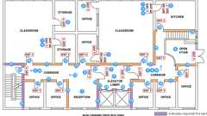
Exit Access & Corridor Continuity (Nonsprinklered, 0-75 ft) - 2024
1010.2.15
Reserved.
1010.3 Special Doors
Diagram
Special doors and security grilles shall comply with the requirements of Sections 1010.3.1 through 1010.3.4.
UpCodes Diagram (1)
Security Grilles
1010.3.1 Revolving Doors
Revolving doors shall comply with the following:
- Revolving doors shall comply with BHMA A156.27 and shall be installed in accordance with the manufacturer's instructions.
- Each revolving door shall be capable of breakout in accordance with BHMA A156.27 and shall provide an aggregate width of not less than 36 inches (914 mm).
- A revolving door shall not be located within 10 feet (3048 mm) of the foot or top of stairways or escalators. A dispersal area shall be provided between the stairways or escalators and the revolving doors.
- The revolutions per minute (rpm) for a revolving door shall not exceed the maximum rpm as specified in BHMA A156.27. Manual revolving doors shall comply with Table 1010.3.1(1). Automatic or power-operated revolving doors shall comply with Table 1010.3.1(2).
- An emergency stop switch shall be provided near each entry point of power or automatic operated revolving doors within 48 inches (1219 mm) of the door and between 34 inches (864 mm) and 48 inches (1219 mm) above the floor. The activation area of the emergency stop switch button shall be not less than 1 inch (25 mm) in diameter and shall be red.
- Each revolving door shall have a side-hinged swinging door that complies with Section 1010.1 in the same wall and within 10 feet (3048 mm) of the revolving door.
- Revolving doors shall not be part of an accessible route required by Section 1009 and Chapter 11A or 11B.
TABLE 1010.3.1(1)—MAXIMUM DOOR SPEED MANUAL REVOLVING DOORS
REVOLVING DOOR MAXIMUM NOMINAL DIAMETER (FT-IN) | MAXIMUM ALLOWABLE REVOLVING DOOR SPEED (RPM)
6-0 | 12
7-0 | 11
8-0 | 10
9-0 | 9
10-0 | 8
For SI: 1 inch = 25.4 mm, 1 foot = 304.8 mm.
TABLE 1010.3.1(2)—MAXIMUM DOOR SPEED AUTOMATIC OR POWER-OPERATED REVOLVING DOORS
REVOLVING DOOR MAXIMUM NOMINAL DIAMETER (FT-IN) | MAXIMUM ALLOWABLE REVOLVING DOOR SPEED (RPM)
8-0 | 7.2
9-0 | 6.4
10-0 | 5.7
11-0 | 5.2
12-0 | 4.8
12-6 | 4.6
14-0 | 4.1
16-0 | 3.6
17-0 | 3.4
18-0 | 3.2
20-0 | 2.9
24-0 | 2.4
For SI: 1 inch = 25.4 mm, 1 foot = 304.8 mm.
1010.3.1.1 Egress Component
A revolving door used as a component of a means of egress shall comply with Section 1010.3.1 and the following three conditions:
- Revolving doors shall not be given credit for more than 50 percent of the minimum width or required capacity.
- Each revolving door shall be credited with a capacity based on not more than a 50-person occupant load.
- Each revolving door shall provide for egress in accordance with BHMA A156.27 with a breakout force of not more than 130 pounds (578 N).
1010.3.1.2 Other Than Egress Component
A revolving door used as other than a component of a means of egress shall comply with Section 1010.3.1. The breakout force of a revolving door not used as a component of a means of egress shall not be more than 180 pounds (801 N).
Exception: A breakout force in excess of 180 pounds (801 N) is permitted if the breakout force is reduced to not more than 130 pounds (578 N) when not less than one of the following conditions is satisfied:
- There is a power failure or power is removed to the device holding the door wings in position.
- There is an actuation of the automatic sprinkler system where such system is provided.
- There is an actuation of a smoke detection system that is installed in accordance with Section 907 to provide coverage in areas within the building that are within 75 feet (22 860 mm) of the revolving doors.
- There is an actuation of a manual control switch, in an approved location and clearly identified, that reduces the breakout force to not more than 130 pounds (578 N).
1010.3.2 Power-Operated Doors
Diagram
Where means of egress doors are operated or assisted by power, the design shall be such that in the event of power failure, the door is capable of being opened manually to permit means of egress travel or closed where necessary to safeguard means of egress. The forces required to open these doors manually shall not exceed those specified in Section 1010.1.3, except that the force to set the door in motion shall not exceed 50 pounds (220 N). The door shall be capable of opening from any position to the full width of the opening in which such door is installed when a force is applied to the door on the side from which egress is made. Power-operated swinging doors, power-operated sliding doors and power-operated folding doors shall comply with BHMA A156.10. Power-assisted swinging doors and low-energy power-operated swinging doors shall comply with BHMA A156.19. Low-energy power-operated sliding doors and low-energy power-operated folding doors shall comply with BHMA A156.38.
Exceptions:
- Occupancies in Group I-3.
- Special purpose horizontal sliding, accordion or folding doors complying with Section 1010.3.3.
- For a biparting door in the emergency breakout mode, a door leaf located within a multiple-leaf opening shall be exempt from the minimum 32-inch (813 mm) single-leaf requirement of Section 1010.1.1, provided that a minimum 32-inch (813 mm) clear opening is provided when the two biparting leaves meeting in the center are broken out.
UpCodes Diagram (1)
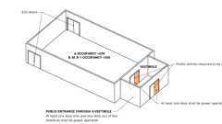
Automatic Doors: When Required
1010.3.3 Special Purpose Horizontal Sliding, Accordion or Folding Doors
In other than Group H occupancies, special purpose horizontal sliding, accordion or folding door assemblies permitted to be a component of a means of egress in accordance with Exception 6 to Section 1010.1.2 shall comply with all of the following criteria:
- The doors shall be power operated and shall be capable of being operated manually in the event of power failure.
- The doors shall be openable by a simple method without special knowledge or effort from the egress side or sides.
- The force required to operate the door shall not exceed 30 pounds (133 N) to set the door in motion and 15 pounds (67 N) to close the door or open it to the minimum required width.
- The door shall be openable with a force not to exceed 15 pounds (67 N) when a force of 250 pounds (1100 N) is applied perpendicular to the door adjacent to the operating device.
- The door assembly shall comply with the applicable fire protection rating and, where rated, shall be self-closing or automatic closing by smoke detection in accordance with Section 716.2.6.6, shall be installed in accordance with NFPA 80 and shall comply with Section 716.
- The door assembly shall have an integrated standby power supply.
- The door assembly power supply shall be electrically supervised.
- The door shall open to the minimum required width within 10 seconds after activation of the operating device.
1010.3.4 Security Grilles
Diagram
In Groups B, F, M and S, horizontal sliding or vertical security grilles are permitted at the main exit and shall be openable from the inside without the use of a key or special knowledge or effort during periods that the space is occupied. The grilles shall remain secured in the full-open position during the period of occupancy by the general public. Where two or more exits or access to exits are required, not more than one-half of the exits or exit access doorways shall be equipped with horizontal sliding or vertical security grilles.
UpCodes Diagram (1)
Primary
Security Grilles
1010.4 Gates
Diagram
Gates serving the means of egress system shall comply with the requirements of this section. Gates used as a component in a means of egress shall conform to the applicable requirements for doors.
UpCodes Diagram (1)
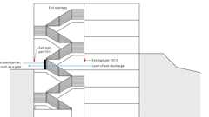
Stairway Discharge Identification
1010.4.1 Stadiums
Diagram
Panic hardware is not required on gates surrounding stadiums where such gates are under constant immediate supervision while the public is present, and where safe dispersal areas based on 3 square feet (0.28 m²) per occupant are located between the fence and enclosed space. Such required safe dispersal areas shall not be located less than 50 feet (15 240 mm) from the enclosed space. See Section 1028.5 for means of egress from safe dispersal areas.
UpCodes Diagram (1)
Primary
Stadium Gates
1010.5 Turnstiles and Similar Devices
Turnstiles or similar devices that restrict travel to one direction shall not be placed so as to obstruct any required means of egress, except where permitted in accordance with Sections 1010.5.1, 1010.5.2 and 1010.5.3.
1010.5.1 Capacity
Each turnstile or similar device shall be credited with a capacity based on not more than a 50-person occupant load where all of the following provisions are met:
- Each device shall turn free in the direction of egress travel when primary power is lost and on the manual release by an employee in the area.
- Such devices are not given credit for more than 50 percent of the required egress capacity or width.
- Each device is not more than 39 inches (991 mm) high.
- Each device has not less than 16¹/₂ inches (419 mm) clear width at and below a height of 39 inches (991 mm) and not less than 22 inches (559 mm) clear width at heights above 39 inches (991 mm).
1010.5.1.1 Clear Width
Where located as part of an accessible route, turnstiles shall have not less than 36 inches (914 mm) clear width at and below a height of 34 inches (864 mm), not less than 32 inches (813 mm) clear width between 34 inches (864 mm) and 80 inches (2032 mm) and shall consist of a mechanism other than a revolving device.
1010.5.2 Security Access Turnstiles
Security access turnstiles that inhibit travel in the direction of egress utilizing a physical barrier shall be permitted to be considered as a component of the means of egress, provided that all of the following criteria are met:
- The building is protected throughout by an approved, supervised automatic sprinkler system in accordance with Section 903.3.1.1.
- Each security access turnstile lane configuration has a minimum clear passage width of 22 inches (559 mm).
- Any security access turnstile lane configuration providing a clear passage width of less than 32 inches (810 mm) shall be credited with a maximum egress capacity of 50 persons.
- Any security access turnstile lane configuration providing a clear passage width of 32 inches (810 mm) or more shall be credited with a maximum egress capacity as calculated in accordance with Section 1005.
- Each secured physical barrier shall automatically retract or swing to an unobstructed open position in the direction of egress, under each of the following conditions:
  - 5.1. Upon loss of power to the turnstile or any part of the access control system that secures the physical barrier.
  - 5.2. Upon actuation of a clearly identified manual release device with ready access that results in direct interruption of power to each secured physical barrier, after which such barriers remain in the open position for not less than 30 seconds. The manual release device shall be positioned at one of the following locations:
5.2.1. On the egress side of each security access turnstile lane.
5.2.2. At an approved location where it can be actuated by an employee assigned to the area at all times that the building is occupied.
  - 5.3. Upon actuation of the building fire alarm system, if provided, after which the physical barrier remains in the open position until the fire alarm system is manually reset.
Exception: Actuation of a manual fire alarm box.
  - 5.4. Upon actuation of the building automatic sprinkler system or fire detection system, after which the physical barrier remains in the open position until the fire alarm system is manually reset.
1010.5.3 High Turnstile
Turnstiles more than 39 inches (991 mm) high shall meet the requirements for revolving doors or the requirements of Section 1010.5.2 for security access turnstiles.
1010.5.4 Additional Door
Where serving an occupant load greater than 300, each turnstile that is not portable shall have a side-hinged swinging door that conforms to Section 1010.1 within 50 feet (15 240 mm).
Exception: A side-hinged swinging door is not required at security access turnstiles that comply with Section 1010.5.2.
Section 1011 Stairways
[DSA-AC] In addition to the requirements of this section, means of egress, which provide access to, or egress from, buildings or facilities where accessibility is required for applications listed in Section 1.9.1 regulated by the Division of the State Architect—Access Compliance, shall also comply with Chapter 11A or Chapter 11B, Sections 11B-210 and 11B-504, as applicable.
1011.1 General
Diagram
Stairways serving occupied portions of a building shall comply with the requirements of Sections 1011.2 through 1011.13. Alternating tread devices shall comply with Section 1011.14. Ship's ladders shall comply with Section 1011.15. Ladders shall comply with Section 1011.16.
Exception: Within rooms or spaces used for assembly purposes, stepped aisles shall comply with Section 1030.
UpCodes Diagram (1)
Ladders: Where Permitted
Building products (19)
Heavy Duty Tubular Rail Fixed Access Ladder - 501 Access Ladder
O'Keeffe's

High Parapet Access with Platform and Return - 533 Cage Ladder
O'Keeffe's

Low Parapet Access with Platform and No Return - 533A Cage Ladder
O'Keeffe's

Low Parapet Access with Roofover Rail Extensions - 532 Cage Ladder
O'Keeffe's

Low Parapet with Walk Through Rail Extension - 534 Cage Ladder
O'Keeffe's

Ship Ladder (60 degrees) - 520A Ship Ladder
O'Keeffe's

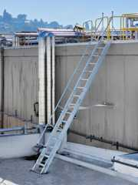
Ship Ladder (75 degrees) - 520 Ship Ladder
O'Keeffe's

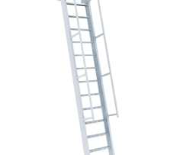
Ship Ladder with Access to Roof Hatch (60 degrees) - 523A Ship Ladder
O'Keeffe's

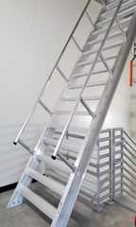
Ship Ladder with Access to Roof Hatch (75 degrees) - 523 Ship Ladder
O'Keeffe's

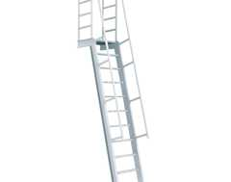
Ship Ladder with Platform (60 degrees) - 521A Ship Ladder
O'Keeffe's

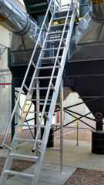
Ship Ladder with Platform (75 degrees) - 521 Ship Ladder
O'Keeffe's

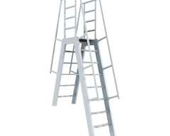
Ship Ladder with Platform and Return (60 degrees) - 522A Ship Ladder
O'Keeffe's

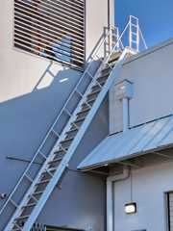
Ship Ladder with Platform and Return (75 degrees) - 522 Ship Ladder
O'Keeffe's

Standard Cage Ladder - 531 Cage Ladder
O'Keeffe's

Standard Duty Channel Rail Fixed Access Ladder - 500 Access Ladder
O'Keeffe's

Tubular Rail High Parapet Access Ladder with Platform and Return - 503 Access Ladder
O'Keeffe's

Tubular Rail Low Parapet Access Ladder with Platform Only - 503A Access Ladder
O'Keeffe's

Tubular Rail Low Parapet Access Ladder with Roofover Rail Extensions - 502 Access Ladder
O'Keeffe's

Tubular Rail Low Parapet Access Ladder with Walk Through Rail Extensions - 504 Access Ladder
O'Keeffe's

1011.2 Width and Capacity
Diagram
The required capacity of stairways shall be determined as specified in Section 1005.1, but the minimum width shall be not less than 44 inches (1118 mm). The minimum width for stairways that serve as part of the accessible means of egress shall comply with Section 1009.3.
Exceptions:
- Stairways serving an occupant load of less than 50 shall have a width of not less than 36 inches (914 mm).
- Spiral stairways as provided for in Section 1011.10.
- Where an incline platform lift or stairway chairlift is installed on stairways serving occupancies in Group R-3, or within dwelling units in occupancies in Group R-2, a clear passage width not less than 20 inches (508 mm) shall be provided. Where the seat and platform can be folded when not in use, the distance shall be measured from the folded position.
Means of egress stairs in a Group I-2 or ambulatory care facility occupancy used for the movement of beds and stretcher patients shall provide a clear width not less than 44 inches (1118 mm).
UpCodes Diagram (1)
Stairway Continuity of Required Width
1011.3 Headroom
Diagram
Stairways shall have a headroom clearance of not less than 80 inches (2032 mm) measured vertically from a line connecting the nosings. Such headroom shall be continuous above the stairway to the point where the line intersects the landing below, one tread depth beyond the bottom riser. The minimum clearance shall be maintained the full width of the stairway and landing.
Exceptions:
- Spiral stairways complying with Section 1011.10 are permitted a 78-inch (1981 mm) headroom clearance.
- In Group R-3 occupancies; within dwelling units in Group R-2 occupancies; and in Group U occupancies that are accessory to a Group R-3 occupancy or accessory to individual dwelling units in Group R-2 occupancies; where the nosings of treads at the side of a flight extend under the edge of a floor opening through which the stair passes, the floor opening shall be allowed to project horizontally into the required headroom not more than 4³/₄ inches (121 mm).
UpCodes Diagram (1)
Primary
Stairway Headroom and Vert. Rise
1011.4 Walkline
Diagram
The walkline across winder treads shall be concentric to the direction of travel through the turn and located 12 inches (305 mm) from the side where the winders are narrower. The 12-inch (305 mm) dimension shall be measured from the widest point of the clear stair width at the walking surface of the winder. Where winders are adjacent within the flight, the point of the widest clear stair width of the adjacent winders shall be used.
UpCodes Diagram (1)
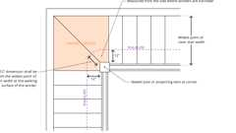Primary
Walkline at Winder Treads
1011.5 Stair Treads and Risers
Diagram
Stair treads and risers shall comply with Sections 1011.5.1 through 1011.5.5.3.
UpCodes Diagrams (8)
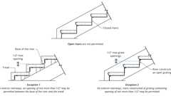
Open Stair Risers (CA)
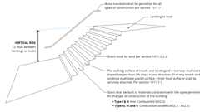
Stairs: General Requirements (CA)
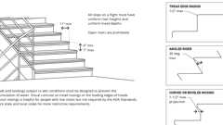
Stair Treads and Risers (ADA, et al.)
Solid Risers in Stairs: Exceptions
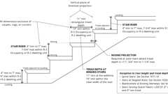
Riser Height and Tread Depth
Example: Precast Stairway Treads
Elevation Changes
Stair Nosing Size
1011.5.1 Dimension Reference Surfaces
Diagram
For the purpose of this section, all dimensions are exclusive of carpets, rugs or runners.
UpCodes Diagram (1)
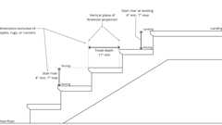Primary
Dimensions at Stairs: Reference Surfaces
1011.5.2 Riser Height and Tread Depth
Diagram
Stair riser heights shall be 7 inches (178 mm) maximum and 4 inches (102 mm) minimum. The riser height shall be measured vertically between the nosings of adjacent treads or between the stairway landing and the adjacent tread. Rectangular tread depths shall be 11 inches (279 mm) minimum measured horizontally between the vertical planes of the foremost projection of adjacent treads and at a right angle to the tread's nosing. Winder treads shall have a minimum tread depth of 11 inches (279 mm) between the vertical planes of the foremost projection of adjacent treads at the intersections with the walkline and a minimum tread depth of 10 inches (254 mm) within the clear width of the stair.
Exceptions:
- Spiral stairways in accordance with Section 1011.10.
- Stairways connecting stepped aisles to cross aisles or concourses shall be permitted to use the riser/tread dimension in Section 1030.14.2.
- In Group R-3 occupancies; within dwelling units in Group R-2 occupancies not required by Chapter 11A or Chapter 11B to be Accessible; and in Group U occupancies that are accessory to a Group R-3 occupancy or accessory to individual dwelling units in Group R-2 occupancies; the maximum riser height shall be 7³/₄ inches (197 mm); the minimum tread depth shall be 10 inches (254 mm); the minimum winder tread depth at the walkline shall be 10 inches (254 mm); and the minimum winder tread depth shall be 6 inches (152 mm). A nosing projection not less than ³/₄ inch (19.1 mm) but not more than 1¹/₄ inches (32 mm) shall be provided on stairways with solid risers where the tread depth is less than 11 inches (279 mm).
- See California Fire Code Chapter 11 and California Existing Building Code for the replacement of existing stairways. [DSA-AC] For applications listed in Section 1.9.1 regulated by the Division of the State Architect—Access Compliance, see Chapter 11B, Section 11B-202.
- In Group I-3 facilities, stairways providing access to guard towers, observation stations and control rooms, not more than 250 square feet (23 m²) in area, shall be permitted to have a maximum riser height of 8 inches (203 mm) and a minimum tread depth of 9 inches (229 mm).
- [SFM] Stairways providing access to lifeguard towers not open to the public, not more than 250 square feet (23 m²) in area, shall be permitted to have a maximum riser height of 8 inches (203 mm) and a minimum tread depth of 9 inches (229 mm).
UpCodes Diagrams (3)
Primary
Dimensions at Stairs: Reference Surfaces
Open Stair Risers (CA)
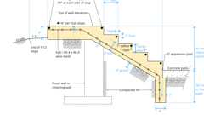
Example: Exterior Conc. Steps
1011.5.3 Winder Treads
Diagram
Winder treads are not permitted in means of egress stairways except within a dwelling unit.
Exceptions:
- Curved stairways in accordance with Section 1011.9.
- Spiral stairways in accordance with Section 1011.10.
UpCodes Diagram (1)
Walkline at Winder Treads
1011.5.4 Dimensional Uniformity
Diagram
Stair treads and risers shall be of uniform size and shape. The tolerance between the largest and smallest riser height or between the largest and smallest tread depth shall not exceed ³/₈ inch (9.5 mm) in any flight of stairs. The greatest winder tread depth at the walkline within any flight of stairs shall not exceed the smallest by more than ³/₈ inch (9.5 mm).
Exceptions:
- Stairways connecting stepped aisles to cross aisles or concourses shall be permitted to comply with the dimensional nonuniformity in Section 1030.14.2.
- Consistently shaped winders, complying with Section 1011.5, differing from rectangular treads in the same flight of stairs.
- Nonuniform riser dimension complying with Section 1011.5.4.1.
UpCodes Diagrams (2)
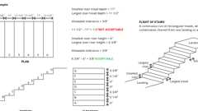Primary
Stair Dimensional Uniformity
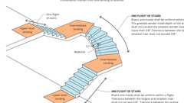
Stairway and Flight of Stairs
1011.5.4.1 Nonuniform Height Risers
Diagram
Where the bottom or top riser adjoins a sloping public way, walkway or driveway having an established grade and serving as a landing, the bottom or top riser is permitted to be reduced along the slope to less than 4 inches (102 mm) in height, with the variation in height of the bottom or top riser not to exceed one unit vertical in 12 units horizontal (8-percent slope) of stair width. The nosings at such nonuniform height risers shall have a distinctive marking stripe, different from any other nosing marking provided on the stair flight. The distinctive marking stripe shall be visible in descent of the stair. Marking stripes shall have a width of not less than 1 inch (25 mm) but not more than 2 inches (51 mm).
UpCodes Diagram (1)
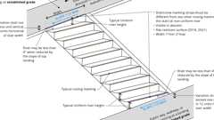Primary
Non-Uniform Height Risers
1011.5.5 Nosing and Riser Profile
Diagram
Nosings shall have a curvature or bevel of not less than ¹/₁₆ inch (1.6 mm) but not more than ⁹/₁₆ inch (14.3 mm) from the foremost projection of the tread. Risers shall be solid and vertical or sloped under the tread above from the underside of the nosing above at an angle not more than 30 degrees (0.52 rad) from the vertical.
UpCodes Diagrams (3)
Primary
Stair Nosing Size
Stair Treads and Risers (ADA, et al.)
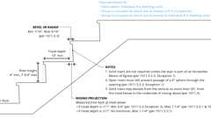
Stair Riser / Tread Depth: R-3/R-2 Exception
1011.5.5.1 Nosing Projection Size
The nosings shall project not more than 1¹/₄ inches (32 mm) beyond the tread below.
Exception: When solid risers are not required, the nosing projection is permitted to exceed the maximum projection.
1011.5.5.2 Nosing Projection Uniformity
Nosing projections shall be of uniform size, including the projections of the nosings of the floor or landing at the top of a flight.
1011.5.5.3 Solid Risers
Diagram
Risers shall be solid.
Exceptions:
- Solid risers are not required for stairways that are not required to comply with Section 1009.3, provided that the opening between treads does not permit the passage of a sphere with a diameter of 4 inches (102 mm).
- Solid risers are not required for occupancies in Group I-3 or in Group F, H and S occupancies other than areas accessible to the public. The size of the opening in the riser is not restricted.
- Solid risers are not required for spiral stairways constructed in accordance with Section 1011.10.
UpCodes Diagrams (3)
Primary
Solid Risers in Stairs: Exceptions
Stairs: General Requirements (CA)
Stair Riser / Tread Depth: R-3/R-2 Exception
1011.6 Stairway Landings
Diagram
There shall be a floor or landing at the top and bottom of each stairway. The width of landings, measured perpendicularly to the direction of travel, shall be not less than the width of stairways served. Every landing shall have a minimum depth, measured parallel to the direction of travel, equal to the width of the stairway or 48 inches (1219 mm), whichever is less. Doors opening onto a landing shall not reduce the landing to less than one-half the required width. When fully open, the door shall not project more than 7 inches (178 mm) into the required width of a landing. Where wheelchair spaces are required on the stairway landing in accordance with Section 1009.6.3, the wheelchair space shall not be located in the required width of the landing and doors shall not swing over the wheelchair spaces.
Exceptions:
- Where stairways connect stepped aisles to cross aisles or concourses, stairway landings are not required at the transition between stairways and stepped aisles constructed in accordance with Section 1030.
- Where curved stairways of constant radius have intermediate landings, the landing depth shall be measured horizontally between the intersection of the walkline of the lower flight at the landing nosing and the intersection of the walkline of the upper flight at the nosing of the lowest tread of the upper flight.
- Where a landing turns 90 degrees (1.57 rad) or more, the minimum landing depth in accordance with this section shall not be required where the landing provided is not less than that described by an arc with a radius equal to the width of the flight served.
- In Group R-3 occupancies a floor or landing is not required at the top of an interior flight of stairs, including stairs in an enclosed garage, provided a door does not swing over the stairs.
UpCodes Diagrams (3)
Primary
Stair Landings
Stairway Door Operations - Excpt. 4 & 5
Stairway Door Operations - Excpt. 1
1011.7 Stairway Construction
Diagram
Stairways shall be built of materials consistent with the types permitted for the type of construction of the building.
Exceptions:
- Wood handrails shall be permitted in all types of construction.
- Interior exit stairways in accordance with Section 510.2.
UpCodes Diagrams (2)
Primary
Example: Exterior Conc. Steps
Stairs: General Requirements (CA)
1011.7.1 Stairway Walking Surface
Diagram
The walking surface of treads and landings of a stairway shall not be sloped steeper than one unit vertical in 48 units horizontal (2-percent slope) in any direction. Stairway treads and landings shall have a solid surface. Finish floor surfaces shall be securely attached.
Exceptions:
- Openings in stair walking surfaces shall be a size that does not permit the passage of ¹/₂-inch-diameter (12.7 mm) sphere. Elongated openings shall be placed so that the long dimension is perpendicular to the direction of travel.
- In Group F, H and S occupancies, other than areas of parking structures accessible to the public, openings in treads and landings shall not be prohibited provided that a sphere with a diameter of 1¹/₈ inches (29 mm) cannot pass through the opening.
UpCodes Diagrams (2)
Primary
Stairway Walking Surface
Example: Precast Stairway Treads
1011.7.2 Outdoor Conditions
Diagram
Outdoor stairways and outdoor approaches to stairways shall be designed so that water will not accumulate on walking surfaces.
UpCodes Diagram (1)
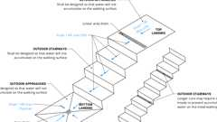Primary
Stairways: Outdoor Conditions
1011.7.3 Enclosures Under Interior Stairways
Assembly
Diagram
The walls and soffits within enclosed usable spaces under enclosed and unenclosed stairways shall be protected by 1-hour fire-resistance-rated construction or the fire-resistance rating of the stairway enclosure, whichever is greater. Access to the enclosed space shall not be directly from within the stairway enclosure.
Exception: Spaces under stairways serving and contained within a single residential dwelling unit in Group R-2 or R-3 shall be permitted to be protected on the enclosed side with ¹/₂-inch (12.7 mm) gypsum board.
UpCodes Diagrams (3)
Primary
Enclosures Under Stairways
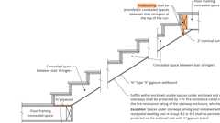
Fireblocking: Stairs
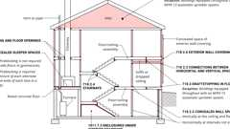
Fireblocking, Draftstopping and Enclosed Space Concepts
Assemblies (3)
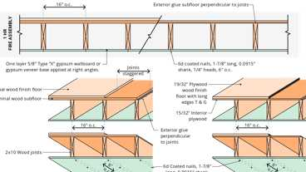
FC 5420: 1hr, Wood Joists
21-1.1: 1hr, Wood Joist
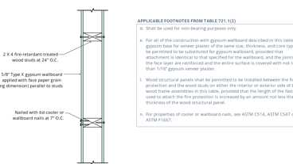
14-1.4: 1hr, Wood
Building products (7)
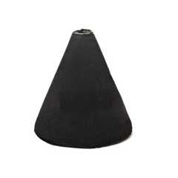
FF109-200 1 Hour Fire Rated LED Downlight Cover
Tenmat

FF109-250 1 Hour Fire Rated LED Downlight Cover
Tenmat

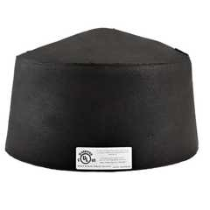
FF109-300 UL Fire Rated Recessed Light Cover
Tenmat

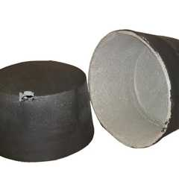
FF109-350 Fire Rated Light Cover
Tenmat

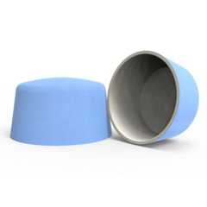
FF109-FRSC 1 Hour Fire Rated Speaker Cover
Tenmat

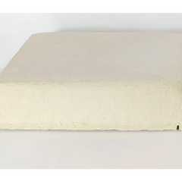
FF130 - 2x2 Fire Rated Troffer Cover
Tenmat

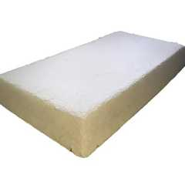
FF130 - 2x4 Fire Rated Troffer Cover
Tenmat

1011.7.4 Enclosures Under Exterior Stairways
Assembly
Diagram
There shall not be enclosed usable space under exterior exit stairways unless the space is completely enclosed in 1-hour fire-resistance-rated construction. The open space under exterior stairways shall not be used for any purpose.
UpCodes Diagrams (2)
Primary
Enclosures Under Stairways
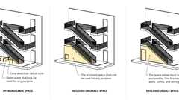Primary
Enclosures Under Exterior Stairways
Assemblies (2)
FC 5420: 1hr, Wood Joists
15-1.4: 1hr, Steel Stud
1011.8 Vertical Rise
Diagram
A flight of stairs shall not have a vertical rise greater than 12 feet (3658 mm) between floor levels or landings.
Exception: Spiral stairways used as a means of egress from technical production areas.
UpCodes Diagrams (2)
Primary
Stairway Headroom and Vert. Rise
Primary
Stairs: General Requirements (CA)
1011.9 Curved Stairways
Curved stairways with winder treads shall have treads and risers in accordance with Section 1011.5 and the smallest radius shall be not less than twice the minimum width or required capacity of the stairway.
Exception: The radius restriction shall not apply to curved stairways in Group R-3 and within individual dwelling units in Group R-2.
1011.10 Spiral Stairways
Diagram
Spiral stairways are permitted to be used as a component in the means of egress only within dwelling units or from a space not more than 250 square feet (23 m²) in area and serving not more than five occupants, or from technical production areas in accordance with Section 410.5.
A spiral stairway shall have a 6³/₄-inch (171 mm) minimum clear tread depth at a point 12 inches (305 mm) from the narrow edge. The risers shall be sufficient to provide a headroom of 78 inches (1981 mm) minimum, but riser height shall not be more than 9¹/₂ inches (241 mm). The minimum stairway clear width at and below the handrail shall be 26 inches (660 mm).
UpCodes Diagram (1)
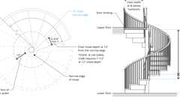Primary
Spiral Stairways for Small Occupant Loads
1011.11 Handrails
Diagram
Flights of stairways shall have handrails on each side and shall comply with Section 1014. Where glass is used to provide the handrail, the handrail shall comply with Section 2407.
[DSA-AC] For applications listed in Section 1.9.1 regulated by the Division of the State Architect—Access Compliance, see Chapter 11B, Sections 11B-504.6 and 11B-505.
Exceptions:
- Flights of stairways within dwelling units and flights of spiral stairways are permitted to have a handrail on one side only.
- Decks, patios and walkways that have a single change in elevation where the landing depth on each side of the change of elevation is greater than what is required for a landing do not require handrails.
- [SFM] In Group R-3 occupancies, a continuous run of treads or flight of stairs with less than four risers does not require handrails.
- Changes in room elevations of three or fewer risers within dwelling units and sleeping units in Groups R-2 and R-3 do not require handrails.
- Where a platform lift is in a stationary position and the floor of the platform lift serves as the upper landing of a stairway, handrails shall not be required on the stairway, provided that all of the following criteria are met:
  - 5.1. The stairway contains not more than two risers.
  - 5.2. A handhold, positioned horizontally or vertically, is located on one side of the stairway adjacent to the top landing.
  - 5.3. The handhold is located not less than 34 inches (864 mm) and not more than 42 inches (1067 mm) above the bottom landing of the stairway.
  - 5.4. The handhold gripping surface complies with Section 1014.4, and is not less than 4.5 inches (114 mm) in length.
UpCodes Diagrams (3)
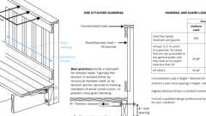
Guards: Connection Requirements
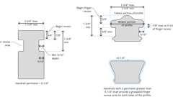
Type II Handrail Profile
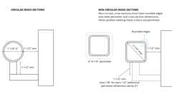
Handrails: Cross Section (Type I)
1011.12 Stairway to Roof
Diagram
In buildings four or more stories above grade plane, one stairway shall extend to the roof surface unless the roof has a slope steeper than four units vertical in 12 units horizontal (33-percent slope).
Exception: Other than where required by Section 1011.12.1, in buildings without an occupiable roof access to the roof from the top story shall be permitted to be by an alternating tread device, a ship's ladder or a permanent ladder.
UpCodes Diagrams (2)
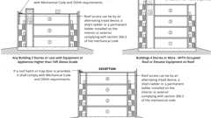Primary
Roof Access Stairs
Primary
Penthouse Stair Access to Roof
Building products (19)
Heavy Duty Tubular Rail Fixed Access Ladder - 501 Access Ladder
O'Keeffe's

High Parapet Access with Platform and Return - 533 Cage Ladder
O'Keeffe's

Low Parapet Access with Platform and No Return - 533A Cage Ladder
O'Keeffe's

Low Parapet Access with Roofover Rail Extensions - 532 Cage Ladder
O'Keeffe's

Low Parapet with Walk Through Rail Extension - 534 Cage Ladder
O'Keeffe's

Ship Ladder (60 degrees) - 520A Ship Ladder
O'Keeffe's

Ship Ladder (75 degrees) - 520 Ship Ladder
O'Keeffe's

Ship Ladder with Access to Roof Hatch (60 degrees) - 523A Ship Ladder
O'Keeffe's

Ship Ladder with Access to Roof Hatch (75 degrees) - 523 Ship Ladder
O'Keeffe's

Ship Ladder with Platform (60 degrees) - 521A Ship Ladder
O'Keeffe's

Ship Ladder with Platform (75 degrees) - 521 Ship Ladder
O'Keeffe's

Ship Ladder with Platform and Return (60 degrees) - 522A Ship Ladder
O'Keeffe's

Ship Ladder with Platform and Return (75 degrees) - 522 Ship Ladder
O'Keeffe's

Standard Cage Ladder - 531 Cage Ladder
O'Keeffe's

Standard Duty Channel Rail Fixed Access Ladder - 500 Access Ladder
O'Keeffe's

Tubular Rail High Parapet Access Ladder with Platform and Return - 503 Access Ladder
O'Keeffe's

Tubular Rail Low Parapet Access Ladder with Platform Only - 503A Access Ladder
O'Keeffe's

Tubular Rail Low Parapet Access Ladder with Roofover Rail Extensions - 502 Access Ladder
O'Keeffe's

Tubular Rail Low Parapet Access Ladder with Walk Through Rail Extensions - 504 Access Ladder
O'Keeffe's

1011.12.1 Stairway to Elevator Equipment
Diagram
Roofs and penthouses containing elevator equipment that must be accessed for maintenance are required to be accessed by a stairway.
UpCodes Diagram (1)
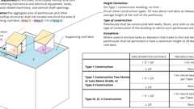
Rooftop Structures and Penthouses
1011.12.2 Roof Access
Diagram
Where a stairway is provided to a roof, access to the roof shall be provided through a penthouse complying with Section 1511.2.
Exception: In buildings without an occupiable roof, access to the roof shall be permitted to be a roof hatch or trap door not less than 16 square feet (1.5 m²) in area and having a minimum dimension of 2 feet (610 mm).
UpCodes Diagrams (2)
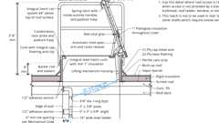Primary
Example: Roof Access Hatch for Built-Up Roof
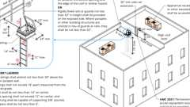
Equipment or Appliance Access on Roofs (UMC)
1011.13 Guards
Diagram
Guards shall be provided along stairways and landings where required by Section 1015 and shall be constructed in accordance with Section 1015. Where the roof hatch opening providing the required access is located within 10 feet (3049 mm) of the roof edge, such roof access or roof edge shall be protected by guards installed in accordance with Section 1015.
UpCodes Diagrams (4)
Guards: Connection Requirements
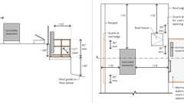
Guards: Mechanical Equip. & Roof Access
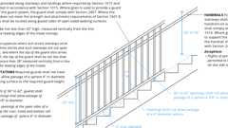
Guards: Stairs (Non-Res)
Guards At Stairs (Res)
1011.14 Alternating Tread Devices
Diagram
Alternating tread devices are limited to an element of a means of egress in buildings of Groups F, H and S from a mezzanine not more than 250 square feet (23 m²) in area and that serves not more than five occupants; in buildings of Group I-3 from a guard tower, observation station or control room not more than 250 square feet (23 m²) in area and for access to unoccupiable roofs. Alternating tread devices used as a means of egress shall not have a rise greater than 20 feet (6096 mm) between floor levels or landings.
UpCodes Diagrams (2)
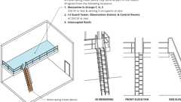Primary
Alternating Tread Devices
Guardrail Openings - Exceptions 3 & 4
1011.14.1 Handrails of Alternating Tread Devices
Handrails shall be provided on both sides of alternating tread devices and shall comply with Section 1014.
1011.14.2 Treads of Alternating Tread Devices
Alternating tread devices shall have a minimum tread depth of 5 inches (127 mm), a minimum projected tread depth of 8¹/₂ inches (216 mm), a minimum tread width of 7 inches (178 mm) and a maximum riser height of 9¹/₂ inches (241 mm). The tread depth shall be measured horizontally between the vertical planes of the foremost projections of adjacent treads. The riser height shall be measured vertically between the leading edges of adjacent treads. The riser height and tread depth provided shall result in an angle of ascent from the horizontal of between 50 and 70 degrees (0.87 and 1.22 rad). The initial tread of the device shall begin at the same elevation as the platform, landing or floor surface.
Exception: Alternating tread devices used as an element of a means of egress in buildings from a mezzanine area not more than 250 square feet (23 m²) in area that serves not more than five occupants shall have a minimum tread depth of 3 inches (76 mm) with a minimum projected tread depth of 10¹/₂ inches (267 mm). The rise to the next alternating tread surface shall not exceed 8 inches (203 mm).
1011.15 Ship's Ladders
Ship's ladders are permitted to be used in lifeguard towers not open to the public and Group I-3 as a component of a means of egress to and from control rooms or elevated facility observation stations not more than 250 square feet (23 m²) with not more than three occupants and for access to unoccupiable roofs. The minimum clear width at and below the handrails shall be 20 inches (508 mm). Ship's ladders shall be designed for the live loads indicated in Section 1607.10.
Building products (8)
Ship Ladder (60 degrees) - 520A Ship Ladder
O'Keeffe's

Ship Ladder (75 degrees) - 520 Ship Ladder
O'Keeffe's

Ship Ladder with Access to Roof Hatch (60 degrees) - 523A Ship Ladder
O'Keeffe's

Ship Ladder with Access to Roof Hatch (75 degrees) - 523 Ship Ladder
O'Keeffe's

Ship Ladder with Platform (60 degrees) - 521A Ship Ladder
O'Keeffe's

Ship Ladder with Platform (75 degrees) - 521 Ship Ladder
O'Keeffe's

Ship Ladder with Platform and Return (60 degrees) - 522A Ship Ladder
O'Keeffe's

Ship Ladder with Platform and Return (75 degrees) - 522 Ship Ladder
O'Keeffe's

1011.15.1 Handrails of Ship's Ladders
Handrails shall be provided on both sides of ship's ladders.
1011.15.2 Treads of Ship's Ladders
Ship's ladders shall have a minimum tread depth of 5 inches (127 mm). The tread shall be projected such that the total of the tread depth plus the nosing projection is not less than 8¹/₂ inches (216 mm). The maximum riser height shall be 9¹/₂ inches (241 mm).
1011.16 Ladders
Permanent ladders shall not serve as a part of the means of egress from occupied spaces within a building. Permanent ladders shall be constructed in accordance with Section 304.3 of the California Mechanical Code and designed for the live loads indicated in Section 1607.10. Permanent ladders shall be permitted to provide access to the following areas:
- Spaces frequented only by personnel for maintenance, repair or monitoring of equipment.
- Nonoccupiable spaces accessed only by catwalks, crawl spaces, freight elevators or very narrow passageways.
- Raised areas used primarily for purposes of security, life safety or fire safety including, but not limited to, observation galleries, prison guard towers, fire towers or lifeguard stands.
- Elevated levels in Group U not open to the general public.
- Nonoccupiable roofs that are not required to have stairway access in accordance with Section 1011.12.1.
- Where permitted to access equipment and appliances in accordance with Section 304.3 of the California Mechanical Code.
Building products (11)
Heavy Duty Tubular Rail Fixed Access Ladder - 501 Access Ladder
O'Keeffe's

High Parapet Access with Platform and Return - 533 Cage Ladder
O'Keeffe's

Low Parapet Access with Platform and No Return - 533A Cage Ladder
O'Keeffe's

Low Parapet Access with Roofover Rail Extensions - 532 Cage Ladder
O'Keeffe's

Low Parapet with Walk Through Rail Extension - 534 Cage Ladder
O'Keeffe's

Standard Cage Ladder - 531 Cage Ladder
O'Keeffe's

Standard Duty Channel Rail Fixed Access Ladder - 500 Access Ladder
O'Keeffe's

Tubular Rail High Parapet Access Ladder with Platform and Return - 503 Access Ladder
O'Keeffe's

Tubular Rail Low Parapet Access Ladder with Platform Only - 503A Access Ladder
O'Keeffe's

Tubular Rail Low Parapet Access Ladder with Roofover Rail Extensions - 502 Access Ladder
O'Keeffe's

Tubular Rail Low Parapet Access Ladder with Walk Through Rail Extensions - 504 Access Ladder
O'Keeffe's

Section 1012 Ramps
Diagram
[DSA-AC] In addition to the requirements of this section, means of egress, which provide access to, or egress from, buildings or facilities where accessibility is required for applications listed in Section 1.9.1 regulated by the Division of the State Architect—Access Compliance, shall also comply with Chapter 11A or Chapter 11B, Section 11B-405, as applicable.
UpCodes Diagram (1)
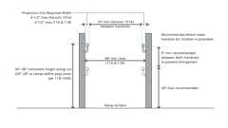
Ramp Handrail Height and Clearance (CA)
1012.1 Scope
Diagram
The provisions of this section shall apply to ramps used as a component of a means of egress.
Exceptions:
- Ramped aisles within assembly rooms or spaces shall comply with the provisions in Section 1030.
- Curb ramps shall comply with Chapter 11A or 11B, 11B-406, as applicable.
- Vehicle ramps in parking garages for pedestrian exit access shall not be required to comply with Sections 1012.3 through 1012.10 where they are not an accessible route serving accessible parking spaces, other required accessible elements or part of an accessible means of egress.
UpCodes Diagram (1)
Parking Garage Exiting: Vehicular Ramps
1012.2 Slope
Diagram
Ramps used as part of a means of egress shall have a running slope not steeper than 1 unit vertical in 12 units horizontal (8.3-percent slope). The slope of other pedestrian ramps shall not be steeper than 1 unit vertical in 8 units horizontal (12.5-percent slope).
UpCodes Diagram (1)
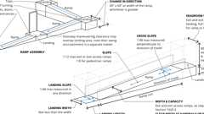
Ramp Slopes and Min. Dimensions
1012.3 Cross Slope
Diagram
The slope measured perpendicular to the direction of travel of a ramp shall not be steeper than one unit vertical in 48 units horizontal (2-percent slope).
UpCodes Diagram (1)
Ramp Slopes and Min. Dimensions
1012.4 Vertical Rise
Diagram
The rise for any ramp run shall be 30 inches (762 mm) maximum.
UpCodes Diagram (1)
Ramp Slopes and Min. Dimensions
1012.5 Minimum Dimensions
Diagram
The minimum dimensions of means of egress ramps shall comply with Sections 1012.5.1 through 1012.5.3.
UpCodes Diagram (1)
Ramp Slopes and Min. Dimensions
1012.5.1 Width and Capacity
The minimum width and required capacity of a means of egress ramp shall be not less than that required for corridors by Section 1020.3. The clear width of a ramp between handrails, if provided, or other permissible projections shall be 36 inches (914 mm) minimum.
1012.5.2 Headroom
The minimum headroom in all parts of the means of egress ramp shall be not less than 80 inches (2032 mm) above the finished floor of the ramp run and any intermediate landings. The minimum clearance shall be maintained for the full width of the ramp and landing.
1012.5.3 Restrictions
Means of egress ramps shall not reduce in width in the direction of egress travel. Projections into the required ramp and landing width are prohibited. Doors opening onto a landing shall not reduce the clear width to less than 42 inches (1067 mm).
1012.6 Landings
Diagram
Ramps shall have landings at the bottom and top of each ramp, points of turning, entrance, exits and at doors. Landings shall comply with Sections 1012.6.1 through 1012.6.5.
UpCodes Diagrams (2)
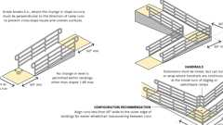
Ramp Landings (ADA)
Ramp Slopes and Min. Dimensions
1012.6.1 Slope
Landings shall have a slope not steeper than one unit vertical in 48 units horizontal (2-percent slope) in any direction. Changes in level are not permitted.
1012.6.2 Width
The landing width shall be not less than the width of the widest ramp run adjoining the landing.
1012.6.3 Length
The landing length shall be 60 inches (1525 mm) minimum.
Exceptions:
- In Group R-2 and R-3 individual dwelling and sleeping units that are not required to be accessible in accordance with Chapter 11A, landings are permitted to be 36 inches (914 mm) minimum.
- Where the ramp is not a part of an accessible route, the length of the landing shall not be required to be more than 48 inches (1219 mm) in the direction of travel.
1012.6.4 Change in Direction
Where changes in direction of travel occur at landings provided between ramp runs, the landing shall be 60 inches by 60 inches (1524 mm by 1524 mm) minimum.
Exception: In Group R-2 and R-3 individual dwelling and sleeping units that are not required to be accessible in accordance with Chapter 11A, landings are permitted to be 36 inches (914 mm) minimum.
1012.6.5 Doorways
Where doorways are located adjacent to a ramp landing, maneuvering clearances required for accessibility are permitted to overlap the required landing area as specified in Chapter 11A or 11B, as applicable.
1012.7 Ramp Construction
Diagram
Ramps shall be built of materials consistent with the types permitted for the type of construction of the building, except that wood handrails shall be permitted for all types of construction.
UpCodes Diagram (1)
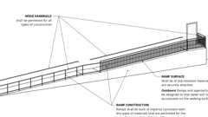Primary
Ramp Construction
1012.7.1 Ramp Surface
Diagram
The surface of ramps shall be of slip-resistant materials that are securely attached.
UpCodes Diagram (1)
Slip-Resistant Surfaces
Building products (4)
Back Up Pavers 4 x 2¼ x 7⅝
Interstate Brick

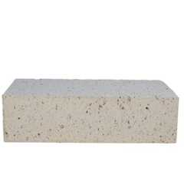
Modular Paver 4 x 2¼ x 7⅝
Interstate Brick

Modular Solid 4 x 2¼ x 8
Interstate Brick

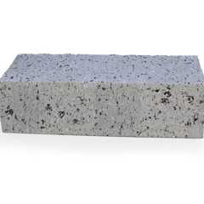
True Paver 4 x 2¼ x 8
Interstate Brick

1012.7.2 Outdoor Conditions
Outdoor ramps and outdoor approaches to ramps shall be designed so that water will not accumulate on walking surfaces.
1012.8 Handrails
Diagram
Ramps with a rise greater than 6 inches (152 mm) shall have handrails on both sides. Handrails shall comply with Section 1014.
UpCodes Diagrams (2)
Ramp Handrail Height and Clearance (CA)
Ramp Landings (ADA)
1012.9 Guards
Diagram
Guards shall be provided where required by Section 1015 and shall be constructed in accordance with Section 1015.
UpCodes Diagram (1)
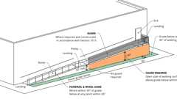Primary
Guards at Ramps
1012.10 Edge Protection
Edge protection complying with Section 1012.10.1 or 1012.10.2 shall be provided on each side of ramp runs and at each side of ramp landings.
Exceptions:
- Edge protection is not required on ramps that are not required to have handrails, provided they have flared sides that comply with Chapter 11A or 11B.
- Edge protection is not required on the sides of ramp landings serving an adjoining ramp run or stairway.
- Edge protection is not required on the sides of ramp landings having a vertical dropoff of not more than ¹/₂ inch (12.7 mm) within 10 inches (254 mm) horizontally of the required landing area.
1012.10.1 Curb, Rail, Wall or Barrier
A curb, rail, wall or barrier shall be provided to serve as edge protection. A curb shall be not less than 4 inches (102 mm) in height. Barriers shall be constructed so that the barrier prevents the passage of a 4-inch-diameter (102 mm) sphere, where any portion of the sphere is within 4 inches (102 mm) of the floor or ground surface.
1012.10.2 Extended Floor or Ground Surface
The floor or ground surface of the ramp run or landing shall extend 12 inches (305 mm) minimum beyond the inside face of a handrail complying with Section 1014.
Section 1013 Exit Signs
Diagram
UpCodes Diagrams (3)
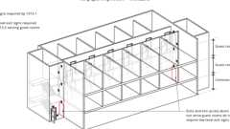
Exit Signs in R-1 Occupancies
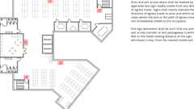
Exit Signs: Where Required
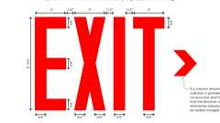
Exit Signs: Size Requirements
1013.1 Where Required
Diagram
Exits and exit access doors shall be marked by an approved exit sign readily visible from any direction of egress travel. The path of egress travel to exits and within exits shall be marked by readily visible exit signs to clearly indicate the direction of egress travel in cases where the exit or the path of egress travel is not immediately visible to the occupants. Intervening means of egress doors within exits shall be marked by exit signs. Exit sign placement shall be such that any point in an exit access corridor or exit passageway is within 100 feet (30 480 mm) or the listed viewing distance of the sign, whichever is less, from the nearest visible exit sign.
Exceptions:
- Exit signs are not required in rooms or areas that require only one exit or exit access.
- Main exterior exit doors or gates that are obviously and clearly identifiable as exits need not have exit signs where approved by the building official.
- Exit signs are not required in occupancies in Group U and individual sleeping units or dwelling units in Group R-1, R-2 or R-3 or R-3.1.
- Exit signs are not required where inmates are housed or held in dayrooms, sleeping rooms or dormitories in occupancies in Group I-3.
- In occupancies in Groups A-4 and A-5, exit signs are not required on the seating side of vomitories or openings into seating areas where exit signs are provided in the concourse that are readily apparent from the vomitories. Egress lighting is provided to identify each vomitory or opening within the seating area in an emergency.
UpCodes Diagrams (5)
Primary
Exit Signs: Where Required
Primary
Exit Signs in R-1 Occupancies
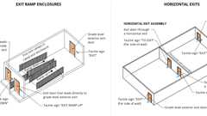
Exit Door Signs: Ramps / Horiz. Exits
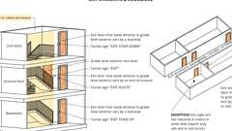
Exit Door Signs at Stairways and Corridors
Exit Signs: Size Requirements
1013.2 Low-Level Exit Signs in Group R-1
Diagram
See Section 1013.7.
UpCodes Diagrams (2)
Primary
Exit Signs in R-1 Occupancies
Exit Signs: Size Requirements
1013.3 Illumination
Exit signs shall be internally or externally illuminated.
Exception: Tactile signs required by Section 1013.4 need not be provided with illumination.
1013.4 Raised Character and Braille Exit Signs
[HCD 1-AC] Tactile exit signs shall be required at the following locations:
- Each grade-level exterior exit door that is required to comply with Section 1013.1, shall be identified by a tactile exit sign with the word, "EXIT".
- Each exit door that is required to comply with Section 1013.1, and that leads directly to a grade-level exterior exit by means of a stairway or ramp shall be identified by a tactile exit sign with the following words as appropriate:
  - 2.1. "EXIT STAIR DOWN"
  - 2.2. "EXIT RAMP DOWN"
  - 2.3. "EXIT STAIR UP"
  - 2.4. "EXIT RAMP UP"
- Each exit door that is required to comply with Section 1013.1, and that leads directly to a grade-level exterior exit by means of an exit enclosure or an exit passageway shall be identified by a tactile exit sign with the words, "EXIT ROUTE."
- Each exit access door from an interior room or area to a corridor or hallway that is required to comply with Section 1013.1, shall be identified by a tactile exit sign with the words "EXIT ROUTE."
- Each exit door through a horizontal exit that is required to comply with Section 1013.1, shall be identified by a sign with the words, "TO EXIT."
Raised character and Braille exit signs shall comply with Chapter 11A, Section 1143A or Chapter 11B, Sections 11B-703.1, 11B-703.2, 11B-703.3 and 11B-703.5.
1013.5 Internally Illuminated Exit Signs
Electrically powered, self-luminous and photoluminescent exit signs shall be listed and labeled in accordance with UL 924 and shall be installed in accordance with the manufacturer's instructions and Chapter 27. Exit signs shall be illuminated at all times.
1013.5.1 Photoluminescent Exit Signs
Photoluminescent exit signs shall be provided with an illumination source to charge the exit sign in accordance with the manufacturer's instructions.
1013.6 Externally Illuminated Exit Signs
Externally illuminated exit signs shall comply with Sections 1013.6.1 through 1013.6.3.
1013.6.1 Graphics
Diagram
Every exit sign and directional exit sign shall have plainly legible letters not less than 6 inches (152 mm) high with the principal strokes of the letters not less than ³/₄ inch (19.1 mm) wide. The word "EXIT" shall have letters having a width not less than 2 inches (51 mm) wide, except the letter "I," and the minimum spacing between letters shall be not less than ³/₈ inch (9.5 mm). Signs larger than the minimum established in this section shall have letter widths, strokes and spacing in proportion to their height.
The word "EXIT" shall be in high contrast with the background and shall be clearly discernible when the means of exit sign illumination is or is not energized. If a chevron directional indicator is provided as part of the exit sign, the construction shall be such that the direction of the chevron directional indicator cannot be readily changed.
UpCodes Diagram (1)
Primary
Exit Signs: Size Requirements
1013.6.2 Exit Sign Illumination
Diagram
The face of an exit sign illuminated from an external source shall have an intensity of not less than 5 footcandles (54 lux).
UpCodes Diagrams (3)
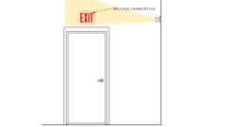
Exist. Bldgs: Exit Sign
Lumens and Footcandles
Lumens and Footcandles - Calculations
1013.6.3 Power Source
Exit signs shall be illuminated at all times. To ensure continued illumination for a duration of not less than 90 minutes in case of primary power loss, the sign illumination means shall be connected to an emergency power system provided from storage batteries, unit equipment or an on-site generator. The installation of the emergency power system shall be in accordance with Chapter 27. Group I-2, Condition 2 exit sign illumination shall not be provided by unit equipment batteries only.
Exception: Approved exit sign illumination types that provide continuous illumination independent of external power sources for a duration of not less than 90 minutes, in case of primary power loss, are not required to be connected to an emergency electrical system.
1013.7 Floor-Level Exit Signs
Diagram
Where exit signs are required by Chapter 10, additional approved low-level exit signs which are internally or externally illuminated photoluminescent or self-luminous, shall be provided in all interior corridors of Group A, E, I and R-2.1 occupancies and in all areas serving guest rooms of hotels in Group R, Division 1 occupancies.
Exceptions:
- Group A occupancies that are protected throughout by an approved supervised fire sprinkler system.
- Group E Occupancies where direct exits have been provided from each classroom.
- Group I and R-2.1 occupancies which are provided with smoke barriers constructed in accordance with Section 407.5.
- Group I-3 occupancies.
The bottom of the sign shall not be less than 6 inches (152 mm) or more than 8 inches (203 mm) above the floor level and shall indicate the path of exit travel. For exit and exit-access doors, the sign shall be on the door or adjacent to the door with the closest edge of the sign or marker within 4 inches (102 mm) of the door frame.
Note: Pursuant to Health and Safety Code Section 13143, this California amendment applies to all newly constructed buildings or structures subject to this section for which a building permit is issued (or construction commenced, where no building permit is issued) on or after January 1, 1989.
UpCodes Diagram (1)
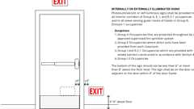Primary
Low-Level Exit Signs (CA)
1013.8 Path Marking
When exit signs are required by Chapter 10, in addition to approved floor-level exit signs, approved path marking shall be installed at floor level or no higher than 8 inches (203 mm) above the floor level in all interior rated exit corridors of unsprinklered Group A, R-1 and R-2 occupancies.
Such marking shall be continuous except as interrupted by door-ways, corridors or other such architectural features in order to provide a visible delineation along the path of travel.
Note: Pursuant to Health and Safety Code Section 13143, the California amendments of this section shall apply to all newly constructed buildings or structures subject to this section for which a building permit is issued (or construction commenced, where no building permit is issued) on or after January 1, 1989.
Section 1014 Handrails
Diagram
[DSA-AC] In addition to the requirements of this section, means of egress, which provide access to, or egress from, buildings or facilities where accessibility is required for applications listed in Section 1.9.1 regulated by the Division of the State Architect—Access Compliance, shall also comply with Chapter 11A or Chapter 11B, Section 11B-505, as applicable.
UpCodes Diagram (1)
Ramp Handrail Height and Clearance (CA)
1014.1 Where Required
Handrails serving flights of stairways, ramps, stepped aisles and ramped aisles shall be adequate in strength and attachment in accordance with Section 1607.9. Handrails required for flights of stairways by Section 1011.11 shall comply with Sections 1014.2 through 1014.10. Handrails required for ramps by Section 1012.8 shall comply with Sections 1014.2 through 1014.9. Handrails for stepped aisles and ramped aisles required by Section 1030.16 shall comply with Sections 1014.2 through 1014.9.
1014.2 Height
Handrail height, measured from a line connecting the nosings of flights of stairs or finish surface of ramp slope, shall be uniform, not less than 34 inches (864 mm) and not more than 38 inches (965 mm). Handrail height of alternating tread devices and ship's ladders, measured from a line connecting the nosings, shall be uniform, not less than 30 inches (762 mm) and not more than 34 inches (864 mm).
Exceptions:
- Where handrail fittings or bendings are used to provide continuous transition between flights, the fittings or bendings shall be permitted to exceed the maximum height.
- In Group R-3 occupancies; within dwelling units in Group R-2 occupancies; and in Group U occupancies that are associated with a Group R-3 occupancy or associated with individual dwelling units in Group R-2 occupancies; where handrail fittings or bendings are used to provide continuous transition between flights, transition at winder treads, transition from handrail to guard, or where used at the start of a flight, the handrail height at the fittings or bendings shall be permitted to exceed the maximum height.
- Handrails on top of a guard where permitted along stepped aisles and ramped aisles in accordance with Section 1030.16.
Building products (8)
Ship Ladder (60 degrees) - 520A Ship Ladder
O'Keeffe's

Ship Ladder (75 degrees) - 520 Ship Ladder
O'Keeffe's

Ship Ladder with Access to Roof Hatch (60 degrees) - 523A Ship Ladder
O'Keeffe's

Ship Ladder with Access to Roof Hatch (75 degrees) - 523 Ship Ladder
O'Keeffe's

Ship Ladder with Platform (60 degrees) - 521A Ship Ladder
O'Keeffe's

Ship Ladder with Platform (75 degrees) - 521 Ship Ladder
O'Keeffe's

Ship Ladder with Platform and Return (60 degrees) - 522A Ship Ladder
O'Keeffe's

Ship Ladder with Platform and Return (75 degrees) - 522 Ship Ladder
O'Keeffe's

1014.3 Lateral Location
Handrails located outward from the edge of the walking surface of flights of stairways, ramps, stepped aisles and ramped aisles shall be located 6 inches (152.4 mm) or less measured horizontally from the edge of the walking surface. Handrails projecting into the width of the walking surface shall comply with Section 1014.9.
1014.4 Handrail Graspability
Required handrails shall comply with Section 1014.4.1 or shall provide equivalent graspability.
Exception: In Group R-3 occupancies; within dwelling units in Group R-2 occupancies; and in Group U occupancies that are accessory to a Group R-3 occupancy or accessory to individual dwelling units in Group R-2 occupancies; handrails shall be Type I in accordance with Section 1014.4.1, Type II in accordance with Section 1014.4.2 or shall provide equivalent graspability.
1014.4.1 Type I
Diagram
Handrails with a circular cross section shall have an outside diameter of not less than 1¹/₄ inches (32 mm) and not greater than 2 inches (51 mm). Where the handrail is not circular, it shall have a perimeter dimension of not less than 4 inches (102 mm) and not greater than 6¹/₄ inches (160 mm) with a maximum cross-sectional dimension of 2¹/₄ inches (57 mm) and minimum cross-sectional dimension of 1 inch (25 mm). Edges shall have a minimum radius of 0.01 inch (0.25 mm).
UpCodes Diagram (1)
Primary
Handrails: Cross Section (Type I)
1014.4.2 Type II
Diagram
Handrails with a perimeter greater than 6¹/₄ inches (160 mm) shall provide a graspable finger recess area on both sides of the profile. The finger recess shall begin within a distance of ³/₄ inch (19 mm) measured vertically from the tallest portion of the profile and achieve a depth of not less than ⁵/₁₆ inch (8 mm) within ⁷/₈ inch (22 mm) below the widest portion of the profile. This required depth shall continue for not less than ³/₈ inch (10 mm) to a level that is not less than 1³/₄ inches (45 mm) below the tallest portion of the profile. The width of the handrail above the recess shall be not less than 1¹/₄ inches (32 mm) to not greater than 2³/₄ inches (70 mm). Edges shall have a minimum radius of 0.01 inch (0.25 mm).
UpCodes Diagram (1)
Primary
Type II Handrail Profile
1014.5 Continuity
Diagram
Handrail gripping surfaces shall be continuous, without interruption by newel posts or other obstructions.
Exceptions:
- Within a dwelling unit that is not an Accessible unit, the continuity of handrail gripping surfaces is allowed to be interrupted by a newel post at a turn or landing.
- Within a dwelling unit, the use of a volute, turnout, starting easing or starting newel is allowed over the lowest tread.
- Handrail brackets or balusters attached to the bottom surface of the handrail that do not project horizontally beyond the sides of the handrail within 1¹/₂ inches (38 mm) of the bottom of the handrail shall not be considered obstructions. For each ¹/₂ inch (12.7 mm) of additional handrail perimeter dimension above 4 inches (102 mm), the vertical clearance dimension of 1¹/₂ inches (38 mm) shall be permitted to be reduced by ¹/₈ inch (3.2 mm).
- Where handrails are provided along walking surfaces with slopes not steeper than 1:20, the bottoms of the handrail gripping surfaces shall be permitted to be obstructed along their entire length where they are integral to crash rails or bumper guards.
- Handrails serving stepped aisles or ramped aisles are permitted to be discontinuous in accordance with Section 1030.16.1.
UpCodes Diagrams (3)
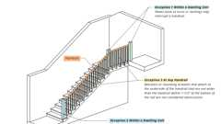Primary
Handrail Continuity - Excpt. 1-3
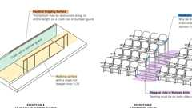Primary
Handrail Continuity - Excpt. 4 & 5
Primary
Handrail Continuity and Extensions (CA)
1014.6 Fittings
Handrails shall not rotate within their fittings.
1014.7 Handrail Extensions
Diagram
Handrails shall return to a wall, guard or the walking surface or shall be continuous to the handrail of an adjacent flight of stairs or ramp run. Where handrails are not continuous between flights, the handrails shall extend horizontally not less than 12 inches (305 mm) beyond the top landing nosing and continue to slope for the depth of one tread beyond the bottom tread nosing. At ramps where handrails are not continuous between runs, the handrails shall extend horizontally above the landing 12 inches (305 mm) minimum beyond the top and bottom of ramp runs. The extensions of handrails shall be in the same direction of the flights of stairs at stairways and the ramp runs at ramps and shall extend the required minimum length before any change in direction or decrease in the clearance required by Section 1014.5 or 1014.8.
Exceptions:
- Handrails within a dwelling unit that is not required to be accessible need extend only from the top riser to the bottom riser.
- Handrails serving aisles in rooms or spaces used for assembly purposes are permitted to comply with the handrail extensions in accordance with Section 1030.16.
- Handrails for alternating tread devices and ships ladders are permitted to terminate at a location vertically above the top and bottom risers. Handrails for alternating tread devices are not required to be continuous between flights or to extend beyond the top or bottom risers.
UpCodes Diagrams (2)
Stairway and Flight of Stairs
Handrail Continuity and Extensions (CA)
1014.8 Clearance
Diagram
Clear space between a handrail and a wall or other surface shall be not less than 1¹/₂ inches (38 mm). A handrail and a wall or other surface adjacent to the handrail shall be free of any sharp or abrasive elements.
Exceptions:
- A decrease in the clearance due to the curvature or angle of handrail returns shall be allowed.
- Mounting flanges not more than ¹/₂-inch (12.7 mm) in thickness at the returned ends of handrails shall be allowed.
UpCodes Diagrams (2)
Primary
Handrails: Cross Section (Type I)
Type II Handrail Profile
1014.9 Projections
Diagram
On ramps and on ramped aisles that are part of an accessible route, the clear width between handrails shall be 36 inches (914 mm) minimum. Projections into the required width of aisles, stairways and ramps at each side shall not exceed 4¹/₂ inches (114 mm) at or below the handrail height. Projections into the required width shall not be limited above the minimum headroom height required in Section 1011.3. Projections due to intermediate handrails shall not constitute a reduction in the egress width. Where a pair of intermediate handrails are provided within the stairway width without a walking surface between the pair of intermediate handrails and the distance between the pair of intermediate handrails is greater than 6 inches (152 mm), the available egress width shall be reduced by the distance between the closest edges of each such intermediate pair of handrails that is greater than 6 inches (152 mm).
In Group I-2 occupancy ramps required for exit access shall not be less than 8 ft in width and handrails are permitted to protrude 3¹/₂ inches from the wall on both sides. Ramps used as exits and stairways used for the movement of bed and litter patients, the clear width between handrails shall be 44 inches (1118 mm) minimum.
[HCD 1-AC] In addition, projections shall comply with Chapter 11A, when applicable.
UpCodes Diagrams (3)
Primary
Ramp Handrail Height and Clearance (CA)
Corridors: Unobstructed Width
Stairs Horizontal Encroachments
1014.10 Intermediate Handrails
Diagram
Stairways shall have intermediate handrails located in such a manner that all portions of the stairway minimum width or required capacity are within 30 inches (762 mm) of a handrail. On monumental stairs, handrails shall be located along the most direct path of egress travel.
UpCodes Diagram (1)
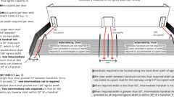Primary
Intermediate Handrails
Section 1015 Guards
Diagram
UpCodes Diagrams (4)
Guards: Connection Requirements
Guards at Ramps
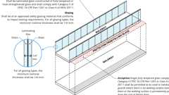
Glass in Guards and Handrails
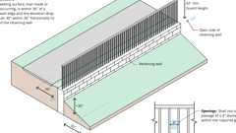
Guards at Retaining Walls
1015.1 General
Guards shall comply with the provisions of Sections 1015.2 through 1015.7. Operable windows with sills located more than 72 inches (1829 mm) above finished grade or other surface below shall comply with Section 1015.8.
1015.2 Where Required
Diagram
Guards shall be located along open-sided walking surfaces, such as mezzanines, equipment platforms, aisles, stairs, ramps and landings, that are located more than 30 inches (762 mm) measured vertically to the floor or grade below at any point within 36 inches (914 mm) horizontally to the edge of the open side and at the perimeter of occupiable roofs. Guards shall be adequate in strength and attachment in accordance with Section 1607.9.
Exceptions: Guards are not required for the following locations:
- On the loading side of loading docks or piers.
- On the audience side of stages and raised platforms, including stairs leading up to the stage and raised platforms.
- On raised stage and platform floor areas, such as runways, ramps and side stages used for entertainment or presentations.
- At vertical openings in the performance area of stages and platforms.
- At elevated walking surfaces appurtenant to stages and platforms for access to and utilization of special lighting or equipment.
- Along vehicle service pits not accessible to the public.
- In assembly seating areas at cross aisles in accordance with Section 1030.17.2.
- On the loading side of station platforms on fixed guideway transit or passenger rail systems.
- Portions of an occupiable roof located less than 30 inches (762 mm) measured vertically to adjacent unoccupiable roof areas where approved guards are present at the perimeter of the roof.
- At portions of an occupiable roof where an approved barrier is provided.
- Elevated facility observation station access hatches at detention facilities.
UpCodes Diagrams (2)
Guardrail Openings - Exceptions 3 & 4
Guardrail Opening Limitations (Ex. 5)
1015.2.1 Glazing
Where glass is used to provide a guard or as a portion of the guard system, the guard shall comply with Section 2407. Where the glazing provided does not meet the strength and attachment requirements of Section 1607.9, complying guards shall be located along glazed sides of open-sided walking surfaces.
1015.3 Height
Diagram
Required guards shall be not less than 42 inches (1067 mm) high, measured vertically as follows:
- From the adjacent walking surfaces.
- On stairways and stepped aisles, from the line connecting the nosings.
- On ramps and ramped aisles, from the ramp surface at the guard.
Exceptions:
- For occupancies in Group R-3, and within individual dwelling units in occupancies in Group R-2, guards on the open sides of stairs shall have a height not less than 34 inches (864 mm) measured vertically from a line connecting the nosings.
- For occupancies in Group R-3, and within individual dwelling units in occupancies in Group R-2, where the top of the guard serves as a handrail on the open sides of stairs, the top of the guard shall be not less than 34 inches (864 mm) and not more than 38 inches (965 mm) measured vertically from a line connecting the nosings.
- The guard height in assembly seating areas shall comply with Section 1030.17 as applicable.
- Along alternating tread devices and ships ladders, guards where the top rail serves as a handrail shall have height not less than 30 inches (762 mm) and not more than 34 inches (864 mm), measured vertically from a line connecting the leading edge of the treads.
- In Group F occupancies where exit access stairways serve fewer than three stories and such stairways are not open to the public, and where the top of the guard also serves as a handrail, the top of the guard shall be not less than 34 inches (864 mm) and not more than 38 inches (965 mm) measured vertically from a line connecting the nosings.
UpCodes Diagrams (2)
Guards: Connection Requirements
Guards at Retaining Walls
1015.4 Opening Limitations
Diagram
Required guards shall not have openings that allow passage of a sphere 4 inches (102 mm) in diameter from the walking surface to the required guard height.
Exceptions:
- From a height of 36 inches (914 mm) to 42 inches (1067 mm), guards shall not have openings that allow passage of a sphere 4³/₈ inches (111 mm) in diameter.
- The triangular openings at the open sides of a stair, formed by the riser, tread and bottom rail shall not allow passage of a sphere 6 inches (152 mm) in diameter.
- At elevated walking surfaces for access to and use of electrical, mechanical or plumbing systems or equipment, guards shall not have openings that allow passage of a sphere 21 inches (533 mm) in diameter.
- In areas that are not open to the public within occupancies in Group I-3, F, H or S, and for alternating tread devices and ships ladders, guards shall not have openings that allow passage of a sphere 21 inches (533 mm) in diameter.
- In assembly seating areas, guards required at the end of aisles in accordance with Section 1030.17.4 shall not have openings that allow passage of a sphere 4 inches (102 mm) in diameter up to a height of 26 inches (660 mm). From a height of 26 inches (660 mm) to 42 inches (1067 mm) above the adjacent walking surfaces, guards shall not have openings that allow passage of a sphere 8 inches (203 mm) in diameter.
- Within individual dwelling units and sleeping units in Group R-2 and R-3 occupancies, guards on the open sides of stairs shall not have openings that allow passage of a sphere 4³/₈ (111 mm) inches in diameter.
- In lifeguard towers not open to the public, guards shall not have openings which allow passage of a sphere 21 inches (533 mm) in diameter.
UpCodes Diagrams (4)
Primary
Guardrail Opening Limitations (Ex. 5)
Primary
Guardrail Openings - Exceptions 3 & 4
Guards: Connection Requirements
Guards at Retaining Walls
1015.5 Screen Porches
Porches and decks that are enclosed with insect screening shall be provided with guards where the walking surface is located more than 30 inches (762 mm) above the floor or grade below.
1015.6 Mechanical Equipment, Systems and Devices
Diagram
Guards shall be provided where various components that require service are located within 10 feet (3048 mm) of a roof edge or open side of a walking surface and such edge or open side is located more than 30 inches (762 mm) above the floor, roof or grade below. The guard shall extend not less than 30 inches (762 mm) beyond each end of such components. The guard shall be constructed so as to prevent the passage of a sphere 21 inches (533 mm) in diameter.
Exception: Guards are not required where personal fall arrest anchorage connector devices that comply with ANSI/ASSE Z 359.1 are installed.
UpCodes Diagram (1)
Primary
Guards: Mechanical Equip. & Roof Access
1015.7 Roof Access
Diagram
Guards shall be provided where the roof hatch opening is located within 10 feet (3048 mm) of a roof edge or open side of a walking surface and such edge or open side is located more than 30 inches (762 mm) above the floor, roof or grade below. The guard shall extend not less than 30 inches (762 mm) beyond each end of the hatch parallel to the roof edge. The guard shall be constructed so as to prevent the passage of a sphere 21 inches (533 mm) in diameter.
Exception: Guards are not required where personal fall arrest anchorage connector devices that comply with ANSI/ASSE Z 359.1 are installed.
UpCodes Diagrams (2)
Primary
Guards: Mechanical Equip. & Roof Access
Example: Roof Access Hatch for Built-Up Roof
1015.8 Window Openings
Diagram
Windows in Group R-1, R-2 and R-3 buildings including dwelling units, where the bottom of the clear opening of an operable window is located less than 36 inches (914 mm) above the finished floor and more than 72 inches (1829 mm) above the finished grade or other surface below on the exterior of the building, shall comply with one of the following:
- Where the bottom of the clear opening of the window is located more than 72 inches (1829 mm) and less than 75 feet (22 860 mm) above the finished grade or other surface below on the exterior of the building, the window shall comply with one of the following:
  - 1.1. Operable windows where the openings will not allow a 4-inch-diameter (102 mm) sphere to pass through the opening when the window is in its largest opened position, provided that the opening is not required for emergency escape or rescue.
  - 1.2. Operable windows where the openings are provided with window fall prevention devices that comply with ASTM F2090.
  - 1.3. Operable windows where the openings are provided with window opening control devices that comply with ASTM F2090. The window opening control device, after operation to release the control device allowing the window to fully open, shall not reduce the minimum net clear opening area of the window unit to less than the area required by Section 1031.3.1 for emergency escape and rescue openings.
- Where the bottom of the clear opening of the window is located 75 feet (22,860 mm) or more above the finished grade or other surface below on the exterior of the building, the window shall comply with one of the following:
  - 2.1. Operable windows where the openings are provided with window fall prevention devices that comply with ASTM F2090.
  - 2.2. Operable windows where the openings will not allow a 4-inch-diameter (102 mm) sphere to pass through the opening when the window is in its largest opened position.
  - 2.3. Window fall prevention devices that comply with ASTM F2006.
UpCodes Diagram (1)
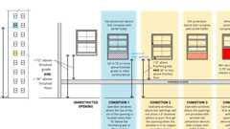Primary
Window Fall Protection
Section 1016 Exit Access
Diagram
UpCodes Diagrams (6)
Separation of Exit and Exit Access Doors
Remoteness of Exit Access
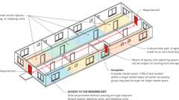
Egress: Multiple Tenants
Means of Egress: Basic Components
Exit Access, Exit and Exit Discharge
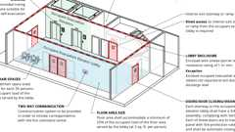
Occupant Evacuation Elevator Lobbies
1016.1 General
The exit access shall comply with the applicable provisions of Sections 1003 through 1015. Exit access arrangement shall comply with Sections 1016 through 1021.
1016.2 Egress Through Intervening Spaces
Diagram
Egress through intervening spaces shall comply with this section.
- Exit access through an enclosed elevator lobby is permitted in other than a Group I-2. Where access to two or more exits or exit access doorways is required in Section 1006.2.1, access to not less than one of the required exits shall be provided without travel through the enclosed elevator lobbies required by Section 3006. Where the path of exit access travel passes through an enclosed elevator lobby, the level of protection required for the enclosed elevator lobby is not required to be extended to the exit unless direct access to an exit is required by other sections of this code.
- In other than Group H occupancies, egress from a room or space is allowed to pass through adjoining or intervening rooms or areas provided that such adjoining rooms or areas and the area served are accessory to one or the other and provide a discernible path of egress travel to an exit.
- In Group H occupancies, egress from a room or space is allowed to pass through adjoining or intervening rooms or areas provided that such adjoining rooms or areas are the same or lesser hazard occupancy group and provide a discernible path of egress travel to an exit.
- An exit access shall not pass through a room that can be locked to prevent egress.
Exception: An electrically locked exit access door providing egress from an elevator lobby shall be permitted in accordance with Section 1010.2.14.
- Means of egress from dwelling units or sleeping areas shall not lead through other sleeping areas, toilet rooms or bathrooms.
- Egress shall not pass through kitchens, storage rooms, closets or spaces used for similar purposes.
Exceptions:
  - Means of egress are not prohibited through a kitchen area serving adjoining rooms constituting part of the same dwelling unit or sleeping unit.
  - Means of egress are not prohibited through stockrooms in Group M occupancies where all of the following are met:
    - 2.1. The stock is of the same hazard classification as that found in the main retail area.
    - 2.2. Not more than 50 percent of the exit access is through the stockroom.
    - 2.3. The stockroom is not subject to locking from the egress side.
    - 2.4. There is a demarcated, minimum 44-inch-wide (1118 mm) aisle defined by full- or partial-height fixed walls or similar construction that will maintain the required width and lead directly from the retail area to the exit without obstructions.
- The means of egress shall not pass through any room subject to locking except in Group I-3 occupancies classified as detention facilities and psychiatric treatment areas in Group I-2 occupancies.
UpCodes Diagrams (4)
Primary
Egress Through Intervening Spaces: #5 Excpt.
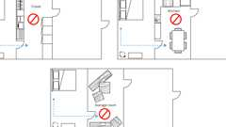Primary
Egress Through Intervening Spaces: #5
Primary
Exit Access & Corridor Continuity (Nonsprinklered, 0-75 ft) - 2024
Cumulative Occ. Loads: Intervening Spaces/Accessory Areas
1016.2.1 Multiple Tenants
Diagram
Where more than one tenant occupies any one floor of a building or structure, each tenant space, dwelling unit and sleeping unit shall be provided with access to the required exits without passing through adjacent tenant spaces, dwelling units and sleeping units.
Exception: The means of egress from a smaller tenant space shall not be prohibited from passing through a larger adjoining tenant space where such rooms or spaces of the smaller tenant occupy less than 10 percent of the area of the larger tenant space through which they pass; are the same or similar occupancy group; a discernible path of egress travel to an exit is provided; and the means of egress into the adjoining space is not subject to locking from the egress side. A required means of egress serving the larger tenant space shall not pass through the smaller tenant space or spaces.
UpCodes Diagram (1)
Primary
Egress: Multiple Tenants
1016.2.2 Basement Exits in Group I-2 Occupancies
For additional requirements for occupancies in Group I-2, see Section 407.
Section 1017 Exit Access Travel Distance
Diagram
UpCodes Diagrams (2)
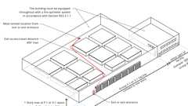
Travel Distance Increase: Group F-1 and S-1
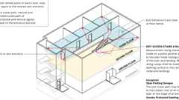
Travel Distance Measurement
1017.1 General
Diagram
Travel distance within the exit access portion of the means of egress system shall be in accordance with this section.
UpCodes Diagram (1)
Travel Distance to Area of Refuge
1017.2 Limitations
Exit access travel distance shall not exceed the values given in Table 1017.2.
TABLE 1017.2—EXIT ACCESS TRAVEL DISTANCEª
OCCUPANCY | WITHOUT AUTOMATIC SPRINKLER SYSTEM (feet) | WITH AUTOMATIC SPRINKLER SYSTEM  (feet)
A, E, F-1, M, R, S-1 | 200e | 250^{b}
R-2.1 | Not Permitted | 250^{b}
B | 200 | 300^{c}
F-2, S-2, U | 300 | 400^{c}
H-1 | Not Permitted | 75^{d}
H-2 | Not Permitted | 100^{d}
H-3 | Not Permitted | 150^{d}
H-4 | Not Permitted | 175^{d}
H-5 | Not Permitted | 200^{c}
I-2, I-3^{f} | Not Permitted | 200^{c}
I-4 | 150 | 200^{c}
L | Not Permitted | 200^{c}
For SI: 1 foot = 304.8 mm.
- See the following sections for modifications to exit access travel distance requirements:
  - Section 402.8: For the distance limitation in malls.
  - Section 407.4: For the distance limitation in Group I-2.
  - Section 408.3.10: For increased limitation in Group I-3.
  - Sections 408.6.1 and 408.8.1: For the distance limitations in Group I-3.
  - Section 411.2: For the distance limitation in special amusement areas.
  - Section 412.6: For the distance limitations in aircraft manufacturing facilities.
  - Section 422.3.4: For the distance limitation in ambulatory care facilities.
  - Section 1006.2.2.2: For the distance limitation in refrigeration machinery rooms.
  - Section 1006.2.2.3: For the distance limitation in refrigerated rooms and spaces.
  - Section 1006.3.4: For buildings with one exit.
  - Section 1017.2.2: For increased distance limitation in Group.
  - Section 1017.2.3: For increased distance limitation in Groups F-1 and S-1.
  - Section 1030.7: For increased limitation in assembly seating.
  - Section 3103.4: For temporary structures.
  - Section 3104.9: For pedestrian walkways.
- Buildings equipped throughout with an automatic sprinkler system in accordance with Section 903.3.1.1 or 903.3.1.2. See Section 903 for occupancies where automatic sprinkler systems are permitted in accordance with Section 903.3.1.2.
- Buildings equipped throughout with an automatic sprinkler system in accordance with Section 903.3.1.1.
- Group H occupancies equipped throughout with an automatic sprinkler system in accordance with Section 903.2.5.1.
- Group R-3 and R-4 buildings equipped throughout with an automatic sprinkler system in accordance with Section 903.3.1.3. See Section 903.2.8 for occupancies where automatic sprinkler systems are permitted in accordance with Section 903.3.1.3.
- Not permitted in nonsprinklered Group I-3 occupancies.
1017.2.1 Exterior Egress Balcony Increase
Diagram
Exit access travel distances specified in Table 1017.2 shall be increased up to an additional 100 feet (30 480 mm) provided that the last portion of the exit access leading to the exit occurs on an exterior egress balcony constructed in accordance with Section 1021. The length of such balcony shall be not less than the amount of the increase taken.
UpCodes Diagram (1)
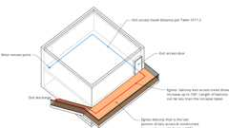Primary
Egress Balcony: Travel Distance
1017.2.2 Groups F-1 and S-1 Increase
Diagram
The maximum exit access travel distance shall be 400 feet (122 m) in Group F-1 or S-1 occupancies where all of the following conditions are met:
- The portion of the building classified as Group F-1 or S-1 is limited to one story in height.
- The minimum height from the finished floor to the bottom of the ceiling or roof slab or deck is 24 feet (7315 mm).
- The building is equipped throughout with an automatic sprinkler system in accordance with Section 903.3.1.1.
UpCodes Diagram (1)
Primary
Travel Distance Increase: Group F-1 and S-1
1017.2.3 Group H-5 Increase
The maximum exit access travel distance shall be 300 feet (91 m) in the fabrication areas of Group H-5 occupancies where all of the following conditions are met:
- The width of the fabrication area is 300 feet (91 m) or greater.
- The area of the fabrication area is 220,000 square feet (18 600 m²) or greater.
- The height of the fabrication area, measured between the raised metal floor and the clean filter ceiling, is 16 feet (48 768 mm) or greater.
- The supply ventilation rate is 20 cubic feet per minute per square foot (0.556 m³/min/m²) or greater and shall remain operational.
1017.3 Measurement
Diagram
Exit access travel distance shall be measured from the most remote point of each room, area or space along the natural and unobstructed path of horizontal and vertical egress travel to the entrance to an exit. Where more than one exit is required, exit access travel distance shall be measured to the nearest exit.
Exceptions:
- In open parking garages, exit access travel distance is permitted to be measured to the closest riser of an exit access stairway or the closest slope of an exit access ramp.
- In smoke protected seating and open air assembly seating, exit access travel distance shall be measured in accordance with Section 1030.7.
UpCodes Diagrams (2)
Primary
Travel Distance Measurement
Common Path of Egress Travel
1017.3.1 Exit Access Stairways and Ramps
Diagram
Travel distance on exit access stairways or ramps shall be included in the exit access travel distance measurement. The measurement along stairways shall be made on a plane parallel and tangent to the stair tread nosings in the center of the stair and landings. The measurement along ramps shall be made on the walking surface in the center of the ramp and landings.
UpCodes Diagrams (2)
Primary
Travel Distance Measurement
Exit Access Stair: Balconies (Ex. 8)
1017.3.2 Atriums
Diagram
Exit access travel distance for areas open to an atrium shall comply with the requirements of Sections 1017.3.2.1 through 1017.3.2.3.
UpCodes Diagrams (2)
Exit Stairways in Atriums
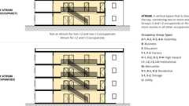
Atrium
1017.3.2.1 Egress Not Through the Atrium
Where required access to the exits is not through the atrium, exit access travel distance shall comply with Section 1017.2.
1017.3.2.2 Exit Access Travel Distance at the Level of Exit Discharge
Where the path of egress travel is through an atrium space, exit access travel distance at the level of exit discharge shall be determined in accordance with Section 1017.2.
1017.3.2.3 Exit Access Travel Distance at Other Than the Level of Exit Discharge
Where the path of egress travel is not at the level of exit discharge from the atrium, that portion of the total permitted exit access travel distance that occurs within the atrium shall be not greater than 200 feet (60 960 mm).
Section 1018 Aisles
[DSA-AC] In addition to the requirements of this section, means of egress, which provide access to, or egress from, buildings or facilities where accessibility is required for applications listed in Section 1.9.1 regulated by the Division of the State Architect—Access Compliance, shall also comply with Chapter 11A or Chapter 11B, Section 11B-403, as applicable.
1018.1 General
Diagram
Aisles and aisle accessways serving as a portion of the exit access in the means of egress system shall comply with the requirements of this section. Aisles or aisle accessways shall be provided from all occupied portions of the exit access that contain seats, tables, furnishings, displays and similar fixtures or equipment. The minimum width or required capacity of aisles shall be unobstructed.
Exception: Encroachments complying with Section 1005.7.
UpCodes Diagram (1)
Primary
Aisles with Tables and Fixtures
1018.2 Aisles in Assembly Spaces
Diagram
Aisles and aisle accessways serving a room or space used for assembly purposes shall comply with Section 1030.
UpCodes Diagrams (3)
Min. Assembly Aisle Widths
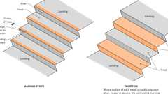
Assembly Egress: Tread Contrasting Marking Stripe
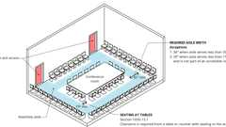
Aisles at Tables or Seats: Assembly Occ.
1018.3 Aisles in Groups B and M
Diagram
In Group B and M occupancies, the minimum clear aisle width shall be determined by Section 1005.1 for the occupant load served, but shall be not less than that required for corridors by Section 1020.3.
Exception: Nonpublic aisles serving less than 50 people and not required to be accessible by Chapter 11B, (see Section 11B-403) need not exceed 28 inches (711 mm) in width.
UpCodes Diagram (1)
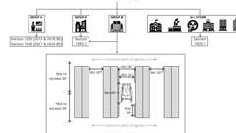
Aisle Req. by Occ. Group
1018.4 Aisle Accessways in Group M
Diagram
An aisle accessway shall be provided on not less than one side of each element within the merchandise pad. The minimum clear width for an aisle accessway not required to be accessible shall be 30 inches (762 mm). The required clear width of the aisle accessway shall be measured perpendicular to the elements and merchandise within the merchandise pad. The 30-inch (762 mm) minimum clear width shall be maintained to provide a path to an adjacent aisle or aisle accessway. The common path of egress travel shall not exceed 30 feet (9144 mm) from any point in the merchandise pad.
Exception: For areas serving not more than 50 occupants, the common path of egress travel shall not exceed 75 feet (22 860 mm).
UpCodes Diagrams (2)
Common Path of Egress Travel
Aisle Req. by Occ. Group
1018.5 Aisles in Other Than Assembly Spaces and Groups B and M
Diagram
In other than rooms or spaces used for assembly purposes and Group B and M occupancies, the minimum clear aisle capacity shall be determined by Section 1005.1 for the occupant load served, but the width shall be not less than that required for corridors by Section 1020.3.
Exception: Nonpublic aisles serving less than 50 people and not required to be accessible by Chapter 11B, (see Section 11B-403) need not exceed 28 inches (711 mm) in width.
UpCodes Diagram (1)
Aisle Req. by Occ. Group
Section 1019 Exit Access Stairways and Ramps
Diagram
UpCodes Diagrams (6)
Exit Access Stairs: Accessible Means of Egress
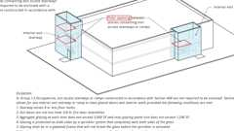
Exit Access Stairway Enclosures: I-2 and I-3
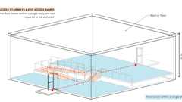
Exit Access Stairways at Same Story
Exit Stairways in Atriums
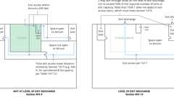
Atriums: Exiting, Pt. 1
Access. Means of Egress: Stairways
1019.1 General
Exit access stairways and ramps serving as an exit access component in a means of egress system shall comply with the requirements of this section. The number of stories connected by exit access stairways and ramps shall include basements, but not mezzanines.
1019.2 All Occupancies
Diagram
Exit access stairways and ramps that serve floor levels within a single story are not required to be enclosed.
UpCodes Diagram (1)
Primary
Exit Access Stairways at Same Story
1019.3 Occupancies Other Than Groups I-2 and I-3 and R-2.1
Diagram
In other than Group I-2, I-3 and R-2.1 occupancies, floor openings containing exit access stairways or ramps shall be enclosed with a shaft enclosure constructed in accordance with Section 713.
Exceptions:
- Exit access stairways and ramps within a two-story opening complying with Section 712.1.9.
- In Group R-1, R-2, R-2.1, R-3 or R-3.1 occupancies, exit access stairways and ramps connecting four stories or less serving and contained within an individual dwelling unit or sleeping unit or live/work unit.
- Exit access stairways serving and contained within a Group R-3 congregate residence or a Group R-4 facility are not required to be enclosed.
- Exit access stairways and ramps in buildings equipped throughout with an automatic sprinkler system in accordance with Section 903.3.1.1, where the area of the vertical opening between stories does not exceed twice the horizontal projected area of the stairway or ramp and the opening is protected by a draft curtain and closely spaced sprinklers in accordance with NFPA 13. In other than Group B and M occupancies, this provision is limited to openings that do not connect more than four stories.
- Exit access stairways and ramps within an atrium complying with the provisions of Section 404.
- Exit access stairways and ramps in open parking garages that serve only the parking garage.
- Exit access stairways and ramps serving smoke-protected or open-air assembly seating complying with the exit access travel distance requirements of Section 1030.7.
- Exit access stairways and ramps between the balcony, gallery or press box and the main assembly floor in occupancies such as theaters, places of religious worship, auditoriums and sports facilities.
- Exterior exit access stairways or ramps between occupiable roofs.
- Fixed-guideway transit stations, constructed in accordance with Section 443.
UpCodes Diagrams (9)
Primary
Exit Access Stair: Enclosure (Ex. 2)
Primary
Exit Access Stair: Enclosure (Ex. 3)
Primary
Exit Access Stair: Enclosure (Ex. 4)
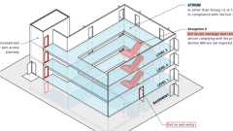Primary
Exit Access Stair: Enclosure (Ex. 5)
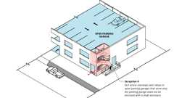Primary
Exit Access Stair: Enclosure (Ex. 6)
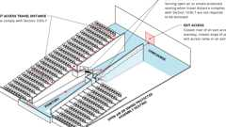Primary
Exit Access Stair: Enclosure (Ex. 7)
Primary
Exit Access Stair: Balconies (Ex. 8)
Primary
Exit Access Stair: Occupied Roofs (Ex. 9)
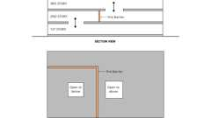
Two Story Openings
1019.4 Group I-2, I-3 and R-2.1 Occupancies
Diagram
In Group I-2, I-3 and R-2.1 occupancies, floor openings between stories containing exit access stairways or ramps are required to be enclosed with a shaft enclosure constructed in accordance with Section 713.
Exception: In Group I-3 occupancies, exit access stairways or ramps constructed in accordance with Section 408 are not required to be enclosed.
UpCodes Diagram (1)
Primary
Exit Access Stairway Enclosures: I-2 and I-3
Section 1020 Corridors
Diagram
UpCodes Diagrams (12)
Corridor Widths in Hospitals
Corridors: Air Movement Above Corridor
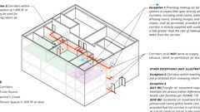
Corridors: Air Movement within Corridors
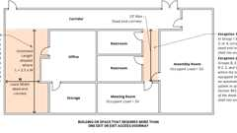
Dead End Corridor Measurement
Exit Separation Distance with Rated Corridors - Excpt. 1
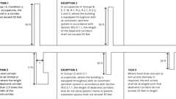
Dead End Corridor: CA 2022/2025
Means of Egress Continuity: Obstructions
Egress Balcony: Wall Separation
Corridors: Unobstructed Width
Exit Separation at Scissor Stairs
Show 2 more
1020.1 General
Diagram
Corridors serving as an exit access component in a means of egress system shall comply with the requirements of Sections 1020.2 through 1020.7.
UpCodes Diagram (1)
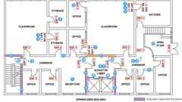
Exit Access & Corridor Continuity (Sprinklered, 75-120 ft) - 2024
1020.2 Construction
Assembly
Diagram
Corridors shall be fire-resistance rated in accordance with Table 1020.2. The corridor walls required to be fire-resistance rated shall comply with Section 708 for fire partitions.
Exceptions:
- A fire-resistance rating is not required for corridors in an occupancy in Group E where each room that is used for instruction has not less than one door opening directly to the exterior and rooms for assembly purposes have not less than one-half of the required means of egress doors opening directly to the exterior. Exterior doors specified in this exception are required to be at ground level.
- A fire-resistance rating is not required for corridors contained within a dwelling unit or sleeping unit in an occupancy in Group R.
- A fire-resistance rating is not required for corridors in open parking garages.
- A fire-resistance rating is not required for corridors in an occupancy in Group B that is a space requiring only a single means of egress complying with Section 1006.2.
- Corridors adjacent to the exterior walls of buildings shall be permitted to have unprotected openings on unrated exterior walls where unrated walls are permitted by Table 705.5 and unprotected openings are permitted by Table 705.9.
- A fire-resistance rating is not required for corridors within suites in a Group I-2 constructed in accordance with Section 407.4.4 or 407.4.5.
- A fire-resistance rating is not required for corridors within Group I-3 occupancies that comply with intervening spaces, see Section 408.1.2.2.
TABLE 1020.2—CORRIDOR FIRE-RESISTANCE RATING
OCCUPANCY | OCCUPANT LOAD SERVED  BY CORRIDOR | REQUIRED FIRE-RESISTANCE RATING (hours)
OCCUPANCY | OCCUPANT LOAD SERVED  BY CORRIDOR | Without automatic sprinkler system | With automatic sprinkler system
H-1, H-2, H-3 | All | Not Permitted | 1^{c}
H-4, H-5, L | Greater than 30 | Not Permitted | 1^{c}
A^{e}, B, E, F, M, S, U | Greater than 30 | 1 | 0
R-1, R-2, R-2.2, R-3^{d}, R-3.1, R-4^{d} | Greater than 10 | Not Permitted | 1
I-2ª | Greater than 6 | Not Permitted | 1
I-3, R-2.1 | Greater than 6 | Not Permitted | 1^{b, c}
I-4 | All | 1 | 1
- For requirements for occupancies in Group I-2, see Sections 407.2 and 407.3.
- For a reduction in the fire-resistance rating for occupancies in Group I-3, see Section 408.8.
- Buildings equipped throughout with an automatic sprinkler system in accordance with Section 903.3.1.1 or 903.3.1.2 where allowed.
- Group R-3 and R-4 buildings equipped throughout with an automatic sprinkler system in accordance with Section 903.3.1.3. See Section 903.2.8 for occupancies where automatic sprinkler systems are permitted in accordance with Section 903.3.1.3.
- [SFM] See Section 1029.
UpCodes Diagrams (10)
Primary
Fire Partitions: Corridor Walls
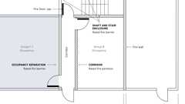
Fire Rated Wall Assemblies
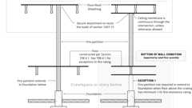
Fire Partition Continuity
Fire Partition Continuity: Corridors (Ex. 2.1)
Fire Partition Continuity: Corridors (Ex. 2.2)
Egress Balcony: Wall Separation
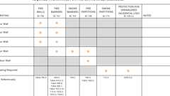
Required Fire Ratings for Protective Wall Assemblies
Means of Egress: Multiple Occupancies
Exit Access & Corridor Continuity (Nonsprinklered, 0-75 ft) - 2024
Egress Balcony: Travel Distance
Assemblies (4)
WP 1051: 1hr, 50-54 STC, Steel Stud
14-1.1: 1hr, Wood Joist
14-1.4: 1hr, Wood
13-1.1: 1hr Steel Studs
Building products (3)
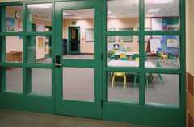
SuperLite® I
SaftiFirst

SuperLite® I-XL
SaftiFirst

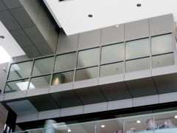
SuperLite® I-XL IGU
SaftiFirst

1020.2.1 Hoistway Protection
Elevator hoistway doors in elevators hoistway enclosures required to be fire-resistance rated shall be protected in accordance with Section 716. Elevator hoistway doors shall also be protected in accordance with Section 3006.2.
1020.3 Width and Capacity
Diagram
The required capacity of corridors shall be determined as specified in Section 1005.1, but the minimum width shall be not less than that specified in Table 1020.3.
Exception: In Group I-2 occupancies, corridors are not required to have a clear width of 96 inches (2438 mm) in areas where there will not be stretcher or bed movement for access to care or as part of the defend-in-place strategy.
TABLE 1020.3—MINIMUM CORRIDOR WIDTH
OCCUPANCY | MINIMUM WIDTH  (inches)
Any facility not listed in this table | 44
Access to and utilization of mechanical, plumbing or electrical systems or equipment | 24
With an occupant load of less than 50 | 36
Within a dwelling unit | 36
In Group E with a corridor having an occupant load of 100 or more | 72
In corridors and areas serving stretcher traffic in ambulatory care facilities | 72
Group I-2 and I-3 in areas where required for bed movement | 96
Corridors in Group I-2 and I-3 occupancies serving any area caring for one or more nonambulatory persons.ª | 72
For SI: 1 inch = 25.4 mm.
- See Section 1224.4.7.1 for Group I-2.
UpCodes Diagrams (4)
Primary
Corridor Widths in Hospitals
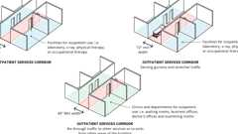
Outpatient Corridor Widths (CA)
Corridors: Unobstructed Width
Corridor Width Example
1020.4 Obstruction
Diagram
The minimum width or required capacity of corridors shall be unobstructed.
Exception: Encroachments complying with Section 1005.7.
UpCodes Diagrams (3)
Primary
Corridors: Unobstructed Width
Projections in Nursing Home Corridors
Means of Egress Continuity: Obstructions
1020.5 Dead Ends
Diagram
Where more than one exit or exit access doorway is required, the exit access shall be arranged such that dead-end corridors do not exceed 20 feet (6096 mm) in length.
Exceptions:
- In Group I-3, Condition 2, 3 or 4, occupancies, the dead end in a corridor shall not exceed 50 feet (15 240 mm).
- In occupancies in Groups B, E, F, M, R-1, R-2, R-2.1, R-2.2, S and U, where the building is equipped throughout with an automatic sprinkler system in accordance with Section 903.3.1.1, the length of the dead-end corridors shall not exceed 50 feet (15 240 mm).
- A dead-end corridor shall not be limited in length where the length of the dead-end corridor is less than 2.5 times the least width of the dead-end corridor.
- In Group I-2 occupancies, where the building is equipped throughout with an automatic sprinkler system in accordance with Section 903.3.1.1, the length of dead-end corridors that do not serve patient rooms or patient treatment spaces shall not exceed 30 feet (9144 mm).
UpCodes Diagrams (3)
Primary
Dead End Corridor: CA 2022/2025
Primary
Dead End Corridor Measurement
Example: Single Exit Condition
1020.6 Air Movement in Corridors
Diagram
Corridors shall not serve as supply, return, exhaust, relief or ventilation air ducts.
Exceptions:
- Use of a corridor as a source of makeup air for exhaust systems in rooms that open directly onto such corridors, including toilet rooms, bathrooms, dressing rooms, smoking lounges and janitor closets, shall be permitted, provided that each such corridor is directly supplied with outdoor air at a rate greater than the rate of makeup air taken from the corridor.
- Where located within a dwelling unit, the use of corridors for conveying return air shall not be prohibited.
- Where located within tenant spaces of 1,000 square feet (93 m²) or less in area, utilization of corridors for conveying return air is permitted.
- Transfer air movement required to maintain the pressurization difference within health care facilities and Group L occupancies in accordance with ASHRAE 170.
- For health care facilities under the jurisdiction of the Office of Statewide Hospital Planning and Development (OSHPD), see the California Mechanical Code.
UpCodes Diagrams (2)
Primary
Corridors: Air Movement within Corridors
Corridors: Air Movement Above Corridor
1020.6.1 Corridor Ceiling
Diagram
Use of the space between the corridor ceiling and the floor or roof structure above as a return air plenum is permitted for one or more of the following conditions:
- The corridor is not required to be of fire-resistance-rated construction.
- The corridor is separated from the plenum by fire-resistance-rated construction.
- The air-handling system serving the corridor is shut down upon activation of the air-handling unit smoke detectors required by the California Mechanical Code.
- The air-handling system serving the corridor is shut down upon detection of sprinkler water flow where the building is equipped throughout with an automatic sprinkler system.
- The space between the corridor ceiling and the floor or roof structure above the corridor is used as a component of an approved engineered smoke control system.
UpCodes Diagrams (4)
Primary
Corridors: Air Movement within Corridors
Primary
Corridors: Air Movement Above Corridor
Plenum (definition)
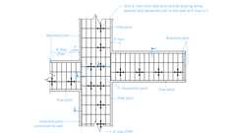
Example: Suspended Ceiling Slip Joint Plan: Corridors
1020.7 Corridor Continuity
Diagram
Fire-resistance-rated corridors shall be continuous from the point of entry to an exit, and shall not be interrupted by intervening rooms. Where the path of egress travel within a fire-resistance-rated corridor to the exit includes travel along unenclosed exit access stairways or ramps, the fire-resistance rating shall be continuous for the length of the stairway or ramp and for the length of the connecting corridor on the adjacent floor leading to the exit.
Exceptions:
- Foyers, lobbies or reception rooms constructed as required for corridors shall not be construed as intervening rooms.
- Enclosed elevator lobbies as permitted by Item 1 of Section 1016.2 shall not be construed as intervening rooms.
- [SFM] In fully sprinklered office buildings, corridors may lead through enclosed elevator lobbies if all areas of the building have access to at least one required exit without passing through the elevator lobby.
UpCodes Diagrams (5)
Primary
Exit Access & Corridor Continuity (Nonsprinklered, 0-75 ft) - 2024
Primary
Exit Access & Corridor Continuity (Sprinklered, 75-120 ft) - 2018
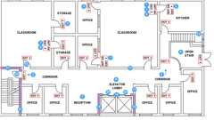Primary
Exit Access & Corridor Continuity (Sprinklered, 0-75 ft) - 2018
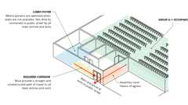
Foyers and Lobbies (Group A-1) Pt 2
Foyers and Lobbies (Group A-1) Pt 1
Section 1021 Egress Balconies
Diagram
UpCodes Diagrams (8)
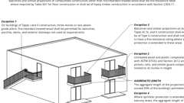
Balcony Construction Requirements
Egress Balconies: Location
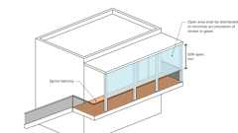
Egress Balconies: Openness
Egress Balcony: Wall Separation
Egress Balcony: Travel Distance
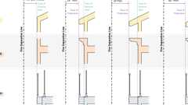
Exterior Wall Projections
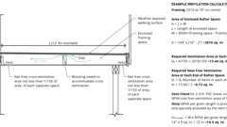
Balcony Ventilation
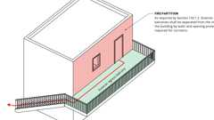
Fire Partitions: Egress Balcony Wall Separation
1021.1 General
Balconies used for egress purposes shall conform to the same requirements as corridors for minimum width, required capacity, headroom, dead ends and projections.
1021.2 Wall Separation
Diagram
Exterior egress balconies shall be separated from the interior of the building by walls and opening protectives as required for corridors.
Exception: Separation is not required where the exterior egress balcony is served by not less than two stairways and a dead-end travel condition does not require travel past an unprotected opening to reach a stairway.
UpCodes Diagrams (2)
Primary
Egress Balcony: Wall Separation
Fire Partitions: Egress Balcony Wall Separation
1021.3 Openness
Diagram
The long side of an egress balcony shall be not less than 50 percent open, and the open area above the guards shall be so distributed as to minimize the accumulation of smoke or toxic gases.
UpCodes Diagram (1)
Primary
Egress Balconies: Openness
1021.4 Location
Diagram
Exterior egress balconies shall have a minimum fire separation distance of 10 feet (3048 mm) measured at right angles from the exterior edge of the egress balcony to the following:
- Adjacent lot lines.
- Other portions of the building.
- Other buildings on the same lot unless the adjacent building exterior walls and openings are protected in accordance with Section 705 based on fire separation distance.
For the purposes of this section, other portions of the building shall be treated as separate buildings.
UpCodes Diagram (1)
Primary
Egress Balconies: Location
Section 1022 Exits
Diagram
UpCodes Diagrams (3)
Exterior Egress Door Arrangement
Means of Egress: Basic Components
Exit Access, Exit and Exit Discharge
1022.1 General
Exits shall comply with Sections 1022 through 1027 and the applicable requirements of Sections 1003 through 1015. An exit shall not be used for any purpose that interferes with its function as a means of egress. Once a given level of exit protection is achieved, such level of protection shall not be reduced until arrival at the exit discharge. Exits shall be continuous from the point of entry into the exit to the exit discharge.
1022.2 Exterior Exit Doors
Diagram
Buildings or structures used for human occupancy shall have not less than one exterior door that meets the requirements of Section 1010.1.1.
UpCodes Diagram (1)
Ext. Doors and the Public Way
1022.2.1 Detailed Requirements
Exterior exit doors shall comply with the applicable requirements of Section 1010.1.
1022.2.2 Arrangement
Diagram
Exterior exit doors shall lead directly to the exit discharge or the public way.
UpCodes Diagram (1)
Primary
Exterior Egress Door Arrangement
1022.3 Basement Exits in Group I-2 Occupancies
For additional requirements for occupancies in Group I-2, see Section 407.4.1.2.
Section 1023 Interior Exit Stairways and Ramps
Diagram
UpCodes Diagrams (10)
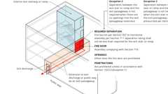
Interior Exit Stair w/ Exit Passageway: Construction
Interior Exit Stairways: Openings
Area of Refuge Access to Stairway or Elevator
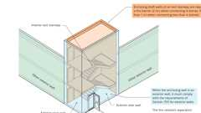
Stair Enclosures at Exterior Walls
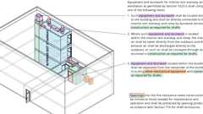
Interior Exit Stairways: Ventilation
High Rise: Additional Stairway
Access. Means of Egress: Stairways
Exit Access, Exit and Exit Discharge
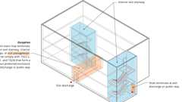
Interior Exit Stairway Termination
Roof Assemblies at Interior Exit Stairs (2024)
1023.1 General
Interior exit stairways and ramps serving as an exit component in a means of egress system shall comply with the requirements of this section. Interior exit stairways and ramps shall be enclosed and lead directly to the exterior of the building or shall be extended to the exterior of the building with an exit passageway conforming to the requirements of Section 1024, except as permitted in Section 1028.2. An interior exit stairway or ramp shall not be used for any purpose other than as a means of egress and a circulation path.
1023.2 Construction
Assembly
Diagram
Enclosures for interior exit stairways and ramps shall be constructed as fire barriers in accordance with Section 707 or horizontal assemblies constructed in accordance with Section 711, or both. Interior exit stairway and ramp enclosures shall have a fire-resistance rating of not less than 2 hours where connecting four stories or more and not less than 1 hour where connecting less than four stories. The number of stories connected by the interior exit stairways or ramps shall include any basements, but not any mezzanines. Enclosures for interior exit stairways and ramps shall have a fire-resistance rating not less than the floor assembly penetrated, but need not exceed 2 hours.
Exceptions:
- Interior exit stairways and ramps in Group I-3 occupancies in accordance with the provisions of Section 408.3.8 of the California Building Code.
- Interior exit stairways within an atrium enclosed in accordance with Section 404.6 of the California Building Code.
- Interior exit stairways in accordance with Section 510.2.
- Fixed guideway transit stations, constructed in accordance with Section 443.
UpCodes Diagrams (5)
Fire Rated Wall Assemblies
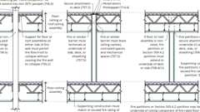
Fire & Smoke: Walls vs. Barriers vs. Partitions
Separation of Exit and Exit Access Doors
Exit Access & Corridor Continuity (Nonsprinklered, 0-75 ft) - 2024
Required Fire Ratings for Protective Wall Assemblies
Assemblies (6)
WP 1015: 1hr, 55-59 STC, Steel Stud
WP 1021: 1hr, 50-54 STC, Steel Stud
WP 1051: 1hr, 50-54 STC, Steel Stud
14-1.1: 1hr, Wood Joist
21-1.1: 1hr, Wood Joist
13-1.1: 1hr Steel Studs
1023.3 Termination
Diagram
Interior exit stairways and ramps shall terminate at an exit discharge or a public way.
Exception: A combination of interior exit stairways, interior exit ramps and exit passageways, constructed in accordance with Sections 1023.2, 1023.3.1 and 1024, respectively, and forming a continuous protected enclosure, shall be permitted to extend an interior exit stairway or ramp to the exit discharge or a public way.
UpCodes Diagram (1)
Primary
Interior Exit Stairway Termination
1023.3.1 Extension
Assembly
Diagram
Where interior exit stairways and ramps are extended to an exit discharge or a public way by an exit passageway, the interior exit stairway and ramp shall be separated from the exit passageway by a fire barrier constructed in accordance with Section 707 or a horizontal assembly constructed in accordance with Section 711, or both. The fire-resistance rating shall be not less than that required for the interior exit stairway and ramp. A fire door assembly complying with Section 716 shall be installed in the fire barrier to provide a means of egress from the interior exit stairway and ramp to the exit passageway. Openings in the fire barrier other than the fire door assembly are prohibited. Penetrations of the fire barrier are prohibited.
Exceptions:
- Penetrations of the fire barrier in accordance with Section 1023.5 shall be permitted.
- Separation between an interior exit stairway or ramp and the exit passageway extension shall not be required where there are no openings into the exit passageway extension.
- Separation between an interior exit stairway or ramp and the exit passageway extension shall not be required where the interior exit stairway and the exit passageway extension are pressurized in accordance with Section 909.20.4.
UpCodes Diagrams (2)
Primary
Interior Exit Stair w/ Exit Passageway: Construction
Exit Passageways: Termination; Openings (BC)
Assemblies (7)
WP 1015: 1hr, 55-59 STC, Steel Stud
WP 1021: 1hr, 50-54 STC, Steel Stud
WP 1051: 1hr, 50-54 STC, Steel Stud
14-1.1: 1hr, Wood Joist
21-1.1: 1hr, Wood Joist
13-1.1: 1hr Steel Studs
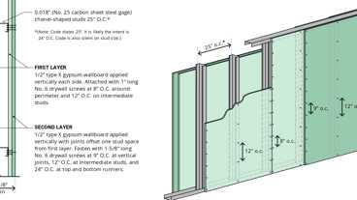
13-1.2: 2hr, Steel Studs
Building products (4)
GPX® Ballistic
SaftiFirst

SuperClear® 45-HS
SaftiFirst

SuperClear® 45-HS-LI
SaftiFirst

SuperLite® X-45/60/90
SaftiFirst

1023.4 Openings
Diagram
Interior exit stairway and ramp opening protectives shall be in accordance with the requirements of Section 716.
Openings in interior exit stairways and ramps other than unprotected exterior openings shall be limited to those required for exit access to the enclosure from normally occupied spaces and for egress from the enclosure.
Elevators shall not open into interior exit stairways and ramps.
UpCodes Diagram (1)
Primary
Interior Exit Stairways: Openings
Building products (4)
GPX® Ballistic
SaftiFirst

SuperClear® 45-HS
SaftiFirst

SuperClear® 45-HS-LI
SaftiFirst

SuperLite® X-45/60/90
SaftiFirst

1023.5 Penetrations
Diagram
Penetrations into or through interior exit stairways and ramps are prohibited except for the following:
- Equipment and ductwork necessary for independent ventilation or pressurization.
- Fire protection systems.
- Security systems.
- Two-way communication systems.
- Electrical raceway for fire department communication systems.
- Electrical raceway serving the interior exit stairway and ramp and terminating at a steel box not exceeding 16 square inches (0.010 m²).
- Structural elements, such as beams or joists, supporting the interior exit stairway or ramp or enclosure.
- Structural elements, such as beams or joists, supporting a roof at the top of the interior exit stairway or ramp.
Such penetrations shall be protected in accordance with Section 714. There shall not be penetrations or communication openings, whether protected or not, between adjacent interior exit stairways and ramps.
Exception: Membrane penetrations shall be permitted on the outside of the interior exit stairway and ramp. Such penetrations shall be protected in accordance with Section 714.4.2.
UpCodes Diagrams (6)
Primary
Interior Exit Stairways: Penetrations
Interior Exit Stair w/ Exit Passageway: Construction
Interior Exit Stairways: Ventilation
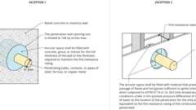
Fire Rated Through Penetrations - Exceptions
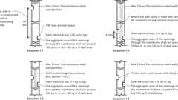
Fire Rated Membrane Penetration Exception 1
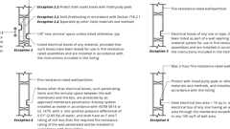
Fire Rated Membrane Penetrations: Electrical Boxes
Building products (12)
FF109-200 1 Hour Fire Rated LED Downlight Cover
Tenmat

FF109-250 1 Hour Fire Rated LED Downlight Cover
Tenmat

FF109-300 UL Fire Rated Recessed Light Cover
Tenmat

FF109-350 Fire Rated Light Cover
Tenmat

FF109-FRSC 1 Hour Fire Rated Speaker Cover
Tenmat

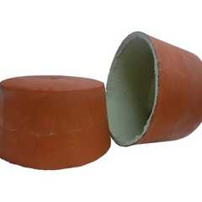
FF109X 2 Hour UL Fire Rated Recessed Light Cover
Tenmat

FF130 - 2x2 Fire Rated Troffer Cover
Tenmat

FF130 - 2x4 Fire Rated Troffer Cover
Tenmat

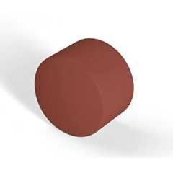
FF160 Fire Protection Plug
Tenmat

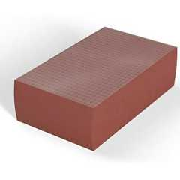
FF260 Fire Protection Block
Tenmat

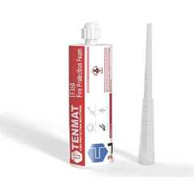
FF360 Fire Protection Foam
Tenmat

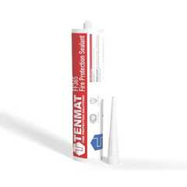
FF365 Fire Protection Sealant
Tenmat

1023.6 Ventilation
Diagram
Equipment and ductwork for interior exit stairway and ramp ventilation as permitted by Section 1023.5 shall comply with one of the following items:
- Such equipment and ductwork shall be located exterior to the building and shall be directly connected to the interior exit stairway and ramp by ductwork enclosed in construction as required for shafts.
- Where such equipment and ductwork is located within the interior exit stairway and ramp, the intake air shall be taken directly from the outdoors and the exhaust air shall be discharged directly to the outdoors, or such air shall be conveyed through ducts enclosed in construction as required for shafts.
- Where located within the building, such equipment and ductwork shall be separated from the remainder of the building, including other mechanical equipment, with construction as required for shafts.
In each case, openings into the fire-resistance-rated construction shall be limited to those needed for maintenance and operation and shall be protected by opening protectives in accordance with Section 716 for shaft enclosures.
The interior exit stairway and ramp ventilation systems shall be independent of other building ventilation systems.
UpCodes Diagram (1)
Primary
Interior Exit Stairways: Ventilation
1023.7 Interior Exit Stairway and Ramp Exterior Walls
Assembly
Diagram
Exterior walls of the interior exit stairway or ramp shall comply with the requirements of Section 705 for exterior walls. Where nonrated walls or unprotected openings enclose the exterior of the stairway or ramps and the walls or openings are exposed by other parts of the building at an angle of less than 180 degrees (3.14 rad), building construction within 10 feet (3048 mm) of the exterior walls of the interior exit stairway or ramp shall comply with Sections 1023.7.1 and 1023.7.2.
UpCodes Diagrams (2)
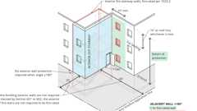Primary
Interior Stair & Ramp Exterior Wall Protection
Roof Assemblies at Interior Exit Stairs (2024)
Assemblies (13)
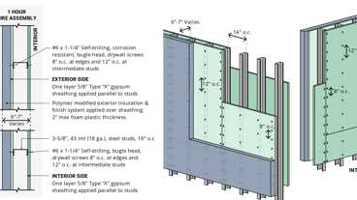
WP 8122: 1hr, Steel Studs, Polymer Mod. EIFS
WP 8105: 1hr, Sheathing & Wood Studs
15-1.4: 1hr, Steel Stud
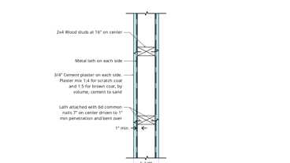
15-1.2: 1hr, Wood
15-1.1: 1hr, Wood
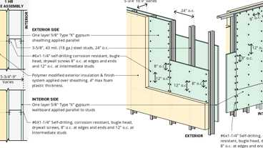
WP 8123; 1hr Steel Studs, Polymer Based EIFS
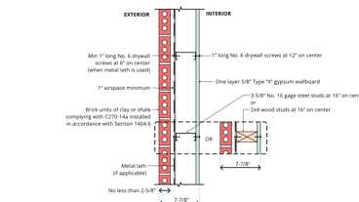
15-2.3: 1hr, Steel or Wood
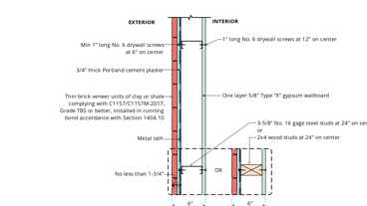
15-2.1: 1hr, Steel or Wood
15-1.13: 1hr, Wood
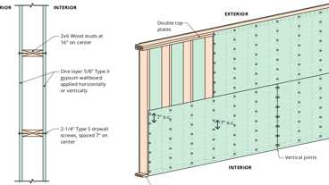
15-1.14: 1hr, Wood
Show 3 more
1023.7.1 Building Exterior Walls
Building exterior walls within 10 feet (3048 mm) horizontally of a nonrated wall or unprotected opening in an interior exit stairway or ramp shall have a fire-resistance rating of not less than 1 hour. Openings within such exterior walls shall be protected by opening protectives having a fire protection rating of not less than ³/₄ hour. This construction shall extend vertically from the ground to a point 10 feet (3048 mm) above the topmost landing of the stairway or ramp, or to the roof line, whichever is lower.
1023.7.2 Roof Assemblies
Diagram
Where the interior exit stairway or ramp extends above an adjacent roof of the same building, the adjacent roof assembly shall have a fire-resistance rating of not less than 1 hour and openings shall be protected by opening protectives having a fire protection rating of not less than ³/₄ hour. The fire-resistance rating and opening protection shall extend horizontally not less than 10 feet (3048 mm) from the exterior wall of the stairway or ramp, or to the perimeter of the adjacent roof, whichever is less.
Exceptions:
- The roof assembly need not be rated and openings in the roof need not be protected where they are adjacent to the penthouse of the stairway or ramp, unless otherwise required by this code.
- The adjacent roof assembly need not be rated and adjacent openings in the roof need not be protected where the exterior wall of the stairway or ramp has a fire-resistance rating of 1 hour and openings are protected by opening protectives having a fire protection rating of not less than ³/₄ hour, extending not less than 10 feet (3048 mm) above the roof.
UpCodes Diagram (1)
Primary
Roof Assemblies at Interior Exit Stairs (2024)
1023.8 Barrier at Level of Exit Discharge
Diagram
An interior exit stairway and ramp shall not continue below its level of exit discharge unless an approved barrier is provided at the level of exit discharge to prevent persons from unintentionally continuing into levels below. Directional exit signs shall be provided as specified in Section 1013.
UpCodes Diagram (1)
Primary
Stairway Discharge Identification
1023.9 Stairway Identification Signs
A sign shall be provided at each floor landing in an interior exit stairway and ramp connecting more than three stories designating the floor level, the terminus of the top and bottom of the interior exit stairway and ramp and the identification of the stairway or ramp. The signage shall state the story of and direction to the exit discharge, and the availability of roof access from the interior exit stairway and ramp for the fire department. The bottom of the sign shall be located not less than 5 feet (1524 mm) above the floor landing in a position that is readily visible when the doors are in the open and closed positions.
In addition to the stairway identification sign, raised characters and braille floor identification signs that comply with Chapter 11A, Section 1143A or Chapter 11B shall be located at the landing of each floor level, placed adjacent to the door on the latch side, in all enclosed stairways in buildings two or more stories in height to identify the floor level. At the exit discharge level, the sign shall include a raised five pointed star located to the left of the identifying floor level. The outside diameter of the star shall be the same as the height of the raised characters.
1023.9.1 Signage Requirements
Stairway identification signs shall comply with all of the following requirements:
- The signs shall be a minimum size of 18 inches (457 mm) by 12 inches (305 mm).
- The letters designating the identification of the interior exit stairway and ramp such as STAIR NO. 1 or WEST STAIR, shall be placed at the top of the sign and shall be not less than 1 ¹/₂ inches (38 mm) in height block lettering with ¹/₄-inch (6 mm) strokes.
- The number designating the floor level shall be not less than 5 inches (127 mm) in height with ³/₄-inch (19 mm) strokes and located in the center of the sign. The mezzanine levels shall have the letter "M" preceding the floor level. Basement levels shall have the letter "B" preceding the floor number.
- Other lettering and numbers shall be not less than 1 inch (25 mm) in height.
- The stairway's upper terminus, such as ROOF ACCESS or NO ROOF ACCESS, shall be placed under the stairway identification in 1-inch-high (25 mm) block lettering with ¹/₄-inch (6 mm) strokes.
- The lower and upper terminus of the stairway shall be placed at the bottom of the sign in 1-inch-high (25 mm) block lettering with ¹/₄-inch (6 mm) strokes.
- Characters and their background shall have a nonglare finish. Characters shall contrast with their background, with either light characters on a dark background or dark characters on a light background.
- Where signs required by Section 1023.9 are installed in the interior exit stairways and ramps of buildings subject to Section 1025, the signs shall be made of the same materials as required by Section 1025.4.
1023.10 Elevator Lobby Identification Signs
At landings in interior exit stairways where two or more doors lead to the floor level, any door with direct access to an enclosed elevator lobby shall be identified by signage located on the door or directly adjacent to the door stating "Elevator Lobby." Signage shall be in accordance with Section 1023.9.1, Items 4, 5 and 6.
1023.11 Tactile Floor-Level Signs
Where floor level signs are provided in interior exit stairways and ramps, a floor-level sign identifying the floor level in visual characters, raised characters and braille complying with Chapter 11A, Section 1143A shall be located at each floor-level landing adjacent to the door leading from the interior exit stairway and ramp into the corridor.
1023.12 Smokeproof Enclosures
Diagram
Where required by Section 403.5.4, 405.7.2 or 412.2.2.1, interior exit stairways and ramps shall be smokeproof enclosures in accordance with Section 909.20.
UpCodes Diagrams (3)
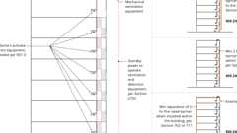
High Rise Smokeproof Encl: Equipment
High Rise Smokeproof Encl: No Vestibule
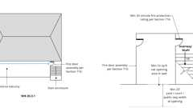
High Rise Smokeproof Encl: Natural Ventilation
1023.12.1 Termination and Extension
Assembly
A smokeproof enclosure shall terminate at an exit discharge or a public way. The smokeproof enclosure shall be permitted to be extended by an exit passageway in accordance with Section 1023.3. The exit passageway shall be without openings other than the fire door assembly required by Section 1023.3.1 and those necessary for egress from the exit passageway. The exit passageway shall be separated from the remainder of the building by 2-hour fire barriers constructed in accordance with Section 707 or horizontal assemblies constructed in accordance with Section 711, or both.
Exceptions:
- Openings in the exit passageway serving a smokeproof enclosure are permitted where the exit passageway is protected and pressurized in the same manner as the smokeproof enclosure, and openings are protected as required for access from other floors.
- The fire barrier separating the smokeproof enclosure from the exit passageway is not required, provided that the exit passageway is protected and pressurized in the same manner as the smokeproof enclosure.
- A smokeproof enclosure shall be permitted to egress through areas on the level of exit discharge or vestibules as permitted by Section 1028.
Assembly (1)
13-1.2: 2hr, Steel Studs
1023.12.2 Enclosure Access
Access to the stairway or ramp within a smokeproof enclosure shall be by way of a vestibule or an open exterior balcony.
1023.13 Standpipes
Diagram
Standpipes and standpipe hose connections shall be provided where required by Sections 905.3 and 905.4.
UpCodes Diagram (1)
Standpipe Types
Section 1024 Exit Passageways
Diagram
UpCodes Diagrams (10)
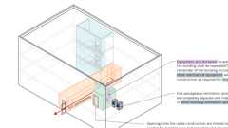
Exit Passageways: Ventilation Pt. 3
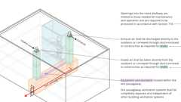
Exit Passageways: Ventilation Pt. 2
Exit Passageways: Ventilation Pt. 1
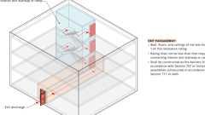
Exit Passageways: Construction (IBC)
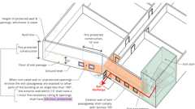
Exit Passageways: Exterior Walls (IBC)
Exit Passageways: Termination; Openings (BC)
Exit Passageways: Width and Capacity
Separation of a Third Stairway
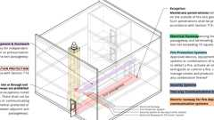
Exit Passageways: Prohibited Penetrations
Exit Passageway Usage
1024.1 General
Diagram
Exit passageways serving as an exit component in a means of egress system shall comply with the requirements of this section. An exit passageway shall not be used for any purpose other than as a means of egress and a circulation path.
UpCodes Diagram (1)
Primary
Exit Passageway Usage
1024.2 Width and Capacity
Diagram
The required capacity of exit passageways shall be determined as specified in Section 1005.1 but the minimum width shall be not less than 44 inches (1118 mm), except that exit passageways serving an occupant load of less than 50 shall be not less than 36 inches (914 mm) in width. The minimum width or required capacity of exit passageways shall be unobstructed.
Exception: Encroachments complying with Section 1005.7.
The clear width of exit passageways in a Group I-2 occupancy used for the movement of beds and litters shall be 44-inch (1118) minimum.
UpCodes Diagram (1)
Primary
Exit Passageways: Width and Capacity
1024.3 Construction
Assembly
Diagram
Exit passageway enclosures shall have walls, floors and ceilings of not less than a 1-hour fire-resistance rating, and not less than that required for any connecting interior exit stairway or ramp. Exit passageways shall be constructed as fire barriers in accordance with Section 707 or horizontal assemblies constructed in accordance with Section 711, or both.
UpCodes Diagrams (3)
Primary
Exit Passageways: Construction (IBC)
Fire & Smoke: Walls vs. Barriers vs. Partitions
Required Fire Ratings for Protective Wall Assemblies
Assemblies (7)
WP 1015: 1hr, 55-59 STC, Steel Stud
WP 1021: 1hr, 50-54 STC, Steel Stud
WP 1051: 1hr, 50-54 STC, Steel Stud
14-1.1: 1hr, Wood Joist
21-1.1: 1hr, Wood Joist
13-1.1: 1hr Steel Studs
FC 1105: 1hr, 50-54 STC, Conc & Steel Joist
1024.4 Termination
Diagram
Exit passageways on the level of exit discharge shall terminate at an exit discharge. Exit passageways on other levels shall terminate at an exit.
UpCodes Diagram (1)
Primary
Exit Passageways: Termination; Openings (BC)
1024.5 Openings
Diagram
Exit passageway opening protectives shall be in accordance with the requirements of Section 716.
Except as permitted in Section 402.8.7, openings in exit passageways other than unprotected exterior openings shall be limited to those necessary for exit access to the exit passageway from normally occupied spaces and for egress from the exit passageway.
Where an interior exit stairway or ramp is extended to an exit discharge or a public way by an exit passageway, the exit passageway shall comply with Section 1023.3.1.
Elevators shall not open into an exit passageway.
UpCodes Diagram (1)
Primary
Exit Passageways: Termination; Openings (BC)
Building products (4)
GPX® Ballistic
SaftiFirst

SuperClear® 45-HS
SaftiFirst

SuperClear® 45-HS-LI
SaftiFirst

SuperLite® X-45/60/90
SaftiFirst

1024.6 Penetrations
Diagram
Penetrations into or through an exit passageway are prohibited except for the following:
- Equipment and ductwork necessary for independent ventilation or pressurization.
- Fire protection systems.
- Security systems.
- Two-way communication systems.
- Electrical raceway for fire department communication.
- Electrical raceway serving the exit passageway and terminating at a steel box not exceeding 16 square inches (0.010 m²).
- Structural elements, such as beams or joists, supporting a floor or roof at the top of the exit passageway.
Such penetrations shall be protected in accordance with Section 714. There shall not be penetrations or communicating openings, whether protected or not, between adjacent exit passageways.
Exception: Membrane penetrations shall be permitted on the outside of the exit passageway. Such penetrations shall be protected in accordance with Section 714.4.2.
UpCodes Diagram (1)
Primary
Exit Passageways: Prohibited Penetrations
Building products (8)
FF109-200 1 Hour Fire Rated LED Downlight Cover
Tenmat

FF109-250 1 Hour Fire Rated LED Downlight Cover
Tenmat

FF109-300 UL Fire Rated Recessed Light Cover
Tenmat

FF109-350 Fire Rated Light Cover
Tenmat

FF109-FRSC 1 Hour Fire Rated Speaker Cover
Tenmat

FF109X 2 Hour UL Fire Rated Recessed Light Cover
Tenmat

FF130 - 2x2 Fire Rated Troffer Cover
Tenmat

FF130 - 2x4 Fire Rated Troffer Cover
Tenmat

1024.7 Ventilation
Diagram
Equipment and ductwork for exit passageway ventilation as permitted by Section 1024.6 shall comply with one of the following:
- The equipment and ductwork shall be located exterior to the building and shall be directly connected to the exit passageway by ductwork enclosed in construction as required for shafts.
- Where the equipment and ductwork is located within the exit passageway, the intake air shall be taken directly from the outdoors and the exhaust air shall be discharged directly to the outdoors, or the air shall be conveyed through ducts enclosed in construction as required for shafts.
- Where located within the building, the equipment and ductwork shall be separated from the remainder of the building, including other mechanical equipment, with construction as required for shafts.
In each case, openings into the fire-resistance-rated construction shall be limited to those needed for maintenance and operation and shall be protected by opening protectives in accordance with Section 716 for shaft enclosures.
Exit passageway ventilation systems shall be independent of other building ventilation systems.
UpCodes Diagrams (3)
Primary
Exit Passageways: Ventilation Pt. 1
Primary
Exit Passageways: Ventilation Pt. 2
Primary
Exit Passageways: Ventilation Pt. 3
1024.8 Exit Passageway Exterior Walls
Assembly
Diagram
Exterior walls of the exit passageway shall comply with Section 705. Where nonrated walls or unprotected openings enclose the exterior of the exit passageway and the walls or openings are exposed by other parts of the building at an angle of less than 180 degrees (3.14 rad), the building exterior walls within 10 feet (3048 mm) horizontally of a nonrated wall or unprotected opening shall have a fire-resistance rating of not less than 1 hour. Openings within such exterior walls shall be protected by opening protectives having a fire protection rating of not less than ³/₄ hour. This construction shall extend vertically from the ground to a point 10 feet (3048 mm) above the floor of the exit passageway, or to the roof line, whichever is lower.
UpCodes Diagrams (2)
Primary
Exit Passageways: Exterior Walls (IBC)
Exit Passageways: Termination; Openings (BC)
Assemblies (13)
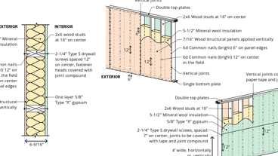
16-1.2: 1hr, Wood
16-1.1: 1hr, Wood
15-1.4: 1hr, Steel Stud
15-1.2: 1hr, Wood
15-1.1: 1hr, Wood
16-1.3: 1hr, Wood
15-2.3: 1hr, Steel or Wood
15-2.1: 1hr, Steel or Wood
15-1.13: 1hr, Wood
15-1.14: 1hr, Wood
Show 3 more
1024.9 Standpipes
Diagram
Standpipes and standpipe hose connections shall be provided where required by Sections 905.3 and 905.4.
UpCodes Diagram (1)
Standpipe Types
Section 1025 Luminous Egress Path Markings
Diagram
UpCodes Diagram (1)
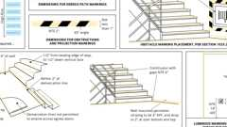Primary
Luminous Egress Paths
1025.1 General
Approved luminous egress path markings delineating the exit path shall be provided in high-rise buildings of Group A, B, E, M or R-1 occupancies in accordance with this section.
Exception: Luminous egress path markings shall not be required on the level of exit discharge in lobbies that serve as part of the exit path in accordance with Section 1028.2, Exception 1.
1025.2 Markings Within Exit Components
Egress path markings shall be provided in interior exit stairways, interior exit ramps and exit passageways, in accordance with Sections 1025.2.1 through 1025.2.6.3.
1025.2.1 Steps
A solid and continuous stripe shall be applied to the horizontal leading edge of each step and shall extend for the full length of the step. Outlining stripes shall have a minimum horizontal width of 1 inch (25 mm) and a maximum width of 2 inches (51 mm). The leading edge of the stripe shall be placed not more than ¹/₂ inch (12.7 mm) from the leading edge of the step and the stripe shall not overlap the leading edge of the step by not more than ¹/₂ inch (12.7 mm) down the vertical face of the step.
Exception: The minimum width of 1 inch (25 mm) shall not apply to outlining stripes listed in accordance with UL 1994.
1025.2.2 Landings
The leading edge of landings shall be marked with a stripe consistent with the dimensional requirements for steps.
1025.2.3 Handrails
Handrails and handrail extensions shall be marked with a solid and continuous stripe having a minimum width of 1 inch (25 mm). The stripe shall be placed on the top surface of the handrail for the entire length of the handrail, including extensions and newel post caps. Where handrails or handrail extensions bend or turn corners, the stripe shall not have a gap of more than 4 inches (102 mm).
Exception: The minimum width of 1 inch (25 mm) shall not apply to outlining stripes listed in accordance with UL 1994.
1025.2.4 Perimeter Demarcation Lines
Stair landings and other floor areas within interior exit stairways, interior exit ramps and exit passageways, with the exception of the sides of steps, shall be provided with solid and continuous demarcation lines on the floor or on the walls or a combination of both. The stripes shall be 1 to 2 inches (25 mm to 51 mm) wide with interruptions not exceeding 4 inches (102 mm).
Exception: The minimum width of 1 inch (25 mm) shall not apply to outlining stripes listed in accordance with UL 1994.
1025.2.4.1 Floor-Mounted Demarcation Lines
Perimeter demarcation lines shall be placed within 4 inches (102 mm) of the wall and shall extend to within 2 inches (51 mm) of the markings on the leading edge of landings. The demarcation lines shall continue across the floor in front of all doors.
Exception: Demarcation lines shall not extend in front of exit discharge doors that lead out of an exit and through which occupants must travel to complete the exit path.
1025.2.4.2 Wall-Mounted Demarcation Lines
Perimeter demarcation lines shall be placed on the wall with the bottom edge of the stripe not more than 4 inches (102 mm) above the finished floor. At the top or bottom of the stairs, demarcation lines shall drop vertically to the floor within 2 inches (51 mm) of the step or landing edge. Demarcation lines on walls shall transition vertically to the floor and then extend across the floor where a line on the floor is the only practical method of outlining the path. Where the wall line is broken by a door, demarcation lines on walls shall continue across the face of the door or transition to the floor and extend across the floor in front of such door.
Exception: Demarcation lines shall not extend in front of exit discharge doors that lead out of an exit and through which occupants must travel to complete the exit path.
1025.2.4.3 Transition
Where a wall-mounted demarcation line transitions to a floor-mounted demarcation line, or vice versa, the wall-mounted demarcation line shall drop vertically to the floor to meet a complimentary extension of the floor-mounted demarcation line, thus forming a continuous marking.
1025.2.5 Obstacles
Obstacles at or below 6 feet 6 inches (1981 mm) in height and projecting more than 4 inches (102 mm) into the egress path shall be outlined with markings not less than 1 inch (25 mm) in width comprised of a pattern of alternating equal bands, of luminous material and black, with the alternating bands not more than 2 inches (51 mm) thick and angled at 45 degrees (0.79 rad). Obstacles shall include, but are not limited to, standpipes, hose cabinets, wall projections and restricted height areas. However, such markings shall not conceal any required information or indicators including but not limited to instructions to occupants for the use of standpipes.
Exception: The minimum width of 1 inch (25 mm) shall not apply to markings listed in accordance with UL 1994.
1025.2.6 Doors Within the Exit Path
Doors through which occupants must pass in order to complete the exit path shall be provided with markings complying with Sections 1025.2.6.1 through 1025.2.6.3.
1025.2.6.1 Emergency Exit Symbol
The doors shall be identified by a low-location luminous emergency exit symbol complying with NFPA 170. The exit symbol shall be not less than 4 inches (102 mm) in height and shall be mounted on the door, centered horizontally, with the top of the symbol not higher than 18 inches (457 mm) above the finished floor.
1025.2.6.2 Door Hardware Markings
Diagram
Door hardware shall be marked with not less than 16 square inches (10 323 mm²) of luminous material. This marking shall be located behind, immediately adjacent to, or on the door handle or escutcheon. Where a panic bar is installed, such material shall be not less than 1 inch (25 mm) wide for the entire length of the actuating bar or touchpad.
UpCodes Diagram (1)
Door Hardware Height
1025.2.6.3 Door Frame Markings
The top and sides of the door frame shall be marked with a solid and continuous 1-inch- to 2-inch-wide (25 mm to 51 mm) stripe. Where the door molding does not provide sufficient flat surface on which to locate the stripe, the stripe shall be permitted to be located on the wall surrounding the frame.
1025.3 Uniformity
Placement and dimensions of markings shall be consistent and uniform throughout the same enclosure.
1025.4 Self-Luminous and Photoluminescent
Luminous egress path markings shall be permitted to be made of any material, including paint, provided that an electrical charge is not required to maintain the required luminance. Such materials shall include, but not be limited to, self-luminous materials and photoluminescent materials. Materials shall comply with either of the following standards:
- UL 1994.
- ASTM E2072, except that the charging source shall be 1 footcandle (11 lux) of fluorescent illumination for 60 minutes, and the minimum luminance shall be 30 milicandelas per square meter at 10 minutes and 5 milicandelas per square meter after 90 minutes.
1025.5 Illumination
Where photoluminescent exit path markings are installed, they shall be provided with not less than 1 footcandle (11 lux) of illumination for not less than 60 minutes prior to periods when the building is occupied and continuously during occupancy.
Section 1026 Horizontal Exits
Diagram
UpCodes Diagrams (5)
Primary
Horizontal Exit Egress Analysis
Standpipes at Horiz. Exits and Stairways
Area of Refuge Access to Stairway or Elevator
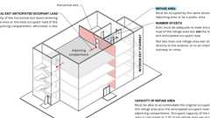
Horizontal Exits: Refuge Areas
Horizontal Exits
1026.1 General
Horizontal exits serving as an exit in a means of egress system shall comply with the requirements of this section. A horizontal exit shall not serve as the only exit from a portion of a building, and where two or more exits are required, not more than one-half of the total number of exits or total exit minimum width or required capacity shall be horizontal exits.
Exceptions:
- Horizontal exits are permitted to comprise two-thirds of the required exits from any building or floor area for occupancies in Group I-2.
- Horizontal exits are permitted to comprise 100 percent of the exits required for occupancies in Group I-3. Not less than 6 square feet (0.6 m²) of accessible space per occupant shall be provided on each side of the horizontal exit for the total number of people in adjoining compartments.
1026.2 Separation
Assembly
Diagram
The separation between buildings or refuge areas connected by a horizontal exit shall be provided by a fire wall complying with Section 706; or by a fire barrier complying with Section 707 or a horizontal assembly complying with Section 711, or both. The minimum fire-resistance rating of the separation shall be 2 hours. Opening protectives in horizontal exits shall also comply with Section 716. Duct and air transfer openings in a fire wall or fire barrier that serves as a horizontal exit shall also comply with Section 717. The horizontal exit separation shall extend vertically through all levels of the building unless floor assemblies have a fire-resistance rating of not less than 2 hours and do not have unprotected openings.
Exception: A fire-resistance rating is not required at horizontal exits between a building area and an above-grade pedestrian walkway constructed in accordance with Section 3104, provided that the distance between connected buildings is more than 20 feet (6096 mm).
Horizontal exits constructed as fire barriers shall be continuous from exterior wall to exterior wall so as to divide completely the floor served by the horizontal exit.
UpCodes Diagrams (4)
Fire & Smoke: Walls vs. Barriers vs. Partitions
Required Fire Ratings for Protective Wall Assemblies
Fire Walls and Party Walls
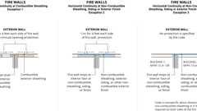
Fire Walls: Horiz. Continuity
Assemblies (5)
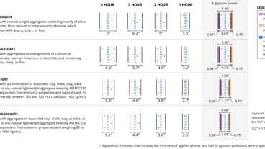
4-1.1: Concrete Walls
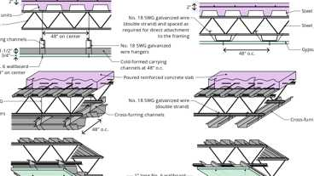
6-4.1: 2hr Steel - Opt. 2 & 3
6-4.1: 2hr Steel - Opt. 1
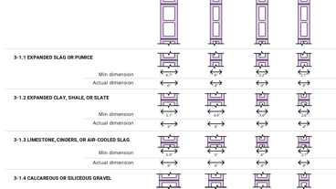
3-1.1 thru 3-1.4: CMU walls
13-1.2: 2hr, Steel Studs
1026.3 Opening Protectives
Fire doors in horizontal exits shall be self-closing or automatic-closing when activated by a smoke detector in accordance with Section 716.2.6.6. Doors, where located in a cross-corridor condition, shall be automatic-closing by activation of a smoke detector installed in accordance with Section 716.2.6.6.
1026.4 Refuge Area
Diagram
The refuge area of a horizontal exit shall be a space occupied by the same tenant or a public area and each such refuge area shall be adequate to accommodate the original occupant load of the refuge area plus the occupant load anticipated from the adjoining compartment. The anticipated occupant load from the adjoining compartment shall be based on the capacity of the horizontal exit doors entering the refuge area or the total occupant load of the adjoining compartment, whichever is less.
UpCodes Diagram (1)
Primary
Horizontal Exits: Refuge Areas
1026.4.1 Capacity
Diagram
The capacity of the refuge area shall be computed based on a net floor area allowance of 3 square feet (0.2787 m²) for each occupant to be accommodated therein. Where the horizontal exit also forms a smoke compartment, the capacity of the refuge area for Group I-2, I-3 and R-2.1 occupancies and ambulatory care facilities shall comply with Sections 407.5.3, 408.6.2, 420.6.2 and 422.3.2 as applicable.
UpCodes Diagrams (2)
Primary
Horizontal Exits: Refuge Areas
Gross vs. Net Area
1026.4.2 Number of Exits
Diagram
The refuge area into which a horizontal exit leads shall be provided with exits adequate to meet the occupant requirements of this chapter, but not including the added occupant load imposed by persons entering the refuge area through horizontal exits from other areas. In other than I-3 occupancies, not less than one refuge area exit shall lead directly to the exterior or to an interior exit stairway or ramp.
Exception: The adjoining compartment shall not be required to have a stairway or door leading directly outside, provided that the refuge area into which a horizontal exit leads has stairways or doors leading directly outside and are so arranged that egress shall not require the occupants to return through the compartment from which egress originates.
UpCodes Diagram (1)
Primary
Horizontal Exits: Refuge Areas
1026.5 Standpipes
Diagram
Standpipes and standpipe hose connections shall be provided where required by Sections 905.3 and 905.4.
UpCodes Diagrams (3)
Primary
Standpipes at Horiz. Exits and Stairways
Standpipe Types
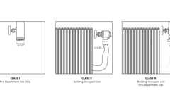
Standpipe System Classes
1026.6 Two-Way Communication
Where a refuge area does not contain a two-way communication system at an elevator landing or within an area of refuge, a two-way communication system shall be installed in an approved location in a public area and shall comply with Sections 1009.8.1, 1009.8.2 and 1009.11.
Exception: Two-way communication systems are not required in Group I-2 and I-3 facilities.
Section 1027 Exterior Exit Stairways and Ramps
Diagram
UpCodes Diagrams (6)
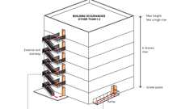
Exterior Exit Stairways and Ramps: When Permitted
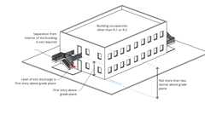
Exterior Exit Stairway and Ramp Protection - Exception 1
Exterior Exit Stairway and Ramp Protection - Exception 2
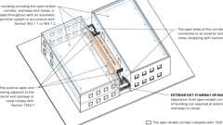
Exterior Exit Stairway and Ramp Protection - Exception 3
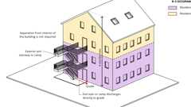
Exterior Exit Stairway and Ramp Protection - Exception 4
Exterior Wall Projections
1027.1 General
Exterior exit stairways and ramps serving as an exit component in a means of egress system shall comply with the requirements of this section.
1027.2 Use in a Means of Egress
Diagram
Exterior exit stairways shall not be used as an element of a required means of egress for Group I-2 occupancies. For occupancies in other than Group I-2, exterior exit stairways and ramps shall not be used as an element of a required means of egress for buildings exceeding six stories above grade plane or that are high-rise buildings.
UpCodes Diagram (1)
Primary
Exterior Exit Stairways and Ramps: When Permitted
1027.3 Open Side
Diagram
Exterior exit stairways and ramps serving as an element of a required means of egress shall be open on not less than one side, except for required structural columns, beams, handrails and guards. An open side shall have not less than 35 square feet (3.3 m²) of aggregate open area adjacent to each floor level and the level of each intermediate landing. The required open area shall be located not less than 42 inches (1067 mm) above the adjacent floor or landing level.
UpCodes Diagram (1)
Primary
Exterior Exit Stairway and Ramp Protection
1027.4 Side Yards
The open areas adjoining exterior exit stairways or ramps shall be either yards, courts or public ways; the remaining sides are permitted to be enclosed by the exterior walls of the building.
1027.5 Location
Diagram
Exterior exit stairways and ramps shall have a minimum fire separation distance of 10 feet (3048 mm) measured at right angles from the exterior edge of the stairway or ramps, including landings, to:
- Adjacent lot lines.
- Other portions of the building.
- Other buildings on the same lot unless the adjacent building exterior walls and openings are protected in accordance with Section 705 based on fire separation distance.
For the purposes of this section, other portions of the building shall be treated as separate buildings.
Exception: Exterior exit stairways and ramps serving individual dwelling units of Group R-3 shall have a minimum fire separation distance of 5 feet (1525 mm).
UpCodes Diagrams (4)
Primary
Exterior Exit Stairway and Ramp Protection
Exterior Exit Stairway and Ramp Protection - Exception 2
Ext. Stairway / Ramp Protection, Pt. 1
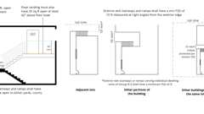
Ext. Stairway / Ramp Protection, Pt. 2
1027.6 Exterior Exit Stairway and Ramp Protection
Diagram
Exterior exit stairways and ramps shall be separated from the interior of the building as required in Section 1023.2. Openings shall be limited to those necessary for egress from normally occupied spaces. Where a vertical plane projecting from the edge of an exterior exit stairway or ramp and landings is exposed by other parts of the building at an angle of less than 180 degrees (3.14 rad), the exterior wall shall be rated in accordance with Section 1023.7.
Exceptions:
- Separation from the interior of the building is not required for occupancies, other than those in Group R-1 or R-2, in buildings that are not more than two stories above grade plane where a level of exit discharge serving such occupancies is the first story above grade plane.
- Separation from the interior of the building is not required where the exterior exit stairway or ramp is served by an exterior exit ramp or balcony that connects two remote exterior exit stairways or other approved exits with a perimeter that is not less than 50 percent open. To be considered open, the opening shall be not less than 50 percent of the height of the enclosing wall, with the top of the openings not less than 7 feet (2134 mm) above the top of the balcony.
- Separation from the open-ended corridor of the building is not required for exterior exit stairways or ramps, provided that Items 3.1 through 3.5 are met:
  - 3.1. The building, including open-ended corridors, and stairways and ramps, shall be equipped throughout with an automatic sprinkler system in accordance with Section 903.3.1.1 or 903.3.1.2.
  - 3.2. The open-ended corridors comply with Section 1020.
  - 3.3. The open-ended corridors are connected on each end to an exterior exit stairway or ramp complying with Section 1027.
  - 3.4. The exterior walls and openings adjacent to the exterior exit stairway or ramp comply with Section 1023.7.
  - 3.5. At any location in an open-ended corridor where a change of direction exceeding 45 degrees (0.79 rad) occurs, a clear opening of not less than 35 square feet (3.3 m²) or an exterior stairway or ramp shall be provided. Where clear openings are provided, they shall be located so as to minimize the accumulation of smoke or toxic gases.
- In Group R-3 occupancies not more than four stories in height, exterior exit stairways and ramps serving individual dwelling units are not required to be separated from the interior of the building where the exterior exit stairway or ramp discharges directly to grade.
UpCodes Diagrams (7)
Primary
Ext. Stairway / Ramp Protection, Pt. 2
Primary
Ext. Stairway / Ramp Protection, Pt. 1
Primary
Exterior Exit Stairway and Ramp Protection - Exception 4
Primary
Exterior Exit Stairway and Ramp Protection - Exception 3
Primary
Exterior Exit Stairway and Ramp Protection - Exception 2
Primary
Exterior Exit Stairway and Ramp Protection - Exception 1
Primary
Exterior Exit Stairway and Ramp Protection
Section 1028 Exit Discharge
Diagram
UpCodes Diagrams (6)
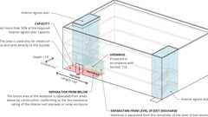
Exit Discharge: Exception 2
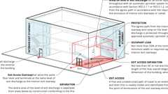
Exit Discharge: Exception 1
Means of Egress: Basic Components
Atriums: Exiting, Pt. 1
Intermediate Handrails
Exit Access, Exit and Exit Discharge
1028.1 General
Diagram
The exit discharge shall comply with Sections 1028 and 1029 and the applicable requirements of Sections 1003 through 1015.
UpCodes Diagram (1)
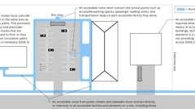
Routes Within the Site
1028.2 Exit Discharge
Assembly
Diagram
Exits shall discharge directly to the exterior of the building. The exit discharge shall be at grade or shall provide a direct path of egress travel to grade. The exit discharge shall not reenter a building. The combined use of Exceptions 1 and 2 shall not exceed 50 percent of the number and minimum width or required capacity of the required exits.
Exceptions:
- Not more than 50 percent of the number and minimum width or required capacity of interior exit stairways and ramps is permitted to egress through areas, including atriums, on the level of discharge provided that all of the following conditions are met:
  - 1.1. Discharge of interior exit stairways and ramps shall be provided with a free and unobstructed path of travel to an exterior exit door and such exit is readily visible and identifiable from the point of termination of the enclosure.
  - 1.2. The entire area of the level of exit discharge is separated from areas below by construction conforming to the fire-resistance rating for the enclosure.
  - 1.3. The egress path from the interior exit stairway and ramp on the level of exit discharge is protected throughout by an approved automatic sprinkler system. Portions of the level of exit discharge with access to the egress path shall be either equipped throughout with an automatic sprinkler system installed in accordance with Section 903.3.1.1 or 903.3.1.2, or separated from the egress path in accordance with the requirements for the enclosure of interior exit stairways or ramps.
  - 1.4. Where a required interior exit stairway or ramp and an exit access stairway or ramp serve the same floor level and terminate at the same level of exit discharge, the termination of the exit access stairway or ramp and the exit discharge door of the interior exit stairway or ramp shall be separated by a distance of not less than 30 feet (9144 mm) or not less than one-fourth the length of the maximum overall diagonal dimension of the building, whichever is less. The distance shall be measured in a straight line between the exit discharge door from the interior exit stairway or ramp and the last tread of the exit access stairway or termination of slope of the exit access ramp.
- Not more than 50 percent of the number and minimum width or required capacity of the interior exit stairways and ramps is permitted to egress through a vestibule provided that all of the following conditions are met:
  - 2.1. The entire area of the vestibule is separated from areas below by construction conforming to the fire-resistance rating of the interior exit stairway or ramp enclosure.
  - 2.2. The depth from the exterior of the building is not greater than 10 feet (3048 mm) and the length is not greater than 30 feet (9144 mm).
  - 2.3. The area is separated from the remainder of the level of exit discharge by a fire partition constructed in accordance with Section 708.
Exception: The maximum transmitted temperature rise is not required.
  - 2.4. The area is used only for means of egress and exits directly to the outside.
- Horizontal exits complying with Section 1026 shall not be required to discharge directly to the exterior of the building.
UpCodes Diagrams (5)
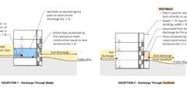Primary
Exit Discharge: Exceptions 1 and 2
Primary
Exit Discharge: Exception 1
Primary
Exit Discharge: Exception 2
Means of Egress: Basic Components
Horizontal Exits
Assemblies (7)
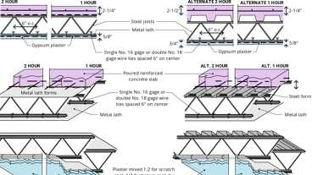
6-1.1: 1hr & 2hr, Steel
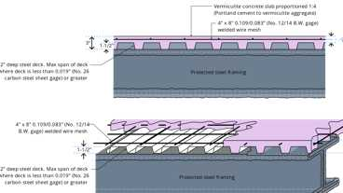
15-1.1: 1hr, Steel, Conc. / Metal Deck
14-1.1: 1hr, Wood Joist
21-1.1: 1hr, Wood Joist
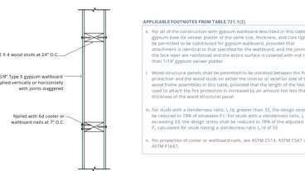
14-1.3: 1hr, Wood
13-1.1: 1hr Steel Studs
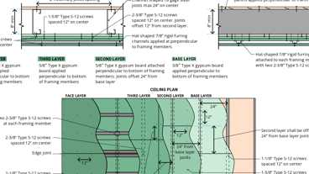
29-1.1: 2-hr, Steel
Building products (8)
FF109-200 1 Hour Fire Rated LED Downlight Cover
Tenmat

FF109-250 1 Hour Fire Rated LED Downlight Cover
Tenmat

FF109-300 UL Fire Rated Recessed Light Cover
Tenmat

FF109-350 Fire Rated Light Cover
Tenmat

FF109-FRSC 1 Hour Fire Rated Speaker Cover
Tenmat

FF109X 2 Hour UL Fire Rated Recessed Light Cover
Tenmat

FF130 - 2x2 Fire Rated Troffer Cover
Tenmat

FF130 - 2x4 Fire Rated Troffer Cover
Tenmat

1028.3 Exit Discharge Width or Capacity
The minimum width or required capacity of the exit discharge shall be not less than the minimum width or required capacity of the exits being served.
1028.4 Exit Discharge Components
Exit discharge components shall be sufficiently open to the exterior so as to minimize the accumulation of smoke and toxic gases.
1028.5 Access to a Public Way
Diagram
The exit discharge shall provide a direct and unobstructed access to a public way.
Exception: Where access to a public way cannot be provided, a safe dispersal area shall be provided where all of the following are met:
- The area shall be of a size to accommodate not less than 5 square feet (0.46 m²) for each person.
- For other than Group E buildings, the area shall be located on the same lot not less than 50 feet (15 240 mm) away from the building requiring egress. For Group E buildings, the area shall be located on the same lot at least 50 feet (15 240 mm) away from any building.
- The area shall be permanently maintained and identified as a safe dispersal area.
- The area shall be provided with a safe and unobstructed path of travel from the building.
- In correctional facilities, the area shall be of a size to accommodate not less than 7 square feet (0.6503 m²) for each person. Accessible path of egress travel to the safe dispersal area and clear ground space for 5 percent of the occupants meeting Section 11B-305.3 shall be provided.
- At facilities regulated by Chapter 11B, an accessible area within the space required by Exception Item 1 shall be provided for a minimum of 2 percent of the facility occupants served by the safe dispersal area. For each occupant, the accessible area shall provide clear ground space complying with Section 11B-305. Accessible routes complying with Chapter 11B, Division 4 shall connect the accessible area with all accessible exits served by the safe dispersal area.
UpCodes Diagrams (5)
Stadium Gates
Non-Uniform Height Risers
Means of Egress: Basic Components
Means of Egress Illumination: Exit Discharge
Ext. Doors and the Public Way
Section 1029 Egress Courts
1029.1 General
Diagram
Egress courts serving as an exit discharge component in the means of egress system shall comply with the requirements in this section.
UpCodes Diagrams (2)
Means of Egress Illumination: Exit Discharge
Yards and Courts
1029.2 Width or Capacity
The required capacity of egress courts shall be determined as specified in Section 1005.1, but the minimum width shall be not less than 44 inches (1118 mm), except as specified herein. Egress courts serving Group R-3 and U occupancies shall be not less than 36 inches (914 mm) in width. The required capacity and width of egress courts shall be unobstructed to a height of 7 feet (2134 mm). The width of the egress court shall be not less than the required capacity.
Exception: Encroachments complying with Section 1005.7.
1029.3 Construction and Openings
Assembly
Where an egress court serving a building or portion thereof is less than 10 feet (3048 mm) in width, the egress court walls shall have not less than 1-hour fire-resistance-rated construction for a distance of 10 feet (3048 mm) above the floor of the egress court. Openings within such walls shall be protected by opening protectives having a fire protection rating of not less than ³/₄ hour.
Exceptions:
- Egress courts serving an occupant load of less than 10.
- Egress courts serving Group R-3.
- Egress courts, located at grade, that provide direct and unobstructed access to a public way through two or more independent paths. The minimum width provided along each path shall be based on the required width or the required capacity, whichever is greater, and shall be maintained along each path.
Assemblies (4)
WP 8105: 1hr, Sheathing & Wood Studs
15-1.4: 1hr, Steel Stud
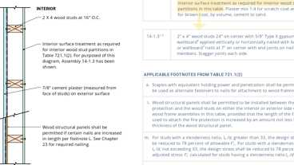
15-1.3: 1hr, Wood
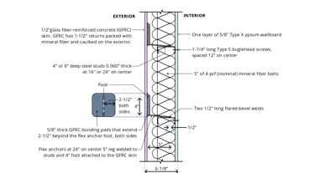
15-1.11: 1hr, Steel Studs w/GFRC
Section 1030 Assembly
Diagram
UpCodes Diagrams (13)
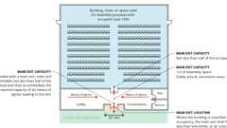
Assembly: Main Exit Provided
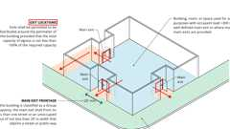
Assembly: No Main Exit or Multiple Exits
Foyers and Lobbies (Group A-1) Pt 2
Foyers and Lobbies (Group A-1) Pt 1
Aisles with Tables and Fixtures
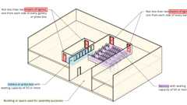
Assembly Balcony and Gallery Means of Egress
Handrails at Aisles: Assembly
Sprinklers: Group A-1
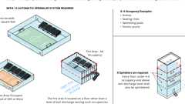
Sprinklers: Group A-4
Assembly Egress: Tread Contrasting Marking Stripe
Show 3 more
1030.1 General
A room or space used for assembly purposes that contains seats, tables, displays, equipment or other material shall comply with this section.
Exception: Group A occupancies within Group I-3 facilities are exempt from egress requirements of Section 1030.
1030.1.1 Bleachers
Bleachers, grandstands and folding and telescopic seating, that are not building elements, shall comply with ICC 300.
1030.1.1.1 Spaces Under Grandstands and Bleachers
Assembly
Diagram
Spaces under grandstands or bleachers shall be separated by fire barriers complying with Section 707 and horizontal assemblies complying with Section 711 with not less than 1-hour fire-resistance-rated construction.
Exceptions:
- Ticket booths less than 100 square feet (9.29 m²) in area.
- Toilet rooms.
- Other accessory use areas 1,000 square feet (92.9 m²) or less in area and equipped with an automatic sprinkler system in accordance with Section 903.3.1.1.
UpCodes Diagrams (2)
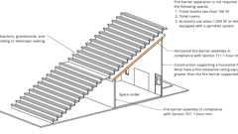Primary
Spaces Under Bleachers
Fire & Smoke: Walls vs. Barriers vs. Partitions
Assemblies (3)
21-1.1: 1hr, Wood Joist
13-1.1: 1hr Steel Studs
FC 1105: 1hr, 50-54 STC, Conc & Steel Joist
1030.2 Assembly Main Exit
Diagram
A building, room or space used for assembly purposes that has an occupant load of greater than 300 and is provided with a main exit, that main exit shall be of sufficient capacity to accommodate not less than one-half of the occupant load, but such capacity shall be not less than the total required capacity of all means of egress leading to the exit. Where the building is classified as a Group A occupancy, the main exit shall front on not less than one street or an unoccupied space of not less than 20 feet (6096 mm) in width that adjoins a street or public way. In a building, room or space used for assembly purposes where there is not a well-defined main exit or where multiple main exits are provided, exits shall be permitted to be distributed around the perimeter of the building provided that the total capacity of egress is not less than 100 percent of the required capacity and not less than one exit shall discharge on a street or an unoccupied space of not less than 20 feet (6096 mm) in capacity that adjoins a street or public way. Smoke-protected seating shall comply with Section 1030.6.2.
UpCodes Diagrams (2)
Primary
Assembly: No Main Exit or Multiple Exits
Primary
Assembly: Main Exit Provided
1030.3 Assembly Other Exits
Diagram
In addition to having access to a main exit, each level in a building used for assembly purposes having an occupant load greater than 300 and provided with a main exit, shall be provided with additional means of egress that shall provide an egress capacity for not less than one-half of the total occupant load served by that level and shall comply with Section 1007.1. Not less than one-half of the additional means of egress required by this section shall be directly to an exit, or through a lobby, that is not used to access the main exit, to an exit or to a 1-hour-rated corridor to an exit. In a building used for assembly purposes where there is not a well-defined main exit or where multiple main exits are provided, exits for each level shall be permitted to be distributed around the perimeter of the building, provided that the total width of egress is not less than 100 percent of the required width and not less than one exit shall discharge on a street or an unoccupied space of not less than 20 feet (6096 mm) in capacity that adjoins a street or publicway. Smoke-protected seating shall comply with Section 1030.6.2.
UpCodes Diagram (1)
Required Exits: Three or More
1030.3.1 Occupant Loads Between 100 and 300
Group A occupancies or assembly occupancies accessory to Group E occupancies that have an occupant load of 100 to 300 not less than one of the required means of egress shall exit through one of the following:
- Directly to an exit
- Egress through a lobby that is not used to access the other required exit
- To a one-hour rated corridor to an exit
- Continuous through a one-hour rated lobby to an exit.
Not less than one exit shall discharge on a street or an unoccupied space of not less than 20 feet (6096 mm) in capacity that adjoins a street or public way.
1030.4 Foyers and Lobbies
Diagram
In Group A-1 occupancies, where persons are admitted to the building at times when seats are not available, such persons shall be allowed to wait in a lobby or similar space, provided that such lobby or similar space shall not encroach on the minimum width or required capacity of the means of egress. Such foyer, if not directly connected to a public street by all the main entrances or exits, shall have a straight and unobstructed corridor or path of travel to every such main entrance or exit.
UpCodes Diagrams (3)
Primary
Foyers and Lobbies (Group A-1) Pt 1
Primary
Foyers and Lobbies (Group A-1) Pt 2
Exits through Lobbies
1030.5 Interior Balcony and Gallery Means of Egress
Diagram
For balconies, galleries or press boxes having a seating capacity of 50 or more located in a building, room or space used for assembly purposes, not less than two means of egress shall be provided, with one from each side of every balcony, gallery or press box.
UpCodes Diagrams (2)
Primary
Assembly Balcony and Gallery Means of Egress
Exit Access Stair: Balconies (Ex. 8)
1030.6 Capacity of Aisle for Assembly
The required capacity of aisles shall be not less than that determined in accordance with Section 1030.6.1 where smoke-protected assembly seating is not provided, Section 1030.6.2 where smoke-protected assembly seating is provided and Section 1030.6.3 where open-air assembly seating is provided.
1030.6.1 Without Smoke Protection
The required capacity in inches (mm) of the aisles for assembly seating without smoke protection shall be not less than the occupant load served by the egress element in accordance with all of the following, as applicable:
- Not less than 0.3 inch (7.6 mm) of aisle capacity for each occupant served shall be provided on stepped aisles having riser heights 7 inches (178 mm) or less and tread depths 11 inches (279 mm) or greater, measured horizontally between tread nosings.
- Not less than 0.005 inch (0.127 mm) of additional aisle capacity for each occupant shall be provided for each 0.10 inch (2.5 mm) of riser height above 7 inches (178 mm).
- Where egress requires stepped aisle descent, not less than 0.075 inch (1.9 mm) of additional aisle capacity for each occupant shall be provided on those portions of aisle capacity that do not have a handrail within a horizontal distance of 30 inches (762 mm).
- Ramped aisles, where slopes are steeper than one unit vertical in 12 units horizontal (8-percent slope), shall have not less than 0.22 inch (5.6 mm) of clear aisle capacity for each occupant served. Level or ramped aisles, where slopes are not steeper than one unit vertical in 12 units horizontal (8-percent slope), shall have not less than 0.20 inch (5.1 mm) of clear aisle capacity for each occupant served.
1030.6.2 Smoke-Protected Assembly Seating
The required capacity in inches (mm) of the aisle for smoke-protected assembly seating shall be not less than the occupant load served by the egress element multiplied by the appropriate factor in Table 1030.6.2. The total number of seats specified shall be those within the space exposed to the same smoke-protected environment. Interpolation is permitted between the specific values shown. A life safety evaluation, complying with NFPA 101, shall be done for a facility utilizing the reduced width requirements of Table 1030.6.2 for smoke-protected assembly seating.
TABLE 1030.6.2—CAPACITY FOR AISLES FOR SMOKE-PROTECTED ASSEMBLY
TOTAL NUMBER  OF SEATS IN THE SMOKE-PROTECTED  ASSEMBLY SEATING | INCHES OF CAPACITY PER SEAT SERVED
 | Stepped aisles with  handrails within  30 inches | Stepped aisles without  handrails within  30 inches | Level aisles or ramped  aisles not steeper than  1 in 10 in slope | Ramped aisles steeper  than 1 in 10 in slope
Equal to or less than 5,000 | 0.200 | 0.250 | 0.150 | 0.165
10,000 | 0.130 | 0.163 | 0.100 | 0.110
15,000 | 0.096 | 0.120 | 0.070 | 0.077
20,000 | 0.076 | 0.095 | 0.056 | 0.062
Equal to or greater than 25,000 | 0.060 | 0.075 | 0.044 | 0.048
For SI: 1 inch = 25.4 mm.
1030.6.2.1 Smoke Control
Aisles and aisle accessways serving a smoke-protected assembly seating area shall be provided with a smoke control system complying with Section 909 or natural ventilation designed to maintain the smoke level not less than 6 feet (1829 mm) above the floor of the means of egress.
1030.6.2.2 Roof Height
Diagram
A smoke-protected assembly seating area with a roof shall have the lowest portion of the roof deck not less than 15 feet (4572 mm) above the highest aisle or aisle accessway.
Exception: A roof canopy in an outdoor stadium shall be permitted to be less than 15 feet (4572 mm) above the highest aisle or aisle accessway provided that there are no objects less than 80 inches (2032 mm) above the highest aisle or aisle accessway.
UpCodes Diagram (1)
Primary
Assembly Egress: Roof Height at Smoke Protected Seating Areas
1030.6.2.3 Automatic Sprinklers
Enclosed areas with walls and ceilings in buildings or structures containing smoke-protected assembly seating shall be protected with an approved automatic sprinkler system in accordance with Section 903.3.1.1.
Exceptions:
- The floor area used for contests, performances or entertainment provided that the roof construction is more than 50 feet (15 240 mm) above the floor level and the use is restricted to low fire hazard uses.
- Press boxes and storage facilities less than 1,000 square feet (93 m²) in area.
1030.6.3 Open-Air Assembly Seating
In open-air assembly seating, the required capacity in inches (mm) of aisles shall be not less than the total occupant load served by the egress element multiplied by 0.08 (2.0 mm) where egress is by stepped aisle and multiplied by 0.06 (1.52 mm) where egress is by level aisles and ramped aisles.
Exception: The required capacity in inches (mm) of aisles shall be permitted to comply with Section 1030.6.2 for the number of seats in the open-air assembly seating where Section 1030.6.2 permits less capacity.
1030.6.3.1 Automatic Sprinklers
Enclosed areas with walls and ceilings in buildings or structures containing open-air assembly seating shall be protected with an approved automatic sprinkler system in accordance with Section 903.3.1.1.
Exceptions:
- The floor area used for contests, performances or entertainment, provided that the roof construction is more than 50 feet (15 240 mm) above the floor level and the use is restricted to low fire hazard uses.
- Press boxes and storage facilities less than 1,000 square feet (93 m2) in area.
- Open-air assembly seating facilities where seating and the means of egress in the seating area are essentially open to the outside.
1030.6.3.2 Public Address System
See Section 907.2.1.1.
1030.7 Travel Distance
Diagram
The exit access travel distance shall comply with Section 1017. Where aisles are provided for seating, the distance shall be measured along the aisles and aisle accessways without travel over or on the seats.
Exceptions:
- In facilities with smoke-protected assembly seating, the total exit access travel distance shall be not greater than 400 feet (122 m). That portion of the total permitted exit access travel distance from each seat to the nearest entrance to a vomitory or concourse shall not exceed 200 feet (60 960 mm). The portion of the total permitted exit access travel distance from the entrance to the vomitory or concourse to one of the following shall not exceed 200 feet (60 960 mm):
  - 1.1. The closest riser of an exit access stairway.
  - 1.2. The closest slope of an exit access ramp.
  - 1.3. An exit.
- In facilities with open-air assembly seating of Type III, IV or V construction, the total exit access travel distance to one of the following shall not exceed 400 feet (122 m):
  - 2.1. The closest riser of an exit access stairway.
  - 2.2. The closest slope of an exit access ramp.
  - 2.3. An exit.
- In facilities with open-air assembly seating of Type I or II construction, the total exit access travel distance shall not be limited.
UpCodes Diagrams (2)
Exit Access Stair: Enclosure (Ex. 7)
Travel Distance Measurement
1030.8 Common Path of Egress Travel
Diagram
The common path of egress travel for a room or space used for assembly purposes having fixed seating shall not exceed 30 feet (9144 mm) from any seat to a point where an occupant has a choice of two paths of egress travel to two exits.
Exceptions:
- For areas serving less than 50 occupants, the common path of egress travel shall not exceed 75 feet (22 860 mm).
- For smoke-protected or open-air assembly seating, the common path of egress travel shall not exceed 50 feet (15 240 mm).
UpCodes Diagrams (2)
Primary
Common Path of Travel from Assembly Seating
Common Path of Egress Travel
1030.8.1 Path Through Adjacent Row
Where one of the two paths of travel is across the aisle through a row of seats to another aisle, there shall be not more than 24 seats between the two aisles, and the minimum clear width between rows for the row between the two aisles shall be 12 inches (305 mm) plus 0.6 inch (15.2 mm) for each additional seat above seven in the row between aisles.
Exception: For smoke-protected or open-air assembly seating there shall be not more than 40 seats between the two aisles and the minimum clear width shall be 12 inches (305 mm) plus 0.3 inch (7.6 mm) for each additional seat.
1030.9 Assembly Aisles Are Required
Diagram
Every occupied portion of any building, room or space used for assembly purposes that contains seats, tables, displays, similar fixtures or equipment shall be provided with aisles leading to exits or exit access doorways in accordance with this section.
UpCodes Diagram (1)
Primary
Aisles at Tables or Seats: Assembly Occ.
1030.9.1 Minimum Aisle Width
Diagram
The minimum clear width for aisles shall comply with one of the following:
- Forty-eight inches (1219 mm) for stepped aisles having seating on both sides.
Exception: Thirty-six inches (914 mm) where the stepped aisles serve less than 50 seats.
- Thirty-six inches (914 mm) for stepped aisles having seating on only one side.
Exception: Twenty-three inches (584 mm) between a stepped aisle handrail and seating where a stepped aisle does not serve more than five rows on one side.
- Twenty-three inches (584 mm) between a stepped aisle handrail or guard and seating where the stepped aisle is subdivided by a mid-aisle handrail.
- Forty-two inches (1067 mm) for level or ramped aisles having seating on both sides.
Exceptions:
  - Thirty-six inches (914 mm) where the aisle serves less than 50 seats.
  - Thirty inches (762 mm) where the aisle serves less than 15 seats and does not serve as part of an accessible route.
- Thirty-six inches (914 mm) for level or ramped aisles having seating on only one side.
Exception: Thirty inches (762 mm) where the aisle serves fewer than 15 seats and does not serve as part of an accessible route.
- Libraries with open book stacks shall have main aisles not less than 44 inches (1118 mm) in width, and side, range and end aisles not less than 36 inches (914 mm) in width.
UpCodes Diagrams (2)
Primary
Min. Assembly Aisle Widths
Aisles with Tables and Fixtures
1030.9.2 Aisle Catchment Area
The aisle shall provide sufficient capacity for the number of persons accommodated by the catchment area served by the aisle. The catchment area served by an aisle is that portion of the total space served by that section of the aisle. In establishing catchment areas, the assumption shall be made that there is a balanced use of all means of egress, with the number of persons in proportion to egress capacity.
1030.9.3 Converging Aisles
Where aisles converge to form a single path of egress travel, the required capacity of that path shall be not less than the combined required capacity of the converging aisles.
1030.9.4 Uniform Width and Capacity
Those portions of aisles, where egress is possible in either of two directions, shall be uniform in minimum width or required capacity.
1030.9.5 Dead-End Aisles
Each end of an aisle shall be continuous to a cross aisle, foyer, doorway, vomitory, concourse or stairway in accordance with Section 1030.9.7 having access to an exit.
Exceptions:
- Dead-end aisles not greater than 20 feet (6096 mm) in length.
- Dead-end aisles longer than 20 feet (6096 mm) where seats beyond the 20-foot (6096 mm) dead-end aisle are not more than 24 seats from another aisle, measured along a row of seats having a minimum clear width of 12 inches (305 mm) plus 0.6 inch (15.2 mm) for each additional seat above seven in the row where seats have backrests or beyond 10 where seats are without backrests in the row.
- Dead-end aisles serving fewer than 50 seats and complying with Section 1030.8.
- For smoke-protected or open-air assembly seating, dead-end vertical aisles of 21 or fewer rows.
- For smoke-protected or open-air assembly seating, dead-end aisles beyond the 21-row dead-end aisle where such rows are not more than 40 seats from another aisle, measured along a row of seats having an aisle accessway with a minimum clear width of 12 inches (305 mm) plus 0.3 inch (7.6 mm) for each additional seat above seven in the row where seats have backrests or beyond 10 where seats are without backrests in the row.
1030.9.6 Aisle Measurement
The clear width for aisles shall be measured to walls, edges of seating and tread edges except for permitted projections.
Exception: The clear width of aisles adjacent to seating at tables shall be permitted to be measured in accordance with Section 1030.13.1.
1030.9.6.1 Assembly Aisle Obstructions
There shall not be obstructions in the minimum width or required capacity of aisles.
Exception: Handrails are permitted to project into the required width of stepped aisles and ramped aisles in accordance with Section 1014.9.
1030.9.7 Stairways Connecting to Stepped Aisles
A stairway that connects a stepped aisle to a cross aisle or concourse shall be permitted to comply with the assembly aisle walking surface requirements of Section 1030.14. Transitions between stairways and stepped aisles shall comply with Section 1030.10.
1030.9.8 Stairways Connecting to Vomitories
A stairway that connects a vomitory to a cross aisle or concourse shall be permitted to comply with the assembly aisle walking surface requirements of Section 1030.14. Transitions between stairways and stepped aisles shall comply with Section 1030.10.
1030.10 Transitions
Transitions between stairways and stepped aisles shall comply with either Section 1030.10.1 or 1030.10.2.
1030.10.1 Transitions to Stairways That Maintain Stepped Aisle Riser and Tread Dimensions
Stepped aisles, transitions and stairways that maintain the stepped aisle riser and tread dimensions shall comply with Section 1030.14 as one exit access component.
1030.10.2 Transitions to Stairways That Do Not Maintain Stepped Aisle Riser and Tread Dimensions
Transitions between stairways and stepped aisles having different riser and tread dimensions shall comply with Sections 1030.10.2.1 through 1030.10.3.
1030.10.2.1 Stairways and Stepped Aisles in a Straight Run
Where stairways and stepped aisles are in a straight run, transitions shall have one of the following:
- A depth of not less than 22 inches (559 mm) where the treads on the descending side of the transition have greater depth.
- A depth of not less than 30 inches (762 mm) where the treads on the descending side of the transition have lesser depth.
1030.10.2.2 Stairways That Change Direction From Stepped Aisles
Transitions where the stairway changes direction from the stepped aisle shall have a minimum depth of 11 inches (280 mm) or the stepped aisle tread depth, whichever is greater, between the stepped aisle and stairway.
1030.10.3 Transition Marking
A distinctive marking stripe shall be provided at each nosing or leading edge adjacent to the transition. Such stripe shall be not less than 1 inch (25 mm), and not more than 2 inches (51 mm), wide. The edge marking stripe shall be distinctively different from the stepped aisle contrasting marking stripe.
1030.11 Stepped Aisles at Vomitories
Stepped aisles that change direction at vomitories shall comply with Section 1030.11.1 Transitions between a stepped aisle above a vomitory and a stepped aisle to the side of a vomitory shall comply with Section 1030.11.2.
1030.11.1 Stepped Aisles That Change Direction at Vomitories
Stepped aisle treads where the stepped aisle changes direction at a vomitory shall have a depth of not less than 11 inches (280 mm) or the stepped aisle tread depth, whichever is greater. The height of a stepped aisle tread above a transition at a vomitory shall comply with Section 1030.14.2.2.
1030.11.2 Stepped Aisle Transitions at the Top of Vomitories
Transitions between the stepped aisle above a vomitory and stepped aisles to the side of a vomitory shall have a depth of not less than 11 inches (280 mm) or the stepped aisle tread depth, whichever is greater.
1030.12 Construction
Aisles, stepped aisles and ramped aisles shall be built of materials consistent with the types permitted for the type of construction of the building.
Exception: Wood handrails shall be permitted for all types of construction.
1030.12.1 Walking Surface
The surface of aisles, stepped aisles and ramped aisles shall be of slip-resistant materials that are securely attached. The surface for stepped aisles shall comply with Section 1011.7.1.
1030.12.2 Outdoor Conditions
Outdoor aisles, stepped aisles and ramped aisles and outdoor approaches to aisles, stepped aisles and ramped aisles shall be designed so that water will not accumulate on the walking surface.
1030.13 Aisle Accessways
Diagram
Aisle accessways for seating at tables shall comply with Section 1030.13.1. Aisle accessways for seating in rows shall comply with Section 1030.13.2.
UpCodes Diagram (1)
Aisles with Tables and Fixtures
1030.13.1 Seating at Tables
Diagram
Where seating is located at a table or counter and is adjacent to an aisle or aisle accessway, the measurement of required clear width of the aisle or aisle accessway shall be made to a line 19 inches (483 mm) away from and parallel to the edge of the table or counter. The 19-inch (483 mm) distance shall be measured perpendicular to the side of the table or counter. In the case of other side boundaries for aisles or aisle accessways, the clear width shall be measured to walls, edges of seating and tread edges.
Exception: Where tables or counters are served by fixed seats, the width of the aisle or aisle accessway shall be measured from the back of the seat.
UpCodes Diagrams (4)
Aisles with Tables and Fixtures
Aisles at Tables or Seats: Assembly Occ.
Occupant Load: Multiple Function Spaces
Egress Req. for Temporary Structures
1030.13.1.1 Aisle Accessway Capacity and Width for Seating at Tables
Aisle accessways serving arrangements of seating at tables or counters shall comply with the capacity requirements of Section 1005.1 but shall not have less than 12 inches (305 mm) of width plus ¹/₂ inch (12.7 mm) of width for each additional 1 foot (305 mm), or fraction thereof, beyond 12 feet (3658 mm) of aisle accessway length measured from the center of the seat farthest from an aisle.
Exception: Portions of an aisle accessway having a length not exceeding 6 feet (1829 mm) and used by a total of not more than four persons.
1030.13.1.2 Seating at Table Aisle Accessway Length
The length of travel along the aisle accessway shall not exceed 30 feet (9144 mm) from any seat to the point where a person has a choice of two or more paths of egress travel to separate exits.
1030.13.2 Clear Width of Aisle Accessways Serving Seating in Rows
Where seating rows have 14 or fewer seats, the minimum clear aisle accessway width shall be not less than 12 inches (305 mm) measured as the clear horizontal distance from the back of the row ahead and the nearest projection of the row behind. Where chairs have automatic or self-rising seats, the measurement shall be made with seats in the raised position. Where any chair in the row does not have an automatic or self-rising seat, the measurements shall be made with the seat in the down position. For seats with folding tablet arms, row spacing shall be determined with the tablet arm in the used position.
Exception: For seats with folding tablet arms, row spacing is permitted to be determined with the tablet arm in the stored position where the tablet arm when raised manually to vertical position in one motion automatically returns to the stored position by force of gravity.
1030.13.2.1 Dual Access
For rows of seating served by aisles or doorways at both ends, there shall be not more than 100 seats per row. The minimum clear width of 12 inches (305 mm) between rows shall be increased by 0.3 inch (7.6 mm) for every additional seat beyond 14 seats where seats have backrests or beyond 21 where seats are without backrests. The minimum clear width is not required to exceed 22 inches (559 mm).
Exception: For smoke-protected or open-air assembly seating, the row length limits for a 12-inch-wide (305 mm) aisle accessway, beyond which the aisle accessway minimum clear width shall be increased, are in Table 1030.13.2.1.
TABLE 1030.13.2.1—SMOKE-PROTECTED OR OPEN-AIR ASSEMBLY AISLE ACCESSWAYS
NUMBER OF SEATS IN THE SMOKE-  PROTECTED OR OPEN-AIR ASSEMBLY SEATING | MAXIMUM NUMBER OF SEATS PER ROW PERMITTED  TO HAVE A MINIMUM 12-INCH CLEAR WIDTH AISLE ACCESSWAY
 | Aisle or doorway at both ends of row |  | Aisle or doorway at one end of row only
 | Seats with  backrests | Seats without  backrests | Seats with  backrests | Seats without  backrests
Less than 4,000 | 14 | 21 | 7 | 10
4,000 to 6,999 | 15 | 22 | 7 | 10
7,000 to 9,999 | 16 | 23 | 8 | 11
10,000 to 12,999 | 17 | 24 | 8 | 11
13,000 to 15,999 | 18 | 25 | 9 | 12
16,000 to 18,999 | 19 | 26 | 9 | 12
19,000 to 21,999 | 20 | 27 | 10 | 13
22,000 and greater | 21 | 28 | 11 | 14
For SI: 1 inch = 25.4 mm.
1030.13.2.2 Single Access
For rows of seating served by an aisle or doorway at only one end of the row, the minimum clear width of 12 inches (305 mm) between rows shall be increased by 0.6 inch (15.2 mm) for every additional seat beyond seven seats where seats have backrests or beyond 10 where seats are without backrests. The minimum clear width is not required to exceed 22 inches (559 mm).
Exception: For smoke-protected or open-air assembly seating, the row length limits for a 12-inch-wide (305 mm) aisle accessway, beyond which the aisle accessway minimum clear width shall be increased, are in Table 1030.13.2.1.
1030.14 Assembly Aisle Walking Surfaces
Diagram
Ramped aisles shall comply with Sections 1030.14.1 through 1030.14.1.3. Stepped aisles shall comply with Sections 1030.14.2 through 1030.14.2.4.
UpCodes Diagram (1)
Elevation Changes
1030.14.1 Ramped Aisles
Aisles that are sloped more than 1 unit vertical in 20 units horizontal (5-percent slope) shall be considered to be a ramped aisle. Ramped aisles that serve as part of an accessible route in accordance with Sections 1009 and 1109.2 shall have a maximum slope of 1 unit vertical in 12 units horizontal (8-percent slope). The slope of other ramped aisles shall not exceed 1 unit vertical in 8 units horizontal (12.5-percent slope).
1030.14.1.1 Cross Slope
The slope measured perpendicular to the direction of travel of a ramped aisle shall not be steeper than 1 unit vertical in 48 units horizontal (2-percent slope).
1030.14.1.2 Landings
Ramped aisles shall have landings in accordance with Sections 1012.6 through 1012.6.5. Landings for ramped aisles shall be permitted to overlap required aisles or cross aisles.
1030.14.1.3 Edge Protection
Diagram
Ramped aisles shall have edge protection in accordance with Sections 1012.10 and 1012.10.1.
Exception: In assembly spaces with fixed seating, edge protection is not required on the sides of ramped aisles where the ramped aisles provide access to the adjacent seating and aisle accessways.
UpCodes Diagram (1)
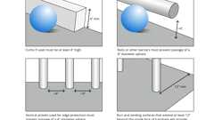
Ramp Edge Protection and Alternatives
1030.14.2 Stepped Aisles
Aisles with a slope exceeding one unit vertical in eight units horizontal (12.5-percent slope) shall consist of a series of risers and treads that extends across the full width of aisles and complies with Sections 1030.14.2.1 through 1030.14.2.4.
1030.14.2.1 Treads
Diagram
Tread depths shall be not less than 11 inches (279 mm) and shall have dimensional uniformity.
Exception: The tolerance between adjacent treads shall not exceed ³/₁₆ inch (4.8 mm).
UpCodes Diagram (1)
Stair Dimensional Uniformity
1030.14.2.2 Risers
Where the gradient of stepped aisles is to be the same as the gradient of adjoining seating areas, the riser height shall be not less than 4 inches (102 mm) nor more than 8 inches (203 mm) and shall be uniform within each flight.
Exceptions:
- Riser height nonuniformity shall be limited to the extent necessitated by changes in the gradient of the adjoining seating area to maintain adequate sightlines. Where nonuniformities exceed ³/₁₆ inch (4.8 mm) between adjacent risers, the exact location of such nonuniformities shall be indicated with a distinctive marking stripe on each tread at the nosing or leading edge adjacent to the nonuniform risers. Such stripe shall be not less than 1 inch (25 mm), and not more than 2 inches (51 mm), wide. The edge marking stripe shall be distinctively different from the contrasting marking stripe.
- Riser heights not exceeding 9 inches (229 mm) shall be permitted where they are necessitated by the slope of the adjacent seating areas to maintain sightlines.
1030.14.2.2.1 Construction Tolerances
The tolerance between adjacent risers on a stepped aisle that were designed to be equal height shall not exceed ³/₁₆ inch (4.8 mm). Where the stepped aisle is designed in accordance with Exception 1 of Section 1030.14.2.2, the stepped aisle shall be constructed so that each riser of unequal height, determined in the direction of descent, is not more than ³/₈ inch (9.5 mm) in height different from adjacent risers where stepped aisle treads are less than 22 inches (560 mm) in depth and ³/₄ inch (19.1 mm) in height different from adjacent risers where stepped aisle treads are 22 inches (560 mm) or greater in depth.
1030.14.2.3 Tread Contrasting Marking Stripe
Diagram
A contrasting marking stripe shall be provided on each tread at the nosing or leading edge such that the location of each tread is readily apparent when viewed in descent. Such stripe shall be not less than 1 inch (25 mm) and not more than 2 inches (51 mm) wide.
Exception: The contrasting marking stripe is permitted to be omitted where tread surfaces are such that the location of each tread is readily apparent when viewed in descent.
UpCodes Diagram (1)
Primary
Assembly Egress: Tread Contrasting Marking Stripe
1030.14.2.4 Nosing and Profile
Diagram
Nosing and riser profile shall comply with Sections 1011.5.5 through 1011.5.5.3.
UpCodes Diagram (1)
Stair Nosing Size
1030.15 Seat Stability
In a building, room or space used for assembly purposes, the seats shall be securely fastened to the floor.
Exceptions:
- In a building, room or space used for assembly purposes or portions thereof without ramped or tiered floors for seating and with 200 or fewer seats, the seats shall not be required to be fastened to the floor.
- In a building, room or space used for assembly purposes or portions thereof with seating at tables and without ramped or tiered floors for seating, the seats shall not be required to be fastened to the floor.
- In a building, room or space used for assembly purposes or portions thereof without ramped or tiered floors for seating and with greater than 200 seats, the seats shall be fastened together in groups of not less than three or the seats shall be securely fastened to the floor.
- In a building, room or space used for assembly purposes where flexibility of the seating arrangement is an integral part of the design and function of the space and seating is on tiered levels, not more than 200 seats shall not be required to be fastened to the floor. Plans showing seating, tiers and aisles shall be submitted for approval.
- Groups of seats within a building, room or space used for assembly purposes separated from other seating by railings, guards, partial height walls or similar barriers with level floors and having not more than 14 seats per group shall not be required to be fastened to the floor.
- Seats intended for musicians or other performers and separated by railings, guards, partial height walls or similar barriers shall not be required to be fastened to the floor.
1030.16 Handrails
Diagram
Ramped aisles having a slope exceeding one unit vertical in 15 units horizontal (6.7-percent slope) and stepped aisles shall be provided with handrails in compliance with Section 1014 located either at one or both sides of the aisle or within the aisle width. Where stepped aisles have seating on one side and the aisle width is 74 inches (1880 mm) or greater, two handrails are required. Where two handrails are required, one of the handrails shall be within 30 inches (762 mm) horizontally of the side of the tiered floor adjacent to the stepped aisle.
Exceptions:
- Handrails are not required for ramped aisles with seating on both sides.
- Handrails are not required where, at the side of the aisle, there is a guard with a top surface that complies with the graspability requirements of handrails in accordance with Section 1014.4.
- Handrail extensions are not required at the top and bottom of stepped aisles and ramped aisles to permit crossovers within the aisles.
UpCodes Diagrams (3)
Primary
Handrails at Aisles: Assembly
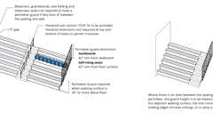
Perimeter Guards at Assembly Seating
Elevation Changes
1030.16.1 Discontinuous Mid-Aisle Handrails
Diagram
Where there is seating on both sides of the aisle, the mid-aisle handrails shall be discontinuous. Where a stepped aisle is required to have two handrails, the mid-aisle handrails shall be discontinuous. Gaps or breaks shall be provided at intervals not exceeding five rows to facilitate access to seating and to permit crossing from one side of the aisle to the other. These gaps or breaks shall have a clear width of not less than 22 inches (559 mm) and not greater than 36 inches (914 mm), measured horizontally, and the mid-aisle handrail shall have rounded terminations or bends.
UpCodes Diagram (1)
Handrail Continuity - Excpt. 4 & 5
1030.16.2 Handrail Termination
Handrails located on the side of stepped aisles shall return to a wall, guard or the walking surface or shall be continuous to the handrail of an adjacent stepped aisle flight.
1030.16.3 Mid-Aisle Termination
Mid-aisle handrails shall not extend beyond the lowest riser and shall terminate within 18 inches (381 mm), measured horizontally, from the lowest riser. Handrail extensions are not required.
Exception: Mid-aisle handrails shall be permitted to extend beyond the lowest riser where the handrail extensions do not obstruct the width of the cross aisle.
1030.16.4 Rails
Where mid-aisle handrails are provided in stepped aisles, there shall be an additional rail located approximately 12 inches (305 mm) below the handrail. The rail shall be adequate in strength and attachment in accordance with Section 1607.9.1.2.
1030.17 Assembly Guards
Guards adjacent to seating in a building, room or space used for assembly purposes shall be provided where required by Section 1015 and shall be constructed in accordance with Section 1015 except where provided in accordance with Sections 1030.17.1 through 1030.17.4. At bleachers, grandstands and folding and telescopic seating, guards must be provided where required by ICC 300 and Section 1030.17.1.
1030.17.1 Perimeter Guards
Diagram
Perimeter guards shall be provided where the footboards or walking surface of seating facilities are more than 30 inches (762 mm) above the floor or grade below. Where the seatboards are adjacent to the perimeter, guard height shall be 42 inches (1067 mm) high minimum, measured from the seatboard. Where the seats are self-rising, guard height shall be 42 inches (1067 mm) high minimum, measured from the floor surface. Where there is an aisle between the seating and the perimeter, the guard height shall be measured in accordance with Section 1015.3.
Exceptions:
- Guards that impact sightlines shall be permitted to comply with Section 1030.17.3.
- Bleachers, grandstands and folding and telescopic seating shall not be required to have perimeter guards where the seating is located adjacent to a wall and the space between the wall and the seating is less than 4 inches (102 mm).
UpCodes Diagram (1)
Primary
Perimeter Guards at Assembly Seating
1030.17.2 Cross Aisles
Cross aisles located more than 30 inches (762 mm) above the floor or grade below shall have guards in accordance with Section 1015.
Where an elevation change of 30 inches (762 mm) or less occurs between a cross aisle and the adjacent floor or grade below, guards not less than 26 inches (660 mm) above the aisle floor shall be provided.
Exception: Where the backs of seats on the front of the cross aisle project 24 inches (610 mm) or more above the adjacent floor of the aisle, a guard need not be provided.
1030.17.3 Sightline-Constrained Guard Heights
Unless subject to the requirements of Section 1030.17.4, a fascia or railing system in accordance with the guard requirements of Section 1015 and having a minimum height of 26 inches (660 mm) shall be provided where the floor or footboard elevation is more than 30 inches (762 mm) above the floor or grade below and the fascia or railing would otherwise interfere with the sightlines of immediately adjacent seating.
1030.17.4 Guards at the End of Aisles
Diagram
A fascia or railing system complying with the guard requirements of Section 1015 shall be provided for the full width of the aisle where the foot of the aisle is more than 30 inches (762 mm) above the floor or grade below. The fascia or railing shall be not less than 36 inches (914 mm) high and shall provide not less than 42 inches (1067 mm) measured diagonally between the top of the rail and the nosing of the nearest tread.
UpCodes Diagram (1)
Guardrail Opening Limitations (Ex. 5)
Section 1031 Emergency Escape and Rescue
Diagram
UpCodes Diagrams (5)
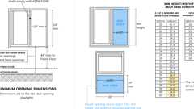
Emergency Egress: Min. Dimensions
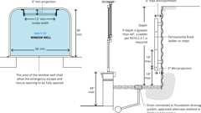
Emergency Egress: Window Wells
Emergency Egress: Doors and Area Wells
Yards and Courts
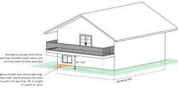
Emergency Windows Under Decks and Porches
1031.1 General
Emergency escape and rescue openings shall comply with the requirements of this section.
1031.2 Where Required
In addition to the means of egress required by this chapter, emergency escape and rescue openings shall be provided in Group R occupancies.
Basements and sleeping rooms below the fourth story above grade plane shall have not fewer than one emergency escape and rescue opening in accordance with this section. Where basements contain one or more sleeping rooms, an emergency escape and rescue opening shall be required in each sleeping room, but shall not be required in adjoining areas of the basement. Such openings shall open directly into a public way or to a yard or court that opens to a public way, or to an egress balcony that leads to a public way.
Exceptions:
- In Groups R-1 and R-2 occupancies constructed of Type I, Type IIA, Type IIIA or Type IV construction equipped throughout with an approved automatic sprinkler system in accordance with Section 903.3.1.1.
- Group R-2.1 occupancies meeting the requirements for delayed egress in accordance with Section 1010.2.13 may have operable windows that are breakable in sleeping rooms permanently restricted to a maximum of 4-inch open position.
- Basements with a ceiling height of less than 80 inches (2032 mm) shall not be required to have emergency escape and rescue openings.
- Emergency escape and rescue openings are not required from basements or sleeping rooms that have an exit door or exit access door that opens directly into a public way or to a yard, court or exterior egress balcony that leads to a public way.
- Basements without habitable spaces and having not more than 200 square feet (18.6 m²) in floor area shall not be required to have emergency escape and rescue openings.
- Storm shelters are not required to comply with this section where the shelter is constructed in accordance with ICC 500.
- Within individual dwelling and sleeping units in Groups R-2 and R-3, where the building is equipped throughout with an automatic sprinkler system installed in accordance with Section 903.3.1.1, 903.3.1.2 or 903.3.1.3, sleeping rooms in basements shall not be required to have emergency escape and rescue openings provided that the basement has one of the following:
  - 7.1. One means of egress and one emergency escape and rescue opening.
  - 7.2. Two means of egress.
- In Group R-2.2 occupancies a certified fire escape is acceptable as a secondary means of egress for existing buildings for this section of the code.
1031.2.1 Operational Constraints and Opening Control Devices
Emergency escape and rescue openings and any exit doors shall be maintained free of any obstructions other than those allowed by this section and shall be operational from inside the room without the use of keys or tools. Window-opening control devices complying with ASTM F2090 shall be permitted for use on windows serving as a required emergency escape and rescue opening. The release mechanism shall be maintained operable at all times.
Such bars, grills, grates or any similar devices shall be equipped with an approved exterior release device for use by the fire department only when required by the authority having jurisdiction.
Where security bars (burglar bars) are installed on emergency egress and rescue windows or doors, on or after July 1, 2000, such devices shall comply with California Building Standards Code, Part 12, Chapter 12-3 and other applicable provisions of Part 2.
Exception: Group R-1 occupancies provided with a monitored fire sprinkler system in accordance with Section 903.2.8 and designed in accordance with NFPA 13 may have openable windows permanently restricted to a maximum 4-inch (102 mm) open position.
1031.2.2 Maintenance
Fire escape stairways and balconies shall be kept clear and unobstructed at all times and shall be maintained in good working order.
1031.2.3 Examination
Fire escape stairways and balconies shall be examined for structural adequacy and safety by a registered design professional or other person acceptable to the fire code official every 5 years. The examination shall determine whether the fire escape stairways and balconies can support the dead load plus a live load of not less than 100 pounds per square foot (4.78 kN/m). An inspection report shall be submitted to the fire code official after such examination.
1031.3 Emergency Escape and Rescue Openings
Emergency escape and rescue openings shall comply with Sections 1031.3.1 through 1031.3.3.
1031.3.1 Minimum Size
Diagram
Emergency escape and rescue openings shall have a minimum net clear opening of 5.7 square feet (0.53 m²).
Exception: The minimum net clear opening for grade-floor emergency escape and rescue openings shall be 5 square feet (0.46 m²).
UpCodes Diagrams (2)
Primary
Emergency Egress: Min. Dimensions
Window Fall Protection
1031.3.2 Minimum Dimensions
Diagram
The minimum net clear opening height dimension shall be 24 inches (610 mm). The minimum net clear opening width dimension shall be 20 inches (508 mm). The net clear opening dimensions shall be the result of normal operation of the opening.
UpCodes Diagram (1)
Emergency Egress: Min. Dimensions
1031.3.3 Maximum Height From Floor
Diagram
Emergency escape and rescue openings shall have the bottom of the clear opening not greater than 44 inches (1118 mm) measured from the floor.
UpCodes Diagram (1)
Primary
Emergency Egress: Min. Dimensions
1031.4 Emergency Escape and Rescue Doors
Where a door is provided as the required emergency escape and rescue opening, it shall be a swinging door or a sliding door.
1031.5 Area Wells
Diagram
An emergency escape and rescue opening with the bottom of the clear opening below the adjacent grade shall be provided with an area well in accordance with Sections 1031.5.1 through 1031.5.3.
UpCodes Diagrams (3)
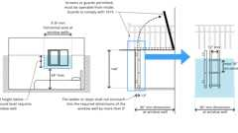Primary
Emergency Escape & Rescue Well Openings
Primary
Emergency Egress: Doors and Area Wells
Primary
Emergency Egress: Window Wells
1031.5.1 Minimum Size
The minimum horizontal area of the area well shall be 9 square feet (0.84 m²), with a horizontal projection and width of not less than 36 inches (914 mm). The area well shall allow the emergency escape and rescue opening to be fully opened.
Exception: The ladder or steps required by Section 1031.5.2 shall be permitted to encroach not more than 6 inches (152 mm) into the required dimensions of the area well.
1031.5.2 Ladders or Steps
Diagram
Area wells with a vertical depth of more than 44 inches (1118 mm) shall be equipped with an approved permanently affixed ladder or steps. The ladder or steps shall not be obstructed by the emergency escape and rescue opening when the window or door is in the open position. Ladders or steps required by this section shall not be required to comply with Section 1011.
UpCodes Diagram (1)
Emergency Egress: Window Wells
1031.5.2.1 Ladders
Ladders or rungs shall have an inside width of at least 12 inches (305 mm), shall project at least 3 inches (76 mm) from the wall and shall be spaced not more than 18 inches (457 mm) on center (o.c.) vertically for the full height of the area well.
1031.5.2.2 Steps
Steps shall have an inside width of not less than 12 inches (305 mm), shall have treads greater than 5 inches (127 mm) in depth and a riser height not greater than 18 inches (457 mm) for the full height of the area well.
1031.5.3 Drainage
Area wells shall be designed for proper drainage by connecting to the building's foundation drainage system required by Section 1805.
Exception: A drainage system for area wells is not required where the foundation is on well-drained soil or sand-gravel mixture soils in accordance with the United Soil Classification System, Group I Soils, in accordance with Section 1803.5.1.
1031.6 Bars, Grilles, Covers and Screens
Diagram
Where bars, grilles, covers, screens or similar devices are placed over emergency escape and rescue openings or area wells that serve such openings, the minimum net clear opening size shall comply with Sections 1031.3 and 1031.5. Such devices shall be releasable or removable from the inside without the use of a key, tool or force greater than that which is required for normal operation of the emergency escape and rescue opening.
UpCodes Diagrams (2)
Emergency Escape & Rescue Well Openings
Security Grilles

